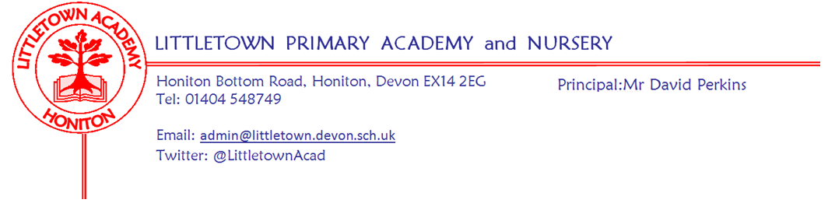
Year 4 Autumn Term 2020 Information
Literacy
In Literacy, we will be studying different types of texts, including both fiction and non-fiction. The focus on non-fiction texts will tie in with our Cornerstones Topic of ‘Burps, Bottoms and Bile’ and children will look at the features of information and explanation texts in more detail. They will also have the opportunity throughout the term to use their imaginations and demonstrate their creativity when writing their own stories, poetry and even song lyrics. We will explore a range of literacy features including letters of persuasion, diary entries and character profiles.
Every Tuesday, key aspects of SPAG (spelling, punctuation and grammar) will also be taught. Please note that Spellodrome has now changed to Readiwriter. This should be easier for your children to access, as it does not require Flash Player. Your child’s login details will be the same as for Spellodrome. The children have stuck their logins in the front of their reading diaries. The spelling activities on Readiwriter will be linked to the weekly spelling list. Please encourage your children to use it regularly. We will also encourage the children to practise writing out their spellings in their best handwriting.

The children will also be developing their reading comprehension skills through Lexia. Please encourage your child to work on Lexia at home for 30 minutes a week. We will also continue with our school reading programme called ‘Accelerated Reader.’ Please remember children can access Accelerated Reader at home to access quizzes. Please let us know if you need a reminder of their login.
Reading books
We have 2-3 class library slots over a 2 week period where the children can change their books. Our teaching assistants can also change books for the children when possible. Due to this, you may find that your child will finish their books and not be able to get a new book straight away due to limited access to the library. If this is the case in school, we have a class book corner where the children can choose a book to read in the meantime. Please also encourage your child to read any books or magazines at home, or go on Lexia. It all counts towards their reading. Don’t forget about Oxford Reading Owl too where the children can read e-books.

Reading diaries
We expect children to be reading at least 5 times a week at home. Please record the reading they are doing at home, don’t forget this includes Lexia. Reading diaries will be looked at on a Monday, and house points given for the children who have read 5 times or more the previous week.
Maths
In Maths, each lesson will begin with a Power Up that is designed to give the children a quick reminder of past learning. We then move on to the main focus of that day’s lesson. This term our units will be Place Value - 4 digit numbers, Addition and Subtraction, Measure - Perimeter and Multiplication and Division.
Please encourage your child to use Times Tables Rockstars as much as possible to practise their multiplication and division facts. Towards the end of Year 4, your child will need to take a short online test to check that their times table knowledge is at the expected level. This is a Department of Education initiative to help schools identify pupils who have not mastered their times tables to enable additional support to be given.
Cornerstones
This half term, our Topic will be ‘Burps, Bottoms and Bile’ and later in the term, we will start our new Topic, ‘Playlist’.
The Home Learning activities for each will be sent out at the start of each topic.

Outdoor Classroom
4GWGA - Monday, 28th September 2020
4SD - Tuesday, 29th September 2020
A letter will be sent out nearer the time giving further details.
The dates for Outdoor Classrooms after the half term will be advised later.
Key reminders
Book Bags: Please send your child’s book bag into school every day (with your child’s Reading Record).

Clothing: Please ensure all items are named, including PE kit and shoes.

Water Bottles: Please ensure your child has a bottle of water (not juice) in the classroom for drinking throughout the day.

Packed Lunches: We have peanut allergies in school, so we ask that no children have nuts or nut based snacks/spreads in their lunchboxes. We are a healthy school and ask that children do not bring in chocolates or sweets for lunch.
School Dinners: Please ensure you book your child’s school dinner by Friday midnight for the following week. If your child does not eat enough school lunch we will send a note home to inform you.

Medication: Please let us know if your child has to take any prescribed medication at school. There is a green form for you to fill in so that we can administer it. We can only give prescribed medication and the medication must have the prescription label on. Please phone the school if your child is off sick. If you have a medical appointment please let the office know.

Birthdays: If it is your child’s birthday they can come to school in their home clothes. Please do not bring cake/sweets in for other children.

Toys: We ask that toys/valuables are not brought into school.

P.E kits: Please can your child have their P.E kit in school every day. We have set P.E slots but they are sometimes subject to change.
4GW/GA - Mondays and Tuesdays
4SD - Tuesdays and Fridays

Key dates for the Autumn term
Friday 16 October Break up for two week half term holiday
Monday 2 November Return to school
Friday 20 December End of term
Class email addresses:
Mrs Wright’s/Mrs Arni’s class: class4gwga@littletown.devon.sch.uk
Mr Driscoll: class4sd@littletown.devon.sch.uk
Thank you for your support
The Year 4 Team

