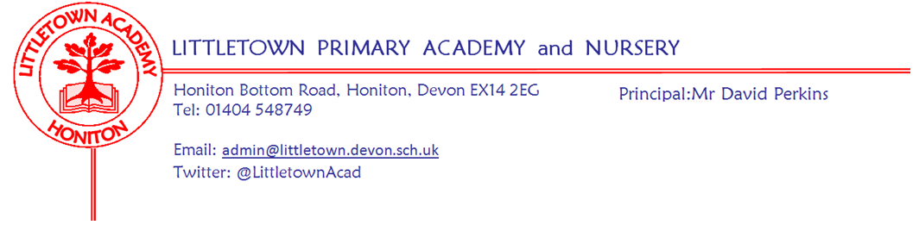
Friday 1st May 2020
Dear Parents and Carers,

I hope you have had a successful week and you have managed to balance remote learning with family time. I have really enjoyed looking at the galleries in the various year group padlets and seeing the amazing learning that children are completing at home and I know the teachers have really valued this feedback. Thank you to parents who have submitted learning for the padlets and to me for Twitter and Facebook. Well done everybody!

Following parent feedback and discussion with staff, as of next week Padlets will be updated for the next week’s learning by 6pm on the previous Friday. This will allow parents to become familiar with the learning over the weekend rather than waiting until Monday.

Also from next week, teachers will be choosing and celebrating ‘Stars of the Week’ on their padlets, celebrating all the great things children are doing. These will also be mentioned in the weekly newsletter.

Friday 1st May is a bank holiday to commemorate the 75th Anniversary of V.E day. Remote learning for the week will take into account that children wouldn’t ordinarily be at school on this day. To celebrate the occasion on Friday, we would like to set you a challenge for the week; each family to host their own 'Stay At Home V.E. Day Tea Party'. It could be a pretend tea party, complete with teddies or a real tea party with the whole household in your garden. On each year group’s padlet there will be bunting and Union Jack templates to help with the decoration as well as a ‘design a commemorative tea cup’ activity. We would love to see your photos and share them on padlets and via Facebook and Twitter with the hashtag #littleteaparty . Pictures can also be emailed to head@littletown.devon.sch.uk.

A final reminder of the message from the Student and Family Support Team: A big thank you to those parents who have completed the My Plan survey so far. This is an opportunity for you to have your say in the future development of your child’s My Plan. Your opinions will enable us to make changes that will continue to improve your involvement in your child’s plan. In line with our Ethical Protocol, all surveys will be completely anonymous Please use the link below to take part in the My Plan Survey.
https://forms.gle/HtG6DQ45QdJw8m1v9

Finally, I am sure you will be paying close attention to all announcements by the Government regarding the reopening of schools. Yesterday, we were told that a plan will be announced next week for returning to school once the five key tests have been met. I wanted to assure you all that as schools we only receive the same information at the same time as you. This makes planning difficult. On Monday the Governors and I will discuss various scenarios and outcomes in order to be as best prepared as we can for when actual plans are announced. However, we won’t be able to say what the school will or won’t do until the definitive plans and time scales are announced. Thank you for your ongoing patience in this uncertain time.

Yours faithfully,
David Perkins
Principal

