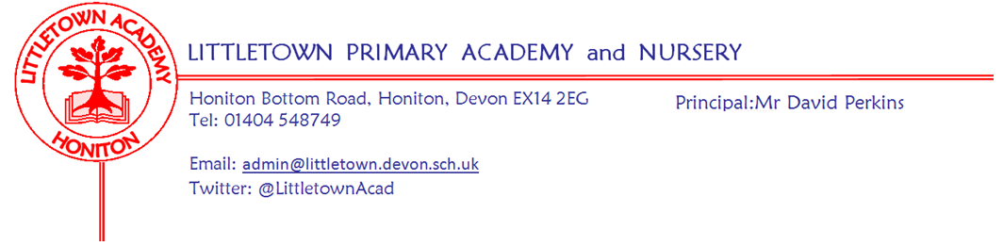
Friday 18th December 2020
Dear Parents and Carers,

As we reach the end of what has been a challenging term for children, staff and parents, it has been lovely to witness the atmosphere around school this week. It has also been lovely to see children in christmas clothes etc these last two days creating some Christmas sparkle despite the dreary weather. Hopefully you have all had a chance to look at the Christmas padlet we sent out yesterday. We have received some lovely emails and comments to share with the children - thank you.

A huge thank you to the ladies in the kitchen for an amazing Christmas dinner for the children yesterday. Serving up 360 meals to classes, whilst keeping everyone in their bubbles was certainly quite the challenge, but the children really enjoyed it. I am pleased that all the children were able to give them a massive cheer via my laptop this morning. We also had the exciting visit from Santa yesterday, who brought a present for each class to have in their classrooms. Thanks to the PTFA for helping Santa with this!

It was great to see the whole school in their classrooms via google meet this morning for a whole school assembly, to give them some praise for the padlet and wish them a Merry Christmas. Thank you to the Governors who bravely made videos of themselves reading Christmas stories for the children.

I would like to give a special mention to class 3JS/SD children and parents this week for their amazing hard work and attitude to remote learning. We can’t wait to have you back at school again after the Christmas holidays.

The experiment with the back gate seems to have been successful with the caveat that we have had many children off school for various reasons this week. We will continue to open it at the end of the day in the week beginning 4th January 2021 and see how it works with all children in school.

If any children are lucky enough to receive a new computer or device for Christmas, parents may want to refer to the attached National Online Safety 12 online safety tips for Christmas. This covers security, setting screen time limits and age appropriateness amongst other things.

As shared with you last week, please see again below and familiarise yourself with crucial information from the DfE regarding any possible or positive Covid-19 cases over the start of the Christmas holidays. If you are unsure in any way about anything to do with Covid-19 or not sure what to do please email me to ask. I would much rather this than possible errors in the process. There really is no such thing as a silly question when it comes to something as important as keeping everyone safe. Thank you for your cooperation with this.

Finally, may I take this opportunity to say a personal and heartfelt thankyou to all parents for being such a key part of our LittletownBigteam this term and for all the support and understanding you have given us since September. May I wish you all the best possible Christmas, a restful and joyous break and be the first to wish you a very happy and prosperous new year!

I look forward to seeing you all when we return to school next year on Monday 4th January 2021

Yours faithfully,
David Perkins
Principal

Info from DfE on notification of symptoms and cases at the end of term

- Where a pupil tests positive for coronavirus (COVID-19), having developed symptoms more than 48 hours since being in school, the school should not be contacted. Parents and carers should follow contact tracing instructions provided by NHS Test and Trace.
- For the first 6 days after teaching ends (up to Christmas day), if a pupil tests positive for coronavirus (COVID-19), having developed symptoms within 48 hours of being in school, parents should contact the school (head@littletown.devon.ch.uk) who will assist in identifying close contacts and advising self-isolation, as the individual may have been infectious whilst in school.

Gymnasts and Dancers success
Gymnastics
Huge congratulations to Poppy, Rosalie, Emily, Amelia, Bella, Leiya, Pippa, Lily and Sophia for taking part in the Devon virtual gymnastics competition. A special well done to Leiya for receiving a certificate for her dedication and Amelia, Lily and Bella for placing in the top 3 in East Devon. Congratulations to Bella who went through to the Devon finals via Zoom and won a silver medal!

Dance
Two Year 6 dance groups took part in the Devon virtual dance competition this half term. Huge congratulations to Chloe, Erin, Isabelle and Sophie who finished in 5th position and to Briar, Freya and Hallie who placed 3rd, out of 30 entries! The girls made up their routines all by themselves and practised at home via Zoom! Now that’s dedication! Well done girls.
Thank you to Miss Bodgin for supporting the children with these competitions.

Breakfast and After School Club bookings
We are now running on a 4 week booking form. Alongside this, we are able to offer some flexibility regarding alterations. If we have a full 2 week notice, we will not charge you for unused bookings. As ever, we will refund for illness, Covid-19 implications and extenuating circumstances.

If you would like to use our provisions between 4th-29th January, please fill in the form following this link.

https://forms.gle/NpjhEyLRQGQrrSPp6

Thank you

PTFA news
Thank you to those of you who have already sent in your entries for the quiz, and those who have kindly donated to us.

We are extending the entry for the quiz until January to give more time for you to complete it over the holidays. All completed entries will be put into a draw for a prize when we return next term, and the answers will be sent out then too. There are a mix of trivia questions, riddles, anagrams and picture questions which all the family can have a go at. You should have already received a copy of the quiz so please enjoy.

There is no charge as such for entering but, if you enjoy it, then please consider making a donation to the PTFA (Account name: Littletown Academy PTFA, Sort code 40-24-28, account number 21450913,and reference “donation”)

As we are unable to run our normal events at the moment any donation will be gratefully received.

Happy Christmas to you all

