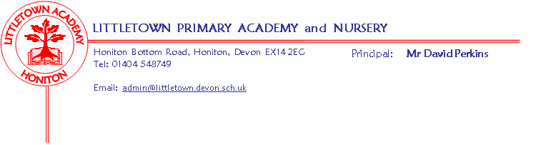
Year 3 Home Learning Activities
Literacy
Reading
Please continue to read books at home. You are able to log on to Accelerated Reader to find out if there is a quiz on the book your child has read. We will then be able to see the results of the quizes your child has taken and what they are reading.
Comprehension sheets
Children can work through the two comprehension texts, answering the questions in full sentences and working through the word work and extension activities.
Spellodrome
Children can work through the activities connected to their lists which will be updated regularly.
Writing
Please see the attached Literacy sheet with lots of writing opportunities for your child. Please ensure they write in their neatest handwriting.
Maths
We have put together a maths booklet which covers addition, subtraction, money and powers of ten (instructions on the front). Should you require further work, we are also sending home the Power Maths A books. The children can work through them from the beginning, completing any questions and challenges they did not have time to complete in class. This will help consolidate their learning.
Times Tables Rockstars
Continue with learning their multiplication facts using TTRS. We will be able to see how they are doing.
Cornerstones
As we start our new topic, Flow, please see the Home Learning ideas sheet for lots of activities based on rivers. House points will be awarded for any pieces of work completed. If you do an activity, perhaps take photos which can be brought in to school.
Useful websites
www.twinkl.co.uk/offer
ukhosted44.renlearn.co.uk/1922601
Login.spellodrome.com
ttrockstars.com
code.org/join
name.surname@littletownacademy.org (Google Classroom – the children will know their personal ‘Chrome Book’ password)

