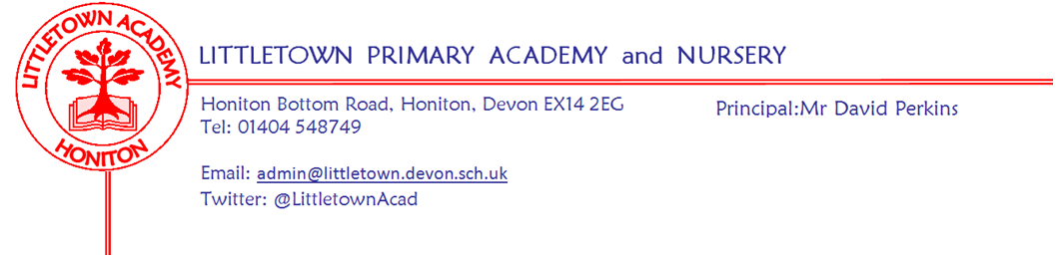
13th December 2019
Dear Parents and Carers,
We have had a very busy penultimate week of term with Christmas activities in full swing! On Monday some of our Year 4 children attended a Dance workshop at Honiton Community College and behaved brilliantly. On Tuesday, Mrs Childs took some of our children to experience The Night before Christmas at Killerton House. Thank you to those who attended the Annual General Meeting on Tuesday afternoon. Minutes will be available on the school website.
Wednesday and Thursday saw our Year 1 and Year 2 children put on magnificent performances of Prickly Hay - the KS1 Christmas production. I was very impressed by the children's speaking, singing, dancing and of course the wonderful costumes! My thanks to all the parents for attending and ferrying children backwards and forwards and to the teachers and staff who supported the children so well. Today Year 2 children enjoyed outdoor classroom and we all celebrated Christmas Jumper Day in support of Save the Children. Thank you for all you donations. Last count we have raised £100.
The final week of term next week is a very busy one. We look forward to Key Stage 2 Christmas concerts in St Paul’s church and the Foundation Stage (Nursery and Reception) Wriggly Nativity! We also have Christmas parties and our whole school Christmas dinner on Thursday.
As well as these Christmas festivities we have a number of express events next week. On Tuesday at 2:30pm Year 4 invite parents to share their Christmas number 1 single, On Wednesday at 9:15am Year 1 parents are invited to a play about The Great Fire of London and on Thursday at 9:15am Year 2 parents are invited for some drumming, marching and other rhythmic activities.
Term will end at the end of the school day on Friday 20th December.
Yours faithfully,
David Perkins
Principal

News from the children

Nursery
We have been making Christmas cards.
We have been writing letters to Santa.

Reception
We have been singing for our nativity.
In Maths we have been singing The Elephant Song.

Year1
We have done our Christmas performance.
We wrote a newspaper report.

Year2
We are doing outdoor classroom.
We are making Christmas cards.

Year3
We have been making iron men.
We are doing times tables in maths.

Year4
We are rewriting Christmas Old Town Road.
We have been learning band in xtobal.

Year5
We are practicing Christmas songs.
We started area and perimeter in maths.

Year6
We have been writing stories about Justino.
Our new topic is blood heart.

Staff news
Mrs Newman Year 2 teacher and Mental Health leader will sadly be leaving us at Christmas. Mrs Newman has relocated to North Devon and is no longer able to make the journey to Littletown each day. Mrs Rossiter will be teaching her Year 2 class from January. I’m sure you will join me in thanking Mrs Newman for her contribution to our school and wishing her all the best for the future.

Week beginning 16th December:
Monday | Tuesday | Wednesday | Thursday | Friday
Foundation performances 2pm and 5pm | Y4 Express event 2:30pm  KS2 Christmas Performance 6pm | Y1 Express event 9:15am  KS2 Christmas Performance 6pm | Y2 Express event 9:15am  Christmas lunch | End of term

Christmas dates
Please see below here a comprehensive list of Christmas dates and times:
Foundation Stage (Nursery and Reception) Performance | Monday 16th December | 2pm and 5pm | School hall
Nursery Christmas Party | Tuesday 17th December | 9.00 - 12.00 noon | Nursery
KS1 (Year 1 and Year 2) Christmas party | Tuesday 17th December | 9:15 - 10:15 | Classrooms and hall
KS2 (Years 3,4,5,6) Christmas Performance | Tuesday 17th December | 6pm | St Paul’s church
KS2 (Years 3,4,5,6) Christmas Performance | Wednesday 18th December | 6pm | St Paul’s church
Reception Classes Christmas party | Thursday 19th December | 10:30 | Classrooms and hall
Christmas Dinner | Thursday 19th December | lunchtime | School hall
Term ends | Friday 20th December | 3:15
*KS2: A Christmas film will be watched in their classrooms over the last week.

