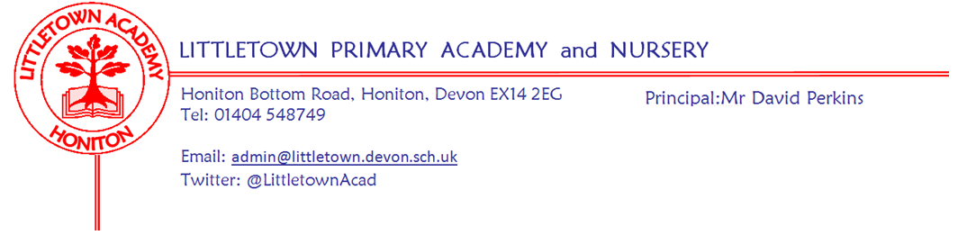
Friday 21st May 2021
Dear Parents and Carers,

This week we have been told to now expect a ‘Roadmap for schools’ to be announced no sooner than early June. This is frustrating for all of us, but is most likely linked to seeing the national impact of the ‘Indian variant’ of Covid-19 and its potential impact on any possible loosening of restrictions in schools. As soon as we are told what is due to change at school and when, I will let you know.

Despite another week of some questionable Summer weather, I have been observing some wonderful learning in the school this week. 3RB/GH made entire rainforests in plastic bottles during Outdoor Classroom on Wednesday and 3JS/SD went to Honiton Bottom Road Nature Reserve for a morning of outdoor activities with Wild East Devon which had been postponed from the Autumn Term. Year 4 have written some high quality letters in Literacy. Nursery children have been making delicious bread and Reception have taught me many great facts about Giraffes and other animals in their ‘Guess Who Factfiles’. Year 1 have been mapping their very own Enchanted Woodlands and Year 2 have been writing some amazing Biographies, including on their Principal! On the top corridor, Year 5 have turned themselves into Pharaohs and Year 6 have been researching the fossil hunting of Mary Anning in Lyme Regis.

As you know, next week is our final Mental Wellbeing week of the year with a cake sale after school on Thursday and non school uniform day next Friday 28th May amongst other activities during the week. Please find all the details from Mrs Davis below.

Finally, I would like to ask you to ensure your child’s voice is heard in the largest scale consultations of children the country has seen. The new Children's Commissioner, Rachel de Sousa has introduced the children’s ‘Big Ask’. This easy to complete survey allows your child’s voice to become part of messages passed directly to Government and policy makers in order to improve life in the UK for all children. There are different surveys depending on the age of children and the deadline is Friday 28th May. Please feel free to ask me if you have any questions. Here is the link:
https://www.childrenscommissioner.gov.uk/thebigask/

Yours faithfully,
David Perkins
Principal

Mental wellbeing Week
Next week we will be having our final Mental Wellbeing Week of the academic year. We will be taking the opportunity to focus on the 10 ways to balance our physical and mental health. The money we raise will be split between mental wellbeing at school and The Parent Support Hub. The Parent Support Hub is a part of Honiton Health Matters and is a group supporting local families living with mental health issues. At school we would like to have ‘covered calm zones’ outside so children who need somewhere quiet to be during playtimes will have a place to go.

The Year 6 Mental Wellbeing Ambassadors will be holding a ‘Lucky Dip Cake Sale’. We are not asking for home-made cakes but donated cakes from supermarkets, bakeries or coffee shops so if you are able to help please let us know via admin@littletown.devon.sch.uk. Cakes will be available on Thursday 27th May after school, Lucky Dip Cake Bags will be £1 and each bag will contain 4 cakes. Any donations of shop bought cakes would be very welcome and can be brought into school prior to the sale.

On Friday 28th May the children will be able to come to school in their own clothes and we would love it if they could dress in something colourful but please don’t buy anything specially. Children can either bring in a voluntary donation of 50p per child or £1 per family on the day..

Children have been set a challenge to complete during the week. During their PE lesson they will be asked to walk either half or one mile around the school grounds. Staff have been challenged to walk a mile a day. We will add up all the miles walked during the week and see how far we have walked. If you would like to support us in our challenge you can make a donation and send it to school in a sealed envelope with your child on Friday 28th May, labelled ‘mile challenge’.

Mental Wellbeing Ambassadors
I would like to say a thank you and well done to all the Year 5’s who have applied to be Mental Wellbeing Ambassadors when they are in Year 6. I have been impressed with all the applications and if I could have you all on the team I would but unfortunately I can only choose six from each class. I will be making the very difficult decision next week and your class teacher will let you know my decision as soon as it has been made.

Parking and dropping off
Some parents are still stopping on double yellow lines and the yellow zigzags to drop off children at the start of the day. As mentioned at length in last week’s newsletter, please do not do this as it makes the road temporarily less safe for everyone when this happens.

Relationships,Sex and Health Education
This week you should’ve received further information on the Relationship and Sex Education curriculum content to be taught after the May Half Term holiday. Please ensure you read the content to help support your child’s learning at home.

School Uniform and shoes
After half term we return to our full uniform policy which includes black school shoes. If you think you will have difficulties with this then please do let us know so we can support you accordingly. Many thanks for your cooperation.

Community news
Last week to send in submissions for below.
Opportunity to be an illustrator for a book: We are very lucky to have an author in our school community! Parent, Leanne Herrett founded her charity 8 years ago called See The Future - Opening eyes to a better health.
It's an awareness charity of the importance of going to the opticians, not just for vision but other health issues that can be detected.

She has written a book to further spread awareness of the importance of having eye tests in a fun and reassuring way. The book now needs illustrations for the animal characters and Leanne has kindly asked me to invite Littletown pupils to provide these illustrations!

The book is based on a family of 6 (therefore they would need to be the same animal). An optician (who can be any animal), and a Mum and daughter (who will be the same animal). The children can choose to either design one character or have a go at all of them.

The winning illustrations will be included in the printed book, along with their name as illustrators.

The money from the sale of the book will be going to See The Future and Littletown Academy.

Please may the children bring their finished characters to school by Friday 28th May where I will collate them and pass them to the author!

