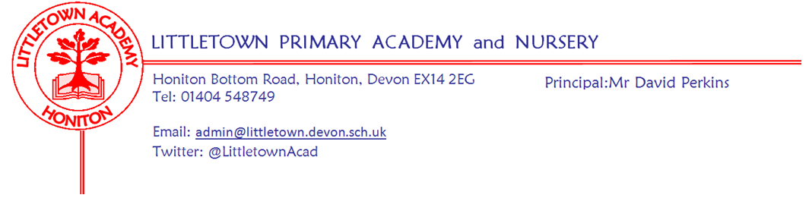
Thursday 28th July 2022
Dear Parents and Carers,

I can only start this final newsletter of the year by paying tribute to our amazing Year 6 children who leave us today. They’ve had quite the week wowing us with their incredible performances on Tuesday and an enjoyable fun swim, BBQ, and inflatable slide yesterday. Finally, this morning an emotional (to say the least!) leavers’ assembly with parents where I was able to thank them for their contribution to the school and wish them the very best for their next step and beyond. It is also always a time when we say farewell to many parents and carers who leave the Littletown community for the last time. A huge thank you from me for all your support over the years. We also have several children leaving us from other year groups too today and I would like to wish all these children the very best for the future.

Elsewhere in the school, on Monday we held our end of Year ACE assemblies where we recognised the fantastic Attitude, Commitment and Effort of many children covering every year group and every subject. We recognised many Year 6 pupils for their achievement in the school and a special mention to Imogen C and Harley for achieving this year’s Outstanding Contribution award. On Tuesday, Year 4 had outdoor classroom where they constructed maps. Yesterday, every child received their end of year report. Thank you for all of the very positive feedback and comments upon receiving these.

A huge thank you from me to all of you for keeping up with all the information, letters, events and activities over the last few weeks of term. As a first time parent in the school myself, I have experienced first-hand (admittedly mostly via my wife!) just what a military operation it requires keeping on top of everything this time of year!

Looking ahead to next year some key reminders to be wary of as we go into the Summer:
- The school day for Reception to Year 6 will finish at 3:30pm.
- Reception and Y1 parents should have received a letter about Read Write Inc our new early literacy approach from September.
- We will be returning to no authorised absence in term time following this year of authorised rescheduled covid affected holidays this year.

Our Student and Family Support Team (SAFS) is taking a new shape next year following us saying farewell and good luck to Mrs Trim (SENDCO) as she moves to Sidmouth Primary School. In September I will share full information on this including specific email addresses for our Pastoral Support Worker and Family Support Worker.

Tomorrow, I hand possession of the site over to the roofing contractor for the large scale roof replacement project first phase over the Summer. We expect the work to proceed as scheduled, but works of this nature can sometimes be unpredictable and weather affected. This means it is possible that I need to write to you about arrangements for September so please make sure you read any emails you receive over the Summer.

I will close by once again thanking you all for your support over the last year. It has been a strange, yet still very successful, year with significant continued covid challenges over the first half, followed by a glorious return to what we consider rich and full Primary school life from March onwards which has been an absolute joy for all of us. I am really pleased with how the school continues to develop and move forwards and I am excited about continuing this journey next year. I wish all of you a restful and relaxing Summer break and I look forward to seeing you all as we return to school on Monday 5th September 2022.

Yours faithfully,
David Perkins
Principal

News from the children
I would like to thank this year’s Year 5 news reporters for all their excellent reporting over the year for our newsletters. They have done an excellent job and have met editorial deadlines far more regularly than the Principal!

Nursery
This week, in Nursery, we have been making pirate hats and enjoying being together in their last week at Nursery.

Reception
This week, in Reception, we have been learning to play tennis and football.

Year 1
This week, in Year 1, we have been drawing their favourite memories this year and fun quizzes.

Year 2
This week, in Year 2, we have been measuring things and painting a mural.

Year 3
This week, in Year 3, we made our volcanoes and our Year 3 work is done. Also, we finished zaffa garaffa leaflet.

Year4
This week, in Year 4, we have watched a film in the hall and we're designing our own lessons.
We made maps in outdoor classroom and played class vs class rounders.

Year 5
This week, in Year 5, we have watched a movie called sing 2. We are also really excited for summer holidays.
We were learning about time (recap) and we have been introduced to rollama.

Year 6
This week, in Year 6, we have had, fun splash, performance, obstacle course, BBQ, leavers assembly, shirt signing and mostly crying and laughing.

Staff news

Farewells
As mentioned in previous newsletters, today we officially say farewell to Mrs Veevers from Year 1 and Mr Firth Premises Manager. I apologise for accidentally omitting in previous newsletters that Mrs Trim is leaving us to take up a post in a school closer to home in September after working at Littletown since 2008 as a teacher and then SENDCO. I would like to thank her for all her hard work. We wish all of them good luck for the future.

Family Support Worker
I am pleased to inform you that we have appointed Mrs Talbot to the role of Family Support Worker in the school from September onwards. We will share more information about Mrs Talbot’s role in September.

Teaching Assistant in 2DBMH next year
As a result of Mrs Talbot being successful in this role, we have subsequently appointed Mrs Sobol to the role of Teaching Assistant in Mrs Bentham and Mrs Hudson-Pike’s class each morning. Mrs Thomas will support Year 2 each afternoon.

Gifts and cards for staff
On behalf of myself and the staff I would like to say a huge thank you for all the gifts, cards and comments as we end the school year. As I mentioned last week, these are really truly valued and appreciated by all of us.

Breakfast and After school club - 2022-23 Sessions and prices

The new timings for sessions from 1st September and the costs are detailed as follows:

Breakfast club - 7:50am until school starts - £4.50

After school club - until 4:30pm - £4.50
- until 5:15pm - £9.00
- until 6:00pm - £13.50

Booking for September-December is now available via this link: https://forms.gle/Taccvz8u6bDvFQcW8

An up to date registration form must also be submitted as this needs to be refreshed annually. It can be reached using the following link: https://forms.gle/YxEJXjWCSEZaA7Ne7

If you have any queries, please email Hannah on hannah.groves@littletownacademy.org

Week Beginning 5th September 2022 events
Monday 5th September | Tuesday 6th September | Wednesday 7th September | Thursday 8th September | Friday 9th September
First day of school

Music at Littletown
We are lucky enough to have 5 talented peripatetic music teachers at Littletown. If you are interested in your child having private music lessons please email littletownmusic@littletown.devon.sch.uk with your enquiry.
Teacher | Instrument(s) | Day
Joseph Binmore | Voice | Monday
Emily Miller | Violin/Ukulele | Monday
Gail Denning | Trumpet/Cornet/Piano/Keyboard | Tuesday
Alan Webster | Guitar | Wednesday
Matt Parr | Drums | Thursday

Community news
Honiton food save
We are committed to stopping food going in the bin. We collect surplus food from supermarkets and give it out for free to anyone in the community. No referrals needed, no questions asked – everyone is welcome, whether you have a specific financial need or have just forgotten an item of shopping.

We are based at the Honiton family church. You can order food from the website on the days they are open:

Mondays – 8:00pm-9pm
Tuesdays – CLOSED
Wednesdays – CLOSED
Thursdays – 8:00pm-9pm
Fridays – 8:00pm-9pm
Saturdays – CLOSED
Sundays – 4:30pm-5:30pm

honitonfoodsave.org.uk

