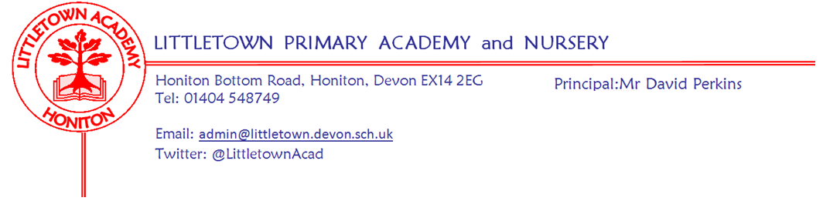

Live . Love . Learn - Littletown
Friday 26th May 2023
Dear Parents and Carers,
It has been a lovely Summer’s week this week with lots of outdoor classroom sessions and den building and the school field in full use as part of OPAL. With the return of the sunny and warm weather and the hope that it continues after half term, please see the seasonal reminders below in this newsletter.
This week, on Monday and Tuesday, 2AL and 2CL/DB had their outdoor classrooms respectively where they were looking for the signs of summer. On Wednesday, Year 1 had their outdoor classroom where they explored the different parts of trees. On Wednesday, some the Year 5 and 6 children took part in some Quad kids activities at school and their scores have been sent in to compare with those from other Honiton Learning Community schools. Yesterday, six, Year 4 children joined me at Awliscombe Primary School where they took part in the Honiton Learning Community Youth Speak competition. The children spoke brilliantly and passionately about Deforestation and the importance of Art to our mindset. A huge well done to these children and to all the other children who also prepared speeches for the class competitions.
When we return after half term some of our Year 5 and 6 boys and girls attend Honiton Primary School on Tuesday for the next round of the Rounders competition.
After half term, as we prepare for transitioning children to their next year groups, I will be writing to parents where children have not been reading at home and this is impacting on their progress. Obviously, it is our job at school to teach children to read, but we know the powerful research evidence on the difference to life chances of young children who read regularly at home. The letter will feature ideas and suggestions from the child about how they can successfully read at home.
Hopefully you notice your children are even more smiley than usual at hometime! In assembly today we discussed how we are in the middle of National Smile Month! We found out it has been proven that the number one thing that makes people smile is someone else smiling at them so this is our Littletown target for our value of Love this term!
Finally, I would like to wish you all a wonderful half term holiday and I look forward to seeing you all when we return to school on Monday 5th June.
Yours faithfully,
David Perkins
Principal

Children’s news

NURSERY: Nursery have been making fruit salads and have been practising using scissors.

RECEPTION: Reception have been weighing items and used the parachute in P.E. to exercise their arms and legs. It was great teamwork!

YEAR 1: Year 1 have been making trees and berries, sketching trees in outdoor classroom, sharing in maths and making maps in Geography.

YEAR 2: Year 2 have been learning about microhabitats and have been making timelines.

YEAR 3: This week, in Maths, Year 3 are learning about time. They have also been writing letters to Gittisham Hill House Residents.

YEAR 4: This week, Year 4 have taken a multiplication test. They have also made amazing Sumerian city statues out of clay.

YEAR 5: Year 5 have this week completed some Maths and Writing assessments. They have also made posters in PSHE.

YEAR 6: Year 6 have been given their blue Leavers hoodies! In PE they have been doing TAG rugby

Mental Wellbeing
We are always very grateful for any donations to wellbeing here at Littletown and all the money donated goes towards benefitting the wellbeing of the whole Littletown community. I would like to say a big thank you to the charity #BroCheck for donating to the Mental Wellbeing Ambassadors wellbeing garden. This donation will go a long way to helping realise their vision for a calm, relaxing place for everyone at Littletown to enjoy. More information about #BroCheck can be found on Facebook

Sunny weather reminders
Children will be outside each day this Summer unless the temperatures are so hot that it is unsafe. We will notify you should the children be kept inside on any given day. With the OPAL provision now in place at lunchtime, all children now have access to numerous areas of shade - most notably the large tree coverage on the edge of the field. Children will be regularly reminded to drink lots of water, remove jumpers and cardigans during the day and seek shade when they become too hot.

Please make sure children have sun cream applied before they come to school on sunny days. Please make sure your child has a sun hat they can wear and ensure they have their water bottle with them each day. Only water is allowed in bottles at school. Please make sure hats and bottles are named. As children can go anywhere at lunch time the chances of reuniting children with unnamed lost items are very small.

E-safety
A reminder to be vigilant over the holiday about children on their devices and what they are accessing. We continue to recommend the ‘Internet Matters’ website. We have had numerous parent’s contact us about Whatsapp over the last couple of weeks so please see below:
WhatsApp
We have had several parents contact school recently sharing concerns over WhatsApp messages their children are receiving from their peers. Please can all parents/carers have a look at the Internet safety information regarding staying safe on WhatsApp. The first advice it states clearly is that this is an app for 16+years.

School advice remains clear and consistent:

Speak to your child about their online activity
Monitor apps your child is using
Enable security/privacy settings
Respect the age restrictions on apps
Remove your child from inappropriate apps
Contact helplines on apps if there has been inappropriate content/messaging/images
Contact the police if you are concerned about threatening messages/ inappropriate images

https://www.internetmatters.org/resources/whatsapp-safety-a-how-to-guide-for-parents/?gad=1&gclid=EAIaIQobChMIucyj95SO_wIVh9LtCh2aJwxKEAAYASAAEgJ-BvD_BwE

Week Beginning 5th June 2023 events
Monday 5th June | Tuesday 6th June | Wednesday 7th June | Thursday 8th June | Friday 9th June
 | Y5/6 Rounders Honiton Primary School | Nursery outdoor classroom |  | Reception outdoor classroom

Community news
Please see attached information on the community events in and around Honiton over half term.

