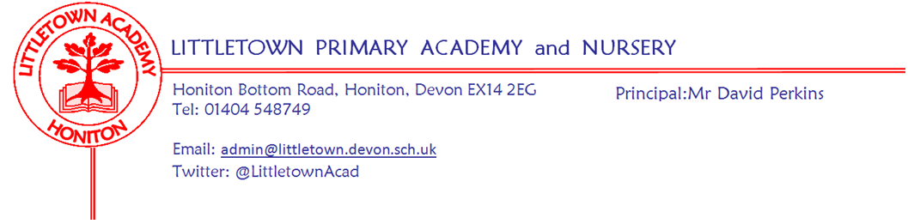
Friday 11th December 2020
Dear Parents and Carers,

Important message about Friday 18th December - we will not be closed on this day. You should have received notification yesterday that despite the Department for Education announcement on Tuesday that schools could make arrangements not to have pupils in school next Friday, we have opted not to do this and to continue as originally planned with children at school on Friday 18th December. This follows discussions I have had with the Governing Board, Senior Leadership Team and Honiton Learning Community Headteachers. The reasons for our decision are many and varied, but the main one is an awareness of the short notice disruption for families. Here is a link to a video of me talking about this in more detail if you are interested. Please don’t hesitate to contact me if you have any questions head@littetown.devon.sch.uk
Video Link: https://littletown.eschools.co.uk/website

School has been like Hollywood (in some ways!) this week and there has been an amazing atmosphere where despite tiredness and bubble restrictions, Christmas joy and festivity is oozing out of the classrooms, as we continue our filming for the ‘Christmas with Littletown’ padlet. Mrs Hawkins and I have really enjoyed visiting each class and filming from the door ways. We will get the padlet link out to you via parentpay mail as soon as it is ready next week. Please remember, this is for you and your families and although we know you will want to share with grandparents and relatives etc, it really is imperative that you don’t send the link out on social media. This message will be reiterated in the email you receive with the link.

It has been amazing to see everyone in such a fine array of Christmas jumpers today, including parents at drop off and pick up! The children have enjoyed dancing for our Christmas video. We will let you know the total raised from your donations for ‘Save the Children’ next week. Remember, the Christmas jumpers can be wheeled out again next week with Christmas accessories if you have them, for the Christmas lunch next Thursday. Like today, this is a non-school uniform day which is Christmas themed!

Next week, Year 2 have their outdoor classroom with 2AL on Monday 14th and 2DB/VR/LM on Tuesday 15th. We are also excited to have 6JF return to school after two weeks, during which they have done lots of brilliant remote learning.

338 children are already booked in for our Christmas lunch on Thursday 17th. My thanks to the kitchen staff for all the extra effort it requires to make this happen. We will also be having our Christmas class bubble parties on this day and the classes may even have a very special visitor pop to see them from the classroom door!

Thank you to the PTFA for their QR code treasure hunt last weekend. I know that many families had a go at this and really enjoyed it. Don’t forget you have also been emailed the PTFA Christmas quiz! This can be emailed back to the PTFA at ptfa@littletown.devon.sch.uk There is no charge for this, but donations can be made.

On behalf of all the staff, I want to say a huge thank you for the burgeoning amount of gifts and cards that have filled up our entrance way over the course of this week! These will be distributed to staff on Monday. Please remember the deadline for all Christmas cards coming into school was today. This was to ensure they have been safely quarantined before we hand them out to the children next week.

As you know, we are always thinking of ways of improving the operation of the school to make it as safe as it possibly can be. Earlier this term, when supply allowed, we installed hand sanitiser stations in every classroom to improve hand hygiene, save time and prevent children from getting irritated skin. You will also remember back in September there was quite a bit of discussion about the back gate and different entrances and exits. Next week, I would like to trial opening the back gate at the end of the day to see if it is effective in relieving pressure at the exit gate on the front playground, where crowds can sometimes form if the stagger isn’t perfect. We all feel the morning staggered start is working very effectively, so the back gate will remain closed in the morning. From Monday though, parents can use the back gate to enter and exit the school at the end of the day. The reason this is only a trial is because we need to see if it can work safely without necessarily having a member of staff supervising and to see whether it results in creating increased traffic and crowding around the one way system along the side of the school. If you still wish for your child to leave the school and meet you outside, this will only be able to happen at the front of the school to ensure supervision. I will let you know in next week’s newsletter whether or not we will be continuing with the back gate opening in the Spring Term or not. If you have any questions about this please don’t hesitate to contact me head@littletown.devon.sch.uk

Finally, the Department for Education has asked Headteachers to share key information about Covid-19 symptoms and cases at the end of term/start of the holiday. Please see this information below.

Yours faithfully,
David Perkins
Principal

Breakfast and After School Club bookings
We are now running on a 4 week booking form. Alongside this, we are able to offer some flexibility regarding alterations. If we have a full 2 week notice, we will not charge you for unused bookings. As ever, we will refund for illness, Covid-19 implications and extenuating circumstances.

If you would like to use our provisions between 4th-29th January, please fill in the form following this link.

https://forms.gle/NpjhEyLRQGQrrSPp6

Thank you

Info from DfE on notification of symptoms and cases at the end of term

- Where a pupil tests positive for coronavirus (COVID-19), having developed symptoms more than 48 hours since being in school, the school should not be contacted. Parents and carers should follow contact tracing instructions provided by NHS Test and Trace.
- For the first 6 days after teaching ends (up to Christmas day), if a pupil tests positive for coronavirus (COVID-19), having developed symptoms within 48 hours of being in school, parents should contact the school (head@littletown.devon.ch.uk) who will assist in identifying close contacts and advising self-isolation, as the individual may have been infectious whilst in school.

Nursery and Reception 2021 Virtual Tour
If you or a friend has a child due to start Nursery or Reception in September 2021 please see and share the poster attached with details on our virtual tour and open day. Please encourage them to call us at school.

