Nursery Topic Information
Is it shiny?
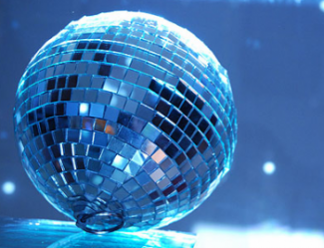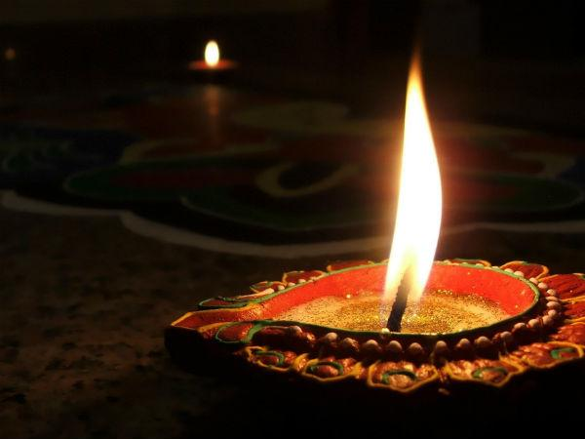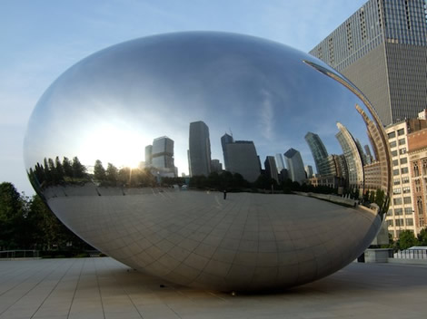

All that glitters is not gold! Is it shiny? Does it sparkle? It’s time to find out more about materials and their properties.
This half term, we’ll hunt for missing treasure and discuss whether the treasure we find is shiny or not. We’ll watch how shiny objects catch the Sun when we hang them outside, and we’ll group and sort different objects. Looking at different types of mirrors, we’ll investigate how our reflections look different in each one.
We will talk about fireworks we have seen, make bonfire pictures and junk rockets. We’ll also find out about stars and space travel, creating our own galaxy pictures and pretending to be a crew of astronauts aboard a space rocket. In literacy, we’ll sing and play instruments along to the nursery rhymes, including Twinkle, Twinkle, Little Star, and we’ll use tools to write letter shapes and numbers on foil. Using our maths skills, we will continue counting and trying to recognise numerals, throughout our play. Getting creative, we’ll become glitter monsters as we explore the texture and appearance of glitter, make edible chocolate sparklers, make warming winter soup and create glittery and shiny Christmas decorations. At the end of the project, we would love you to come and join us for our Stay and Play session – Tuesday 17th and Wednesday 18th December – 2.40-3pm

How you can help your child prepare for their project:
Let it shine! Why not open a jewellery box and explore the treasures inside together. Which item is the shiniest? From what is it made?
You could also take a walk around a local pond or lake on a sunny day. What can you see reflected on the surface of the water? How does the appearance of the water change when the Sun goes behind a cloud?
Look at the twinkling stars at bedtime, and share stories or information books about space. Would you like to travel to space? What do you think it would be like? How would you get there?

