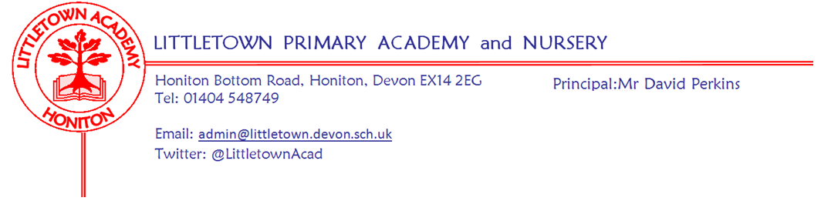

Live . Love . Learn - Littletown
Friday 9th June 2023
Dear Parents and Carers,
A warm and sunny welcome back to the final half term of the academic year. I hope you all had a great half term. This is always a very busy, but special few weeks at Littletown with great occasions such as sports days, fetes, preparations for moving classes and Y6 leavers events.
I would like to start by thanking all of you for your patience and understanding this week regarding the incorrect school dinner menu for this week and the short term closure of the steps to the back gate. The menus are now back in sync and the steps are fully repaired. Please remember, if you booked meals ahead for multiple weeks, you will need to ensure these have been rebooked by the end of tonight.
Over the Half Term holiday the shade canopies for the classrooms on the Year 5/6 corridor have been fixed and serviced meaning they are again in full use for this half term. This offers additional outside shade to these children in combination with the other shaded areas as part of OPAL. Please see the ‘Summer reminders’ for this half term enclosed again below in this newsletter, especially the naming of jumpers and cardigans as we have accumulated a mountain of unnamed items on the field this week.
On Tuesday, some of our Year 5 and 6 Quad kids took part in the East Devon finals at Kings School in Ottery St Mary. The team performed really well with four of our children receiving medals for top 10 overall performances.
In assembly today, as part of our series on ‘British Values’, the children discussed Mutual Respect through the lens of sport and competition. We talked about showing respect for everyone even if we disagree with them and I asked them to make sure they did this at home and at school!
Next week, some children will represent the school at Honiton Leisure Centre in the Honiton Learning Community Handball competition.
Finally, my thanks to the PTFA for organising another disco for the children next Friday evening.
Yours faithfully,
David Perkins
Principal

Children’s news

NURSERY: Nursery made their own perfume and were making sushi bread rolls.

RECEPTION: Reception made their own Intestines and did gymnastics, and made ladders for their Intestines.

YEAR 1: Year 1 have been doing sketches of buildings and learning about animals in science.

YEAR 2: Year 2 have been comparing different religions and learning about quarter past and a quarter to on clocks.

YEAR 3: This week, Year 3 have been doing a plant investigation to answer a question which is what if ? They were also learning about simulation in coding.

YEAR 4: This week, Year 4 have been testing materials to test if they are conductive and also they have been learning about Sourgon The Great.

YEAR 5: This week, Year 5 have started a new book called Radiant Child (Featuring Jean Michel Baquiat).
In Maths they have been measuring acute, obtuse and reflex angles.

YEAR 6: This week, Year 6 have been learning about World War 2 and learning about shadows in Science.

Staff news

Welcome Mrs Horner
This week we have welcomed Mrs Horner to the school as Teaching Assistant. Mrs Horner is working alongside children in Reception.

Mental Wellbeing
The creation of the wellbeing garden is underway, plants and compost have been purchased with the very generous donation from BroCheck ready for planting next week. The ambassadors would like a bench in the garden as there is a fantastic view of Roundball Hill. If anyone is able to donate a bench to the ambassadors then please let us know.

Sunny weather reminders
Children will be outside each day this Summer unless the temperatures are so hot that it is unsafe. We will notify you should the children be kept inside on any given day. With the OPAL provision now in place at lunchtime, all children now have access to numerous areas of shade - most notably the large tree coverage on the edge of the field. Children will be regularly reminded to drink lots of water, remove jumpers and cardigans during the day and seek shade when they become too hot.

Please make sure children have sun cream applied before they come to school on sunny days. Please make sure your child has a sun hat they can wear and ensure they have their water bottle with them each day. Only water is allowed in bottles at school. Please make sure hats and bottles are named. As children can go anywhere at lunch time the chances of reuniting children with unnamed lost items are very small.

Week Beginning 12th June 2023 events
Monday 12th June | Tuesday 13th June | Wednesday 14th June | Thursday 15th June | Friday 16th June
 |  | Nursery outdoor classroom |  | Reception outdoor classroom

Community news
Please see attached poster from the Honiton Community Theatre Company about their upcoming performances at the Beehive.
Coombe Garden Centre Competition
All the entries for the art competition were delivered to Coombe Garden Centre before half term and they were on display during the holiday. I am very pleased to announce that Isaac from Year 5 was chosen as the overall winner with his very creative, broccoli inspired picture. As well as Isaac winning a prize, our school also received a garden voucher to use at Coombe. Thank you to all the children who entered their art into the competition and to Coombe for organising the competition.

