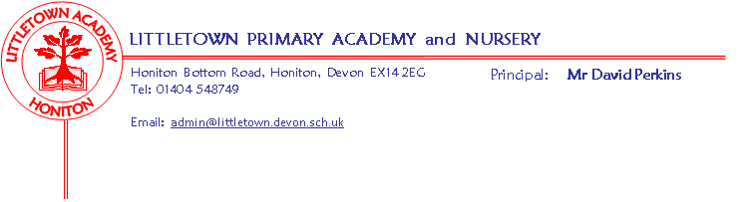
Year 3 Spring Term 2019 Information
Literacy
Our key text for the first half of term is ‘The Iron Man’ by Ted Hughes. By the end of the unit the children will have completed a diary entry and persuasive letter. Our key text for the second half of term is ‘Charlie and the Chocolate Factory’ by Roald Dahl. By the end of this unit each class will have produced a recipe book. Literacy will continue to be taught in the lesson before lunch.
Maths
Maths sessions will take place every day using Power Maths. This term will be focusing on Multiplication & Division and Money. The children will continue to develop their multiplication facts fluency using Times Tables Rock Stars.
Cornerstones
We are starting our new topic of Mighty Metals when we’re going to become fantastic physicists, exploring the world of forces, metals and materials. At a playground, we’ll explore the forces that help us to slide and swing. Then, we’ll bring toys from home to investigate how they work. We’ll look closely at levers and explore how they help us to lift heavy objects. In maths, we’ll have fun investigating where we need to sit to make a seesaw balance. To learn more about forces, we’ll make spinners, play with parachutes and make magnetic games. We’ll also investigate iron, think about why some metals rust and discover the properties of different metals. Using pots, pans and other metal objects, we’ll compose a metal musical extravaganza and use our artistic skills to create embossed patterns and pictures.
The Express Event for Mighty Metals will be held on Friday February 15th at 9.15am in the Year 3 Classrooms and area.
After half term our topic will be Scrumdiddlyumptious.
Key reminders
P.E.
Children will require a PE kit in school all week, especially on their timetabled PE days of Monday (changed from Friday) and Tuesday. They are also allowed to wear track suit bottoms and tops when the weather is colder. Please remember to name all kit and uniform just in case it is mislaid by the children.
Homework
Spellings will be set on Friday and tested the following Wednesday, we do not mind how the children learn their spellings and we will not expect sentences to be written in their homework book as we did last term.
Cornerstone home-learning activities will be sent home at the beginning of each new topic which are optional to do and children will be able to earn House Points for each piece completed, we will also share their work as a class towards the end of the topic.
We will expect children to read for 20 minutes each day and learn multiplication facts using Times Tables Rock Stars. Please let your class teacher know if your child does not have access to a computer to do Times Table Rock Stars and we will provide them with the opportunity to access it during the school day.
Reading Records need to be handed in to school on a Monday and House points will be given if children have read five times in a week. Children can record their own reading in their Reading Record but please could you check they have completed it before they hand it in on the Monday.
Key dates for the spring term
Swimming to continue on Mondays with the 4th March being the last session.
Tuesday 29th January: Outdoor Classroom for both classes
Friday 15th February 9.15 - 9.45 am: Mighty Metals Express Event
Monday 18th - Friday 22nd February: Half Term
Friday 5th April: School finishes for Easter holidays

Year 3 Team (Mrs Davis, Mrs Luxton, Miss Bodgin & Mrs Huguerre)

