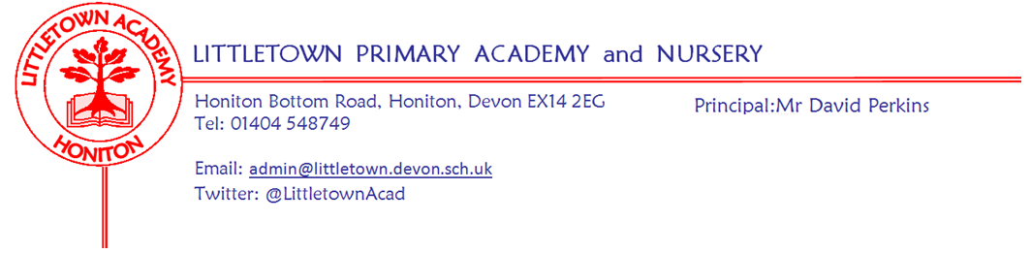
Friday 8th May 2020
Dear Parents and Carers,

Although It is another sadness that we were not able to be all together in school, preparing for marking the 75th Anniversary of VE day today, I know lots is happening in houses and gardens across Honiton. Today, the children in school, staff and I observed silence this morning at 11am and made bunting. I know lots of you are doing amazing things at home today to mark the occasion. Please remember to send us pictures and details via Facebook, Twitter or email using #littleteaparty There are lots of resources on padlets to support you in this if you wish to do so.

A reminder that following feedback, year group padlets will now be updated by 6pm today with the links and resources for next week’s learning.

Thank you yet again for all the amazing learning that is happening at home. I love looking at the padelts and seeing the galleries, as well as checking in on Tapestry and Google Classrooms. I am also lucky to bump into numerous families on daily exercise and enjoy hearing about what children are up to. This week is the first week we are sharing ‘stars of week’ and giving a special mention to children who have wowed us even more than usual this week for a wide range of reasons. However, please, please don’t feel that others are ‘doing more’ or ‘doing better’ than you in the area of remote learning. It seems we are forever comparing ourselves to everyone else in our society these days and it doesn’t do any of us any good. Everybody has their own unique circumstances and challenges and this will mean that remote learning is different for every family. The teachers and I know this as we are all in the same boat too. We know you are all doing your very best. Celebrating and sharing what children are doing is in no way intended to make others feel bad etc so please make sure for your children and yourselves, this is not the case. I have not chosen my own personal stars of the week, but I would like to make a special mention of the children who are in school day in and day out at the moment. It isn’t school as they know it and isn’t always that exciting, but they always come in with a smile on their faces despite the difficult circumstances.
A full list of the stars of the week can be found below.

As you will know, on Sunday evening we will be hearing from the Prime Minister. We have no idea whether he is going to mention schools explicitly or not. However, if he does, we have a Governors meeting scheduled for Monday evening in order to respond, and it may well be that I write to you all before next Friday. It might be that you have questions on Monday following the Prime Minister’s address. As ever, please do contact me to ask them, but please understand, as usual for this time, I might not know the answers!

Finally, I hope you enjoy this strangest of bank holiday weekends together as a family.

Yours faithfully,
David Perkins
Principal

Stars of the week 8.5.20

Nursery
Amelia for showing great concentration and perseverance, threading little pasta onto string to create a spider's web.
Jack for showing fantastic determination and perseverance, learning to ride his bike this week

RNK/MH
James - I particularly enjoyed seeing his photo of a baby calf and reading the letter he wrote about it after his walk one day. He was inspired to write about something that he was really interested in and showed great determination to use his phonic knowledge, spaces and careful letter formation so that I could read it when I received it. Well done for trying so hard!
Dominic - Has been showing great determination to try lots of new activities at home. He has used dinosaurs and mega locks to support his Power Maths and has been developing his fine motor control with an exciting range of different activities in the garden. Well done for persevering with new challenging activities!

RNC
Alice D for a great video giving descriptive clues about an animal for the adults to guess. It was really tricky!
Jas for a brilliant letter to the virus. It captured how we all feel and also used brilliant phonics, finger spaces and full stops.

1CV
Izzy decorated the front of her house ready to celebrate VE day and made all the colourful bunting herself!
Eli has been learning all the countries and capital cities in Europe as part of his own learning- this is Mrs Veevers favourite subject- Geography!!

1LM/CL
Edward. This week, Edward has worked really hard on making his own zoo for our topic. He even gave us a tour by creating his own fantastic, stop-motion film!
Sarah has been doing lots of learning around our topic, she has learnt all about jaguars and has enjoyed writing about the different jobs zoo keepers do. She has even made her own zoo, a map and a video guide!

2DB/VR
Poppy-Mae for showing such enthusiasm for our wriggle and crawl topic. Particularly for her fantastic magic butterfly model and the amazing writing to describe it.
Isaac for his ongoing effort and enthusiasm for all areas of his home learning and a particular well done for all of the amazing writing that he has produced.
Esme for continuous effort with her spelling and consistently achieving high scores on Spellodrome.

2AL
Theo has been working so hard on Spellodrome that he has earned the most points since school has been closed. He has also been taking quizzes on Accelerated Reader, working on TTRS and the new NumBots games, in addition to the topic work he has sent into the Year 2 Gallery. Keep up the hard work Theo.
Amelia has also been working hard on Spellodrome and has the most points of any girl in the class since home-schooling. Amelia has also taken quizzes on Accelerated Reader, worked on TTRS, sent in pictures of her topic work and tried a new reading website called Epic! where she has already read 5 books. Thank you for working so hard on your reading Amelia.
Thomas has also been working hard on the online sites of Spellodrome, TTRS and Accelerated reader while also doing lots of different things related to our topic of Wriggle and Crawl. Thomas has written an amazing story about minibeasts and also a page of fascinating facts about Bullhead Fish. Thank you for wanting to write so much information and a long story Thomas.

3JS/SD
Sophie. Even when she hasn't felt like it, Sophie has demonstrated impressive self-motivation to produce wonderful work.
Thomas has shown great determination to improve his handwriting which has been demonstrated in his written work.
Poppy has been very imaginative and creative with the lovely work she has produced at home.

3RB/GH
Finley - For practising TT Rockstars lots and putting great effort into his writing.
Amelia L - For tackling every Padlet challenge with enthusiasm and producing some great work.
Thomas W - For doing several high quality pieces of work including instructions on how to make chutney and a presentation about the River Nile.

4SD
Sidney for his pizza, Roman Shields, Roman google slides which he made with other children and lots of positive input on Google classroom.

4GW/GA
Rowan for his effort and output with the cornerstones topic and literacy work
Oliver for his amazing short story writing
Brooklyn for his engagement with remote learning and positive attitude at home

5ZU
Poppy - For her incredible efforts producing so much work.
Joshua - For his determination to complete work, even if he is finding it difficult.

5CB
Hallie - For consistently producing thoughtful work and for contributing to the 'class' in every way she can, even though our class looks different at the moment.
Freya - For working hard and producing the most amazing powerpoint about the history of Honiton.
Joshua - For achieving what is possibly the highest score I have ever seen in a TTRockstars battle, doing a huge amount to help year 5 win their Battle of The Bands!

6JF
Alex for his effort for Literacy work about the Princess' Blankets by Carol Ann Duffy.
Harvey for persevering with SPAG work and being successful.
Cayden for his magnificent model of a dragster.

6CP
Dexter for putting in amazing amount of effort this week with literacy and maths work
Kaitlyn for producing excellent work as part of frozen kingdom, particularly the Titanic newspaper and arctic animal research.
Rebecca for working extremely hard in all learning and helping others in google classroom

