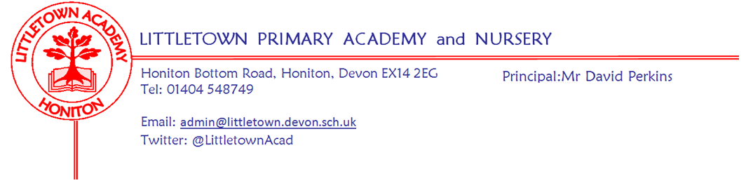
Friday 29th May 2020
Dear Parents and Carers,

I hope you have had a lovely half term week and enjoyed this glorious weather despite the social restrictions. I know I don’t usually send newsletters during holidays, but I wanted to update you on our progress regarding phased reopening planning. I would like to first thank everyone who sent us encouraging and supportive messages following my long letter last week. Your support truly is greatly appreciated always, but especially in these challenging times.

Senior leaders and other staff have been busy this week analysing google forms and completing a range of modelling of different school structures. As you know, we were not in a position to guarantee Year 1 pupils returning in Phase 1. I am pleased to say today that alongside Key worker children, Nursery and Reception, Year 1 pupils whose parents wished them to attend can attend school from Monday 8th June.

We have also been working hard on completing a site management plan and Devon County Risk Assessment for reopening. This is to be discussed at a Full Governing Board meeting on Monday 1st June where a final decision about reopening will be made. This risk assessment will then be made available to view on our school website so all parents can see this for themselves and get in touch if they have any questions.

All parents of children returning to school on 8th June, including key worker families whose children already attend school, will receive a letter early next week outlining arrangements. It will be crucial that parents read, digest and discuss with their children the content of the letter so children enter school safely on Monday 8th June. The letter will include amongst other things; details of staggered drop off and pick up times, information on school lunch provision, social distancing measures the school has implemented and which pod your child is placed in with which staff.

I also said last week that we would have to see how numbers looked in order to project whether we could successfully expand to a Phase 2 that welcomed Year 6 back to school before the end of term. Although there is no guarantee because so much can change both nationally and within school, I am pleased to say that the numbers the school is receiving in Phase 1 make transitioning to Phase 2 a good possibility in time. However, we will stick to our original planning timeline which will see us formally review Phase 1 and make decisions on Phase 2 during the week beginning 22nd June.

Finally, a reminder that after a well deserved week long rest for children (and parents!), remote learning begins again next week for all year groups. Teachers have updated padlets for you to familiarise yourselves over the weekend with the learning set.

Yours faithfully,
David Perkins
Principal

