Friday 18th June 2021
Dear Parents and Carers,

As you will be aware, the loosening of restrictions due for 21st June have been postponed until at least the 19th July. For us this means that we have had to postpone some of our tentative plans for a range of activities such as sports day, transition etc. Following the announcement on Monday I have been in a meeting with all other Devon Headteachers about the remainder of the Summer Term. There is, of course, a huge desire to arrange and hold a range of school events, however, balancing the structure of these days for the children and workload for staff will have to be considered alongside. I want to continue to hold sports days, but these have had to be postponed in the hope that we can hold them under loosened restrictions later in the year. So parents can book time off work if necessary, our new provisional dates for the various sports days for two year groups at a time can be found below.

Year 6 will be a priority group during this time and I have emailed Year 6 parents today to give more detail of our plans for their last weeks at Littletown. I will be in touch about internal transition arrangements for the children in future newsletters.

It has been an exciting week for Mrs Davis and our Mental Health Ambassadors. Please see a full update below.

Please also see some information about PE kits below in this newsletter.

Finally, I just wanted to make parents aware that we have seen a steady increase in the number of Covid related absences since half term and I know this has been the case in other local schools too. This would seem to back up local data that suggests cases are on the rise in East Devon. With this in mind, please make sure you refamiliarise yourselves with the Covid-19 protocols below in this newsletter so we can continue to keep the school community as safe as possible for the remainder of term. If you ever have any questions or aren’t sure about these protocols please do contact the school immediately to ask.

Yours faithfully,
David Perkins
Principal

Sports days
These are now scheduled for the week beginning 19th July in the hope that loosening restrictions mean adults who wish to attend are able to do so. We will stick to our original plan of two year groups at a time taking part across our 4 separate sports days. Please note, if restrictions do not change, we will only be allowed to have 1 person per child attend as we cannot have spectator groups over 30 people. We will share all the details with you when we know either way about restrictions for that week. The sports days will take place as follows:

Tuesday 20th July Morning | Nursery and Reception
Tuesday 20th July Afternoon | Year 3 and Year 4
Wednesday 21st Morning | Year 1 and Year 2
Wednesday 21st Afternoon | Year 5 and Year 6

PE kits and changing
With the hot weather we have been discussing PE kits as a staff. For the remainder of the academic year children can come to school in their PE kit on the days that they have PE in all year groups apart from Reception. The Reception children are still learning and practicing how to get changed. This will depend on parents knowing when their child’s PE days are so please make sure you know. This will act as a trial period and we will make a decision about continuing this or not into next year. Children will be coming home with their PE kits today.
Here is a table of when each class needs to be in PE kits for reference:

Class | PE days
1CV | Mon and Thurs
1CL/LM | Mon and Thurs
2DB/VR | Wed and Thurs
2AL | Wed and Thurs
3RB/GH | Mon and Tues
3JS/SD | Tues and fri
4SD | Mon and Tues
4GW/GA | Mon and Tues
5ZU | Tues and Fri
5CB | Tues and Fri
6CP | Wed and Thurs
6JF | Wed and Thurs

Keeping safe in the sun
Ironically, at the time of writing this reminder the sun seems to have disappeared, however please remember to send your child to school with a named sun hat, suncream applied and a drinks bottle. (We do not allow sunglasses in school unless prescribed by a GP).

Mental Wellbeing
This week our Year 6 Mental Wellbeing Ambassadors presented a cheque for £200 to Sarah, Meg and Steve from the Parent+ Support Hub, a share of the money raised during our Mental Wellbeing Week. The other half of the money raised will be going towards providing Covered Calm Zones for children to use during break times.

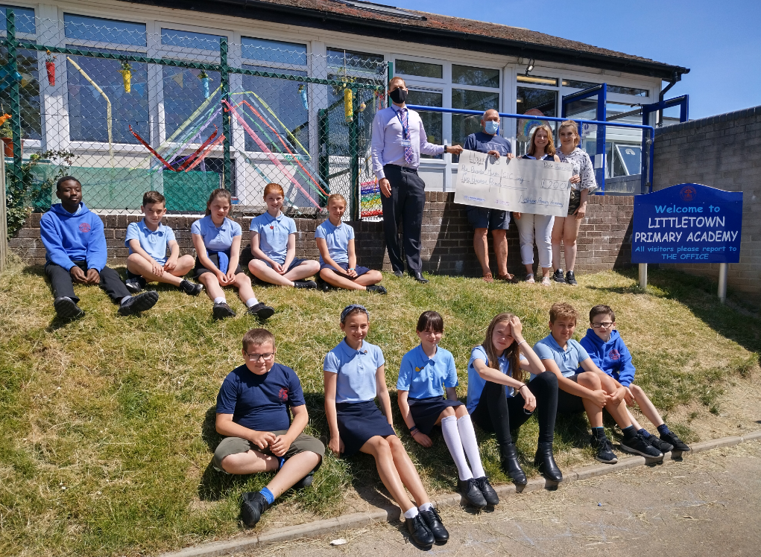

On Tuesday, ten Year 5 pupils enjoyed Mental Wellbeing Ambassador Training which was led by staff from the Wellbeing for Education Return Team. At the end of their training they were presented with their ambassador badges and special sunglasses (more on the sunglasses in subsequent newsletters)! It was a packed morning which will equip the pupils with the skills needed to carry out their role once they are in Year 6. The pupils were a credit to the school and Steve and Tracey who delivered the training were very impressed with the pupils knowledge and awareness of mental wellbeing.

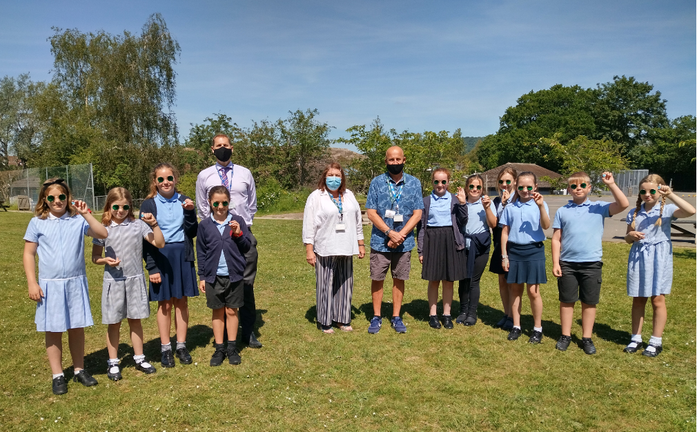

Running club
Some Y3 and Y5 children started their running club on Wednesday as we prepare for competitive running events next year. My thanks to Mrs Clarke and parent volunteer Mrs Hair for running this club for us this term.

Cygnet - parent autism awareness programme
Please see attached a letter from Babcock learner support regarding support for parents regarding Autism Awareness.

Self-employed Sports Coach
I am sad to inform you that after several years supporting the physical development of Littletown children, Mr Conybeare is leaving us at the end of the year to pursue new exciting adventures. I’m sure you will join me in thanking him for his contribution to our school and wishing him every success with his new ventures.

In order to sustain and build on Mr Conybeare’s work, we are looking for a passionate, experienced and flexible self-employed sports coach who will deliver lunchtime and after school clubs, lead and coach our competitive sports teams, lead PE interventions and raise the profile of PE and Sport at Littletown Primary Academy. In order to ‘cast the net’ as wide as possible and get the best possible person for our school please do share this with anyone you think may be interested and encourage them to email the school for more information via admin@littletown.devon.sch.uk

