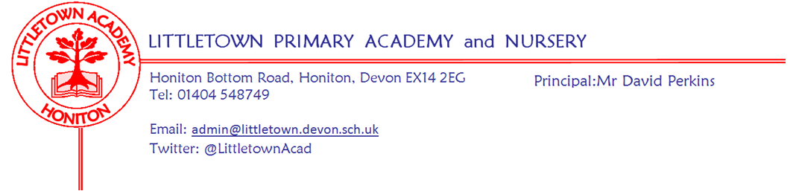
Friday 11th June 2021
Dear Parents and Carers,

I hope you have all had a good half term. It has been great to see the children return to school reinvigorated with renewed energy this week. It is hard to believe that this week last year we were preparing for the phased return of certain year groups in school during the fist lockdown.

Over half term, the Government announced £1.4 billion to support children’s education following the impact of the pandemic. Sadly, this is less than 10% of the £15 billion required by the Government appointed Education Recovery Tsar, Sir Kevan Collins. Unsurprisingly, this resulted in Sir Kevan promptly resigning from his position. This has caused delay and uncertainty to the DfE regarding plans for schools next year. Funding falling short of what is required in schools is far from unusual in recent years, but at such a key time for our children I do find this incredibly disappointing. Nonetheless, we will continue to develop our plans to support Littletown children next academic year and I will share these when they are finalised. In the meantime, if, like me, you want to express any disappointment to the Government, you can contact our MP Mr Neil Parish via this email address: neil.parish.mp@parliament.uk

This week 3RB/GH enjoyed the first school trip for a year and a half when they went fossil hunting in Charmouth. The teachers were so impressed with their attitude and behaviour. Lots of our Year 6 children have been visited by staff from Honiton Community College this week as transition arrangements begin. I was really impressed by their maturity during this visit.

This is always a busy time as we move towards finalising the staffing structure for the next academic year and allocating classes. This process is ongoing and we will share this with you as soon as we can as well as, hopefully, arrangements for in school transition.

Finally, we have once again been told we can expect an announcement about restrictions in schools on Monday next week. This will hopefully allow us to finalise and share plans with you regarding sports days, express events, transition, award assemblies and also allow us to finalise all our plans for our Year 6 children who leave us this year. These include trips, performances, picnics and celebrations. We will do everything we can to make the last few weeks at Littletown for Y6 as memorable and enjoyable as possible. I can yet again only apologise for the delay. Please remember, I am always happy to reply to emails or speak on the phone if there are any questions about any of the above so please don’t hesitate to contact me if you have any questions head@littletown.devon.sch.uk

Yours faithfully,
David Perkins
Principal

Self-employed Sports Coach
I am sad to inform you that after several years supporting the physical development of Littletown children, Mr Conybeare is leaving us at the end of the year to pursue new exciting adventures. I’m sure you will join me in thanking him for his contribution to our school and wishing him every success with his new ventures.

In order to sustain and build on Mr Conybeare’s work, we are looking for a passionate, experienced and flexible self-employed sports coach who will deliver lunchtime and after school clubs, lead and coach our competitive sports teams, lead PE interventions and raise the profile of PE and Sport at Littletown Primary Academy. In order to ‘cast the net’ as wide as possible and get the best possible person for our school please do share this with anyone you think may be interested and encourage them to email the school for more information via admin@littletown.devon.sch.uk

Staff news
I’m sure you will join me in saying huge congratulations to Miss Bodgin in Year 3 who got married in glorious sunshine over half term. She has chosen to remain as Miss Bodgin in school.

This week we are pleased to welcome Mrs Rowe to the role of Teaching Assistant in Year 4 in the afternoons. Mrs Rowe will be working with 4GW/GA on a temporary basis until the end of the year.

Mental Wellbeing
This week’s 10 a day focus is to; ‘Stay connected to those you care about’. This has been a particularly challenging one over the last year and a half and can make a massive difference to your wellbeing as restrictions ease. If you would like more information about the 10 a day and Normal Magic then please visit www.normalmagic.co.uk
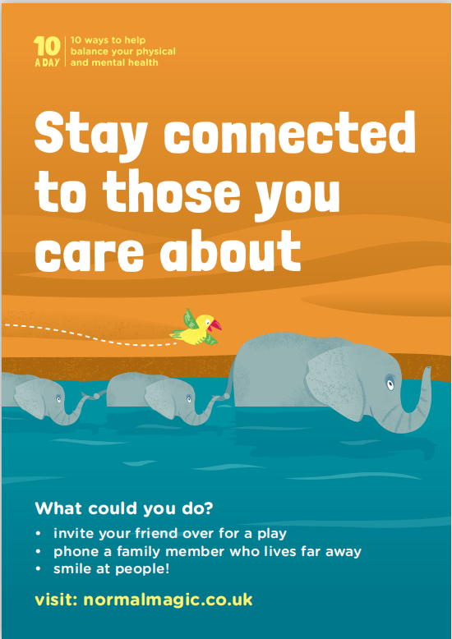

Parking
I was pleased to be accompanied by Civil Enforcement Officers (Traffic Wardens) this week to observe the safety on Honiton Bottom Road. I’m pleased to say that just about everyone parked only where they are allowed to while they were present! Please ensure this continues even when they are not present. Many thanks.

