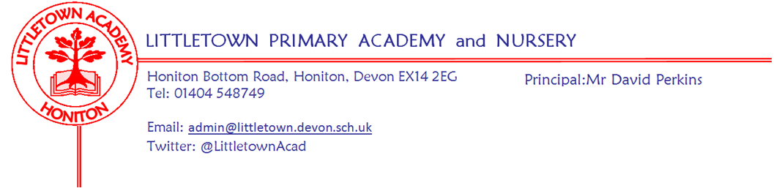
17th January 2020
Dear Parents and Carers,

The children have behaved well during many wet breaks and lunchtimes this week. On Monday Year 3 began their swimming lessons. On Tuesday Year 4 had an exciting trip to Plymouth Aquarium to launch their ‘Blue Abyss’ topic and enjoyed seeing a range of marine life whilst engaging in various workshops. Thanks to parents who assisted with this trip. Thank you to all the parents who braved the awful weather conditions on Tuesday evening to attend the KS1 parent information evening on Maths. I have been out of school interviewing today, but Mrs Hawkins tells me Year 3 hosted a brilliant Science Fayre as their Express Event this morning teaching parents experiments using Mighty Metals.
This evening is our school disco. Please see separate PTFA Newsletter. My thanks again to the PTFA for organising this enjoyable event for the children.
Next week is set to be a quieter week with Year 3 continuing swimming on Monday. On Wednesday, Mrs Hawkins and I will be attending The Bett Show 2020 in London Excel. This will allow us to see and interact with future technology which we could use at Littletown to enhance learning enjoyment and progress whilst ensuring safeguarding and online security.
Over the course of this term I am looking to set up a Parent Council/Forum to meet to discuss school issues and themes. I want this to continue to develop our open, transparent and consultative culture and this will ensure parent feedback and consultation is in a regular loop rather than limited to an annual anonymous survey. To begin this process, I am interested in hearing from parents who may wish to be involved and who have a view as to how it might work most effectively. Please email me at head@littletown.devon.sch.uk or catch me on the playground before or after school. I will then put in a newsletter before half term how we intend to proceed.

Yours faithfully,
David Perkins
Principal

News from the children
A warm welcome to our new reporters and editors for this half term: Poppy Vernon, Noah Pemberton, Anthony Ekejiuba, Lexi Smith, Hallie Bennett, Ruby Kayes, Logan Turner, Finley Cane, Erin Perman and Niamh Storey.

Nursery
We made cheese and vegetable muffins.
We have been looking after guinea pigs

Reception
We have been measuring long and short.
We found a cow in the school hall. We don’t know what to do with it.

Year 1
We have been counting to 20.
We have been drawing teams.

Year 2
We have been making 3D towers.
Learning how to add money.

Year 3
We have been making magnet games.
We have been writing newspaper articles.

Year 4
We went to the aquarium and saw three species of shark.
We are researching the 5 oceans of the world.

Year 5
We have been looking at potions from Alchemy Island
We have been writing our own portal stories.

Year 6
We have been starting to research William Harvey.
We have been writing a diary entry.

Messages
Year 5 Roundball Hill Outdoor Classroom
You will have seen in our Spring term newsletter that we gave you a date of Friday 7th February for our outdoor classroom on Roundball Hill. This date has now changed to Thursday 6th February. A letter will follow with more details.

Nursery requests
We would be grateful for any donations of newspaper they can be brought to the Nursery.
If anyone uses the Method sprays in their house please could we have any empty bottles? The labels come off really easily and we can use them for all sorts of activities. Please hand them in to the Nursery Thank you.

Week beginning 20th January 2020:
Monday | Tuesday | Wednesday | Thursday | Friday
Year 3 swimming

Community news - Honiton in action mental health event
Ways to improve our mental health, including Mindfulness and other positive approaches.
Wednesday 5th February 2020
6th Form Centre. Honiton Community College
5.45pm arrival with tea, coffee and biscuits for a 6pm start. (Finish 7pm)
Find out more about mindfulness and other strategies and learn how to make it part of your everyday life for greater harmony and happiness for you and the children in your life
A free event suitable for parents, grandparents, guardians, carers
– In fact, for everyone over 18 years!
Speaker: Kevin M Hickson. Registered mental health and learning disability nurse. The Beacon Medical Centre, Sidmouth
Further information from Nikki Thomas.
Mental Health and Wellbeing Lead. 01404 42283 ext 235

