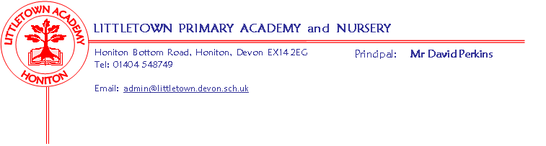
Nursery Autumn Term 2019 Information
Settling in:
We hope your child has enjoyed their first week at Nursery (or have enjoyed returning for their 2nd or 3rd term!). They have all settled in well, but please come and speak to us if you have any concerns. Please continue to come in with your child in the morning and help them register by placing their name in the basket. If they are packed lunches, they should leave their lunchbox on the bench. They can bring their water bottles in with them to leave in the tray at the water station. Please feel free to continue coming in to settle them at an activity.

Theme:
Just as the rest of the school do, we will follow a theme, following the children’s interests. Our theme will always starts with a question in the Early Years, allowing the children to then lead where the learning takes us with their own interests. Our first topic is called ‘Why do you love me so much?’ and will last until half-term. We will decide on which topic to choose next, based on what we learn about the children’s interests over the coming weeks. Please see additional information below about our topic, what we will be covering and how you can support your child’s learning at home. Please upload anything special you do with your child to Tapestry so that we can celebrate this with them at Nursery. You should have already received a letter about sending in photos for the children to make scrapbooks. Please ensure your photos have been sent in in a named envelope or emailed to me ASAP.

Literacy:
This half term we will be assessing what your child can do already to enable us to plan their next steps. We will have daily phonic inputs where we will developing the children’s listening skills and distinguishing different sounds. There will be lots of opportunities daily to work on the children’s fine motor control including; cutting with scissors, pencil grip and control and strengthening the muscles in our hands and fingers using playdough etc... We will also be providing lots of opportunities for the children to mark make in their child-initiated learning. We will spend lots of time this term developing the children’s listening skills and language through story-telling and role play.
Maths:
In maths we will be assessing your child’s confidence and knowledge of numbers and shape in order to plan and teach their next steps. We will be learning to recite number names in order to 10, matching numerals to quantities and looking for numerals in the environment. We will also be naming and describing simple patterns and 2D shapes.

Key reminders:
Collecting at the end of the day: Please ensure that if someone on your named list is collecting your child after Nursery, that they know your chosen password. Your child’s safety is of the upmost importance to us so they will be asked for this.
Clothing: Please ensure all items are named including shoes and wellies. We already have some lost property!

Footwear: Please ensure that your child wears suitable footwear to Nursery every day, to enable them to access the equipment safely. Children should not be wearing open-toed sandals, ‘croc-like’ shoes or wellington boots to Nursery as they cannot run or climb safely in these. When the children use the climbing tower, they will only be able to use if they are wearing suitable footwear. Using the tower supports the children in developing their upper body strength, vital for learning to write and control small tools. Once we start our outdoor classroom sessions after half-term, your child will need wellies, but these should be brought to Nursery in a named bag and left on their peg to prevent mud being walked into the carpets.

Book Bags: Your child should now have their book bag. Please encourage them to choose a book to share with you at home from the two baskets in the cloakroom. They can change this book as often as they like, but please ensure all books are returned.

Outdoor Classroom: Outdoor Classroom will begin after half term and we will provide more information closer to the time.

Water Bottles: Please ensure your child has a bottle of water (not juice) in the Nursery for drinking throughout the day. They may have juice in their lunchbox but no fizzy drinks.

Packed Lunches: We have peanut allergies in Nursery so we ask that no children have nuts or nut based snacks/spreads in their lunchboxes. We are a healthy school and ask that children do not bring in chocolates or sweets for lunch.
Birthdays: We are always excited to celebrate the children’s birthdays with them, but please do not bring in sweets or cakes to share.

Toys: We ask that toys/valuables are not brought in to Nursery, however we do encourage the children to bring in pictures, photos, objects, books etc… linked to our topic. We also encourage the children to bring in other items to show such as postcards and photos from a holiday or certificates or objects celebrating achievements. Please hand the items to a member of staff for ‘Show and Tell’.

Key dates for the autumn term:
- Friday 18th October – Break up for 2 week half term holiday
- Thursday 17th/ Friday 18th October – End of topic celebration stay and play – 9-9.20am – More information to follow (the same activity will be repeated at all 2 sessions – you don’t need to stay for all 2!).
- Monday 4th November - Start of half-term

- Monday 16th December - Christmas performances – 2pm and 5pm – All children to attend if possible
- Week beginning 16th December – Christmas party
- Tuesday 17th/ Wednesday 18th December – End of topic celebration stay and play – 2.40-3pm – More information to follow (the same activity will be repeated at all 2 sessions – you don’t need to stay for all 2!).
- Friday 20th December – End of term - Children to be collected at 3pm

