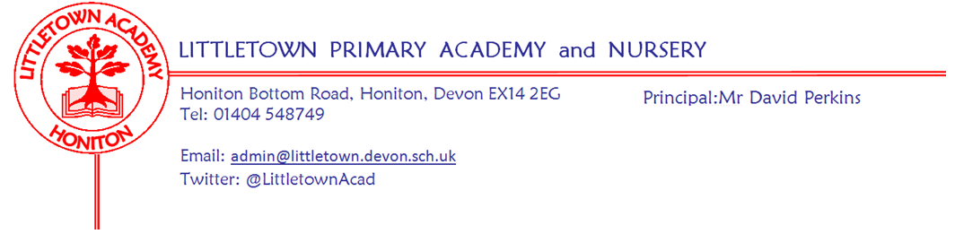

Live. Love . Learn - Littletown
Friday 12th May 2023
Dear Parents and Carers,
I hope you all enjoyed the bank holiday Coronation weekend. It was lovely to see lots of Littletown children and parents enjoying the festivities at Allhallows on Sunday afternoon and evening.

I have to start this newsletter by saying a special word about Year 6 who have completed their Statutory Assessment Tests (SATS) this week. They have shown amazing attitude and perseverance in their approach to their tests this week with some also battling through illness and injury. Their teachers and I are incredibly proud of them for all their hard work. My thanks to the Year 6 staff for supporting and preparing the children so well this week and thank you again to Kirsty in the kitchen for providing the children with their special SATS breakfasts this week.

A special mention to Year 3 too, who showed great behaviour and maturity walking back to school from the swimming pool in the midst of a heavy thunderstorm on Tuesday.

As we go through the academic year, teachers have been keeping track of reading, spelling and other work/support children and parents are completing at home. Where this is not happening and hasn’t been for some time, I will be meeting with children and calling parents next to discuss if we can find solutions and improve these situations.

Next week we return to having a full five day week! On Tuesday we take some Year 6 children to Honiton Primary School for the Honiton Learning Community Rounder’s Tournament. On Thursday, Year 1 hold their Victorian Day at school and on Friday, we host children from other schools to join us for Mental Wellbeing Ambassador training in our Community Room.

Finally, today, we installed our ‘values shields’ on the ramp wall in the front playground. These will, in addition to the photograph display board in the entrance foyer, further increase visibility of our agreed Littletown values and qualities for children, parents and visitors to the school. They were the source of lots of comments and interest this morning which is great. My thanks to Mr Jeffery for installing these for us.

Yours faithfully,
David Perkins
Principal

Children’s news

NURSERY: Nursery has been making bread and drawing maps of farms.

RECEPTION: Reception has been colouring fish, writing a list of sea creatures, learning about under the sea and then in PSHE we have been talking about unkind words.

YEAR 1: Year 1 have been learning about instructions and have also been making fruit and vegetable kebabs from their designs and evaluating them (eating them!).

YEAR 2: Year two have been making carriages and using number grids in maths.

YEAR 3: This week, a few of their tadpoles have turned into frogs and they are returning to Mrs Davis’s garden. In science they have been learning about the life cycle of plants.

YEAR 4: This week, Year 4 have used electrical components to make electrical units. They started a new book in literacy called ‘When the forest meets the sea’.

YEAR 5: Year 5 have been learning about athletics in PE. In History, they have been comparing the Minoen civilisation and the Mycenaean civilisation. They have also learnt how to sing ‘Dancing in the Street’.

YEAR 6: Year 6 have been working really hard on their SATS all week.

OPAL (Outdoor Play and Learning)
Today in assembly the children completed a risk benefit assessment for the new den building area. This is the newest area of OPAL for the children to discover along with the newly built stage area, many thanks to the various members of staff who have made this possible. The Play Team, formerly known as Meal Time Assistants, have been wearing their new uniforms, which look very smart, many thanks to the PTFA for funding these.

Week Beginning 15th May 2023 events
Monday 15th May | Tuesday 16th May | Wednesday 17th May | Thursday 18th May | Friday 19th May
 | HLC Y6 Rounders competition Honiton Primary School |  | Nursery outdoor classroom | Mental Wellbeing Ambassador training
 |  |  | Year 1 Victorian Day

Community news
Coombe Garden Centre Drawing Competition
In today’s assembly the children were told about a drawing competition being run by Coombe Garden Centre to coincide with National Children’s Gardening Week which runs over half term. Children have been asked to draw a gardening related picture (a beautiful garden or their favourite plant). The winning child will receive a £100 store voucher for themselves and the school they attend will receive a £100 store voucher too!
Entries need to be given to your class teacher by Thursday 25th May
T&C's
- One entry per child
- No larger than A4 please
- Can be drawn, painted using pencils and pens, glued - however you'd like! Get creative!
- All entries need to include the child's name, age and the school they attend written on the back.
- Once we've chosen a winner, with your & the child's permission we'd like to pop a picture on social media when the vouchers are collected and display artwork in the shop.

