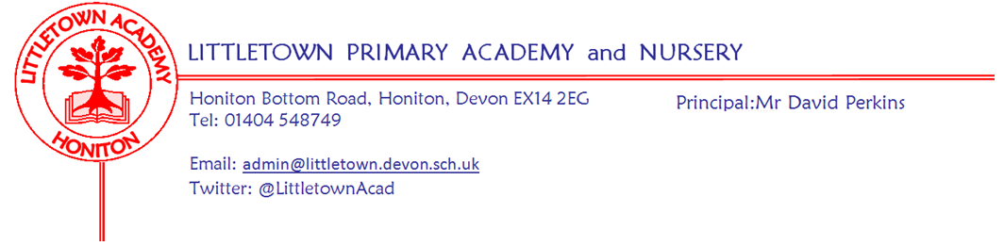
Friday 15th October 2021

Dear Parents and Carers,

You may have noticed from the playground or been informed by your children that this week we have continued to have unprecedented levels of staff absence - mostly through non Covid-19 illness. This has resulted in us using our supply teachers, using part time staff to do additional hours, teachers relinquishing allocated non-contact time and those of us who attended the schools leadership conference return to school early. I would like to thank all the staff for their flexibility and help with all this over the course of the week. I also want to say thank you and well done to the children who have coped with change so well this week and behaved very well in classes.

We have also had lots of illness amongst children and an increase in confirmed cases of Covid-19 and I would like to thank parents for their understanding when called to collect poorly children. As we have had a rise in positive cases of Covid-19 over the course of this week I have been asked to ask you to notify me if your child receives a positive PCR test result over the first week of the two week half term just as was the case last academic year. If you have any questions please don’t hesitate to email me head@littletown.devon.sch.uk All in all it could be argued that it is a good time to have a two week half term so everyone can recover from illness.

Thank you to parents who attended the PTFA Annual General Meeting on Monday. Please see the attached flyer from the PTFA regarding the Bag2SChool event.

On Monday Mr Bilcock took children from across Key Stage 2 to the Honiton Learning Community cross country competition where Littletown won three out of the four races to progress to the East Devon finals. Congratulations to the children who also behaved brilliantly and a thank you to Mr Bilcock and the parent volunteers who assisted with the children. A report from Mr Bilcock can be found below. After school today we look forward to welcoming Honiton Primary School for some Dodgeball matches. On Monday and today, Year 2 have planted bulbs and made brilliant bug hotels in outdoor classroom.

After half term on Tuesday 2nd November Year1 have outdoor classroom to launch their new topic ‘Splendid Skies’. On Friday 5th November Year 5 will be hosting the PTFA cake sale on the playground.

Finally, I would like to wish the children and yourselves a very happy half term. Please remember this is a two week half term break for the school. I look forward to seeing you all on our return to school on Monday 1st November.

Yours faithfully,
David Perkins
Principal

News from pupil reporters

Nursery
This week nursery made apple and blackberry crumble.

Reception
This week reception were cutting pumpkins and printing with fruits.
Year 1
This week year 1 celebrated finishing literacy by watching lost and found and learnet about Rosa Parker.

Year 2
This week year 2 did column addition and planted hello yellow bulbs in outdoor classroom.

Year 3
We have been painting the birds of prey.we have been doing a maths challenge on the chromebooks

Year 4
This week for maths we have been doing addition and subtraction for maths and we have done direct speech for literacy.

Year 5
This week we have been doing a Diary entry about Annie Edson Taylor and the great stunt she has done.
We have been doing things about Tudor homes and what sort of furniture there is inside and what rich homes look like compared to poor homes.

Year 6
In the past 2 days we have been doing Science. We have been learning about how light reflects in your eyes.

Cross Country running competition report from Mr Bilcock
On monday 11th November a selection of year 3,4,5 and 6 children represented the school in the Honiton Learning Community cross country competition at All Hallows sports field. I have to say I was so proud of how the children conducted themselves in terms of their behaviour, attitude and determination to do their best. The year 3/4 girls and boys both came first place overall. The year 5/6 girls and boys also did amazing with the boys coming first overall in their race. Special mentions to Poppy and Sam for winning their races outright! Winning teams will now move on to take part in the East Devon finals later in the year.

Parent Governor election
Nominations remain open for the election of a new Parent Governor for the school. Please get in touch with the school if you are interested or have any questions.

Community news

British library competition
Honiton library have shared the following information with us regarding a competition which ongoing currently:
What makes your hero super?
bl.uk/superheroes
From 11 October to 30 November, we’re asking children to create a comic and help us assemble a new galaxy of superheroes! We’re celebrating heroes of every kind – whether they have the power to scale walls, save forests or make someone smile.

Teachers and parents can help themselves to a raft of free online resources. There are top tips, videos and templates to inspire you to make comics, flying heroes and flip-books: https://www.bl.uk/childrens-books/activities/what-makes-a-hero-super

Share your creations
Share photos of children’s work on Twitter @BL_Learning or by emailing childrens.books@bl.uk. On 30 November we’ll pick 5 lucky schools and 5 lucky families out of our (virtual) hat to win National Book Tokens.

