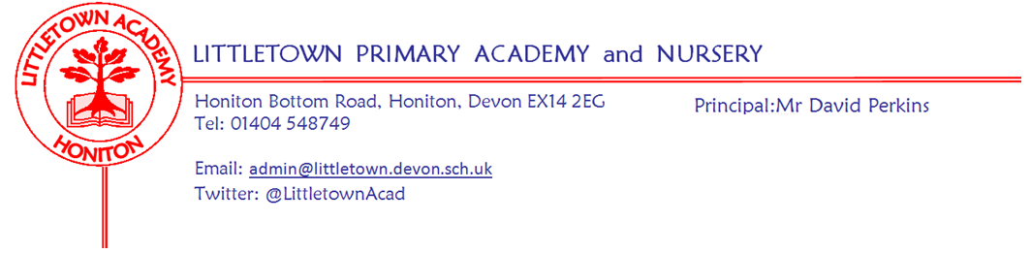
Year 3 – Remote Home Learning Update – 17 April 2020
Dear Year 3 children and parents,
We hope you are keeping well and have enjoyed the lovely Easter weather.
As from Monday 20th April, we are going to use a Padlet Learning Wall to share activities and ideas for your home learning. All of the teachers at Littletown will be using this approach to ensure consistency across school.
Your Y3 Padlet link is; https://padlet.com/susannahdavis/jn5wt9d150ao
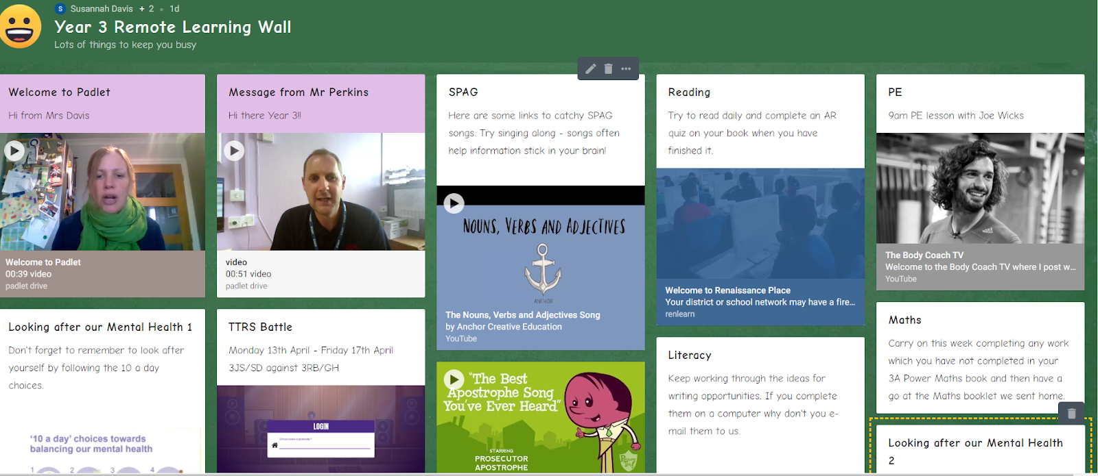
On the padlet, you will find post-it notes, each post-it note has an activity or idea – if you click on the post-it note, it will open up in a new window, in an enlarged form. As time goes on, we will add new post-it notes or update original ones.
Please look at our Remote Learning Wall weekly to see new ideas and updates. Our wall will be added to our Google Classroom and we want you to continue using the Classroom Stream and/or gmail to message Mrs Davis, Mrs Searle, Miss Bodgin and Mrs Huguerre. As a Year 3 team, we are frequently monitoring the stream, gmails and speaking to each other, checking how you are.
We know that the BBC are launching Maths and Literacy daily lessons which can be accessed from laptops and the TV. These lessons may be fantastic – we haven’t seen one yet – watch out for a post-it note if we think they are worth watching. Let us know if you have seen a particular programme or activity that you think others in the year might enjoy or find useful.
The Maths, Literacy and Cornerstones activities will be posted each week on our Google Classroom and/or on the padlet. You are very welcome to gmail us writing, slides or photographs of activities completed.
It would be lovely for your teachers (Mrs Davis & Mrs Searle or Miss Bodgin & Mrs Huguerre) to receive a quick email at the end of each week to say how you are doing. As always, enjoy your learning. We continue to miss working with you every day at school and look forward to seeing you soon. Please message any of the Y3 Team via Google Classroom Stream or Gmail if you have any questions - we’re available to help.
Year 3 children – Remember to look after everyone in your family by being as helpful as possible and don’t worry about any of the Home Learning Activities; message us and ask for help. Be kind to your brothers and sisters if you have any; stay in contact with your friends through our Google Classroom or other devices and support each other. These strange times will pass and you will be back in school at some point – so work hard to keep learning new and exciting things, keep exercising and having fun but most of all be kind.
Mrs Davis, Mrs Searle, Miss Bodgin and Mrs Huguerre

Please note message from Mrs Trim and Mrs Childs:
This is the link that all parents can use to access the SEND/SAFS padlet page. There is a lot of useful information, activities, links... for our SEND children and families.
https://padlet.com/lianechilds/ewjn9i9gxfpw

