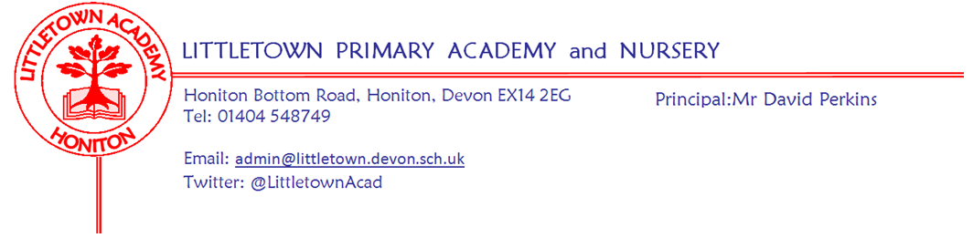
Friday 2nd July 2021
Dear Parents and Carers,

It is hard to believe that we are already in July and nearing the end of the year. There has been lots of talk in the media and Government circles about what September should look like and whether bubbles should close etc, but as yet we are still awaiting any information on this. It is therefore looking increasingly likely that I will need to be writing to you over the Summer regarding school arrangements in September. You should have received a reference sheet from Devon County Council summarising advice to parents at this time with all things related to Covid-19. Please keep this handy for reference in case at any point you need it.

We hope to hear soon on whether school risk assessments can change from 19th July onwards so I can update you on plans for events between now and the end of term. It is disappointing that some in Government are suggesting schools are asking too many pupils to isolate and be away from school unnecessarily. Firstly, Public Health England directives via guidance from the Department for Education make the rules on this crystal clear and there is no room for interpretation for schools. Furthermore, as I hope you know, we are desperate to have all the children in school every day and would never ever want anyone to be at home on a school day. I have been really pleased with some of the Remote learning that children have completed who have been isolating this week and I would like to thank our Admin team at school who continue to manage an ever increasing workload as cases increase locally. Please keep getting in touch with us if you have any questions.

Please find below forms for Breakfast and After School Club. There is lots of information asked for in these forms, but this should allow us not to have to ask you any further information as you book sessions. Year 2 parents should have received a letter from Mrs Childs today ensuring you are able to apply for Pupil Premium. This continues your entitlement to Free School Meals and also secures extra funding for the school. Please make sure you read this and apply if you feel you may be eligible.

Finally, I know lots of children and parents are starting to think about which teachers they will have next year. I will write to you next Friday with information on next year’s classes. Children will then meet their new teachers in school on Monday 19th July.

Yours faithfully,
David Perkins
Principal

Mental Wellbeing
This week our focus is ‘’ask for help’. It is the last of our 10 a day. Please take a moment this weekend to chat to your children about when you have asked for help during the week and if you learnt something new. If you would like more information about the 10 a day and Normal Magic then please visit www.normalmagic.co.uk
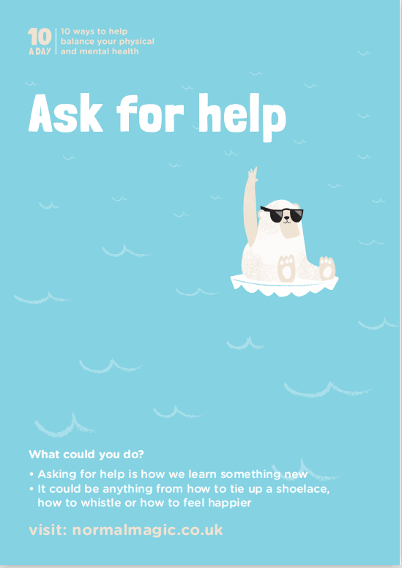

Breakfast and After school clubs
Registration and booking forms are available for next year. If you are interested in using either club, please follow these links to the relevant forms:

Registration form: https://forms.gle/mHgk9tFoTa7ArdVr9

Booking form (Sept-Dec): https://forms.gle/TzXmg2KkxVm1TjCw7

An up to date registration form must be submitted before we can accept your bookings. The deadline for returning booking forms is 16th July.

We will be operating on a week's notice period for refunds on cancellations from September.

Thank you

Community news
Library Summer reading competition and Author events
As you know, the library has been affected significantly from the pandemic. More than ever it is really important that Honiton families use it with their children. Please see below information from Honiton library about upcoming author events. Please also see attached exciting information about Honiton library Summer Reading challenge. It would be fantastic to see lots of Littletown children completing this over the Summer.

The Challenge will launch on Saturday 10th July and will finish on Friday 10th September 2021.
This year the Challenge has an engaging environmental theme, and it will provide a fun way for children to keep up their reading during the summer holidays and earn a shiny medal (while stocks last) and a certificate. There is a dedicated website to the Summer Reading challenge here: https://summerreadingchallenge.org.uk/book-sorter

