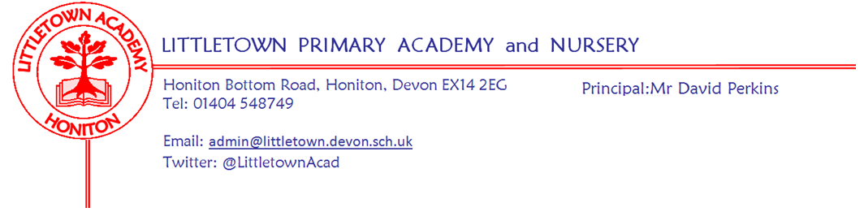

Friday 4th February 2022
Dear Parents and Carers,

I will once again start a newsletter by thanking you for your understanding as we continue to deal with unprecedented levels of staff absence related to Covid-19. I would like to thank staff who are continuing to show great commitment and flexibility in assisting with covering absences, being resourceful in meeting the needs of children and for supporting remote learning for isolating children.

Yesterday, along with other Honiton Learning Community headteachers, I met with Paul Whiteman, the General Secretary of the National Association of Headteachers. We were able to discuss the ongoing challenges in education and what is required nationally to improve outcomes and support for your children over the next several years as we navigate schools out of the pandemic. Paul directly lobbies the Secretary of State for Education on a regular basis and will communicate our concerns on behalf of your children.

As you know from previous newsletters, in conjunction with the Education Welfare Officer and like all schools, we have been implementing revised attendance and lateness protocols inline with national expectations. The Government has been talking about school attendance again this week. A flowchart of this procedure is attached to the newsletter. This week, acting on the advice of the Education Welfare Officer, we have been talking with children about how they feel when they are not at school or are late for school. Some families will receive a letter today notifying them of their child’s current attendance percentage, sharing the views of the child and inviting them to work closely with us to improve attendance. A reminder that we are aware that Covid-19 does impact on attendance percentages. All Covid-19 related absences are fully authorised. Do get in touch with us if you have any questions or wish to discuss your child’s attendance.

I would like to say well done and thank you to Year 6 for working so hard on their mock SATS this week.

Next week is a busy week for the school. Our Year 6 children go to Pixies Holt for their Residential activity visit. My thanks to the staff who are accompanying the children. On Monday, some of our Year 5 and Year 6 children represent the school in the Honiton Learning Community Futsal tournament and our Netballers once again represent the school in the last round of the Honiton Learning Community tournament on Tuesday. Tuesday we also mark Internet Safety day and you can find lots of information to support you keeping children safe online below in this newsletter. Wednesday we take runners from across Key Stage2 to compete in the Stockland Cross Country. It is also Mental Wellbeing week at Littletown which includes a non-uniform day on Friday and information on this can be found below.

Yours faithfully,
David Perkins
Principal
News from pupil reporters

Nursery
This week, Nursery have been learning about a story called ‘Kip’s sunny day’ and making snowflake pictures.

Reception
This week, Reception students have learnt in PE to kick and roll a ball and have been writing speech bubbles.

Year 1
This week, Year 1 have been sorting animals using greater than and less than symbols and learning all about carnivores, herbivores and omnivores.

Year 2
This week, Year 2 have been finishing the book ‘Dragon’ and learning about dividing.

Year 3
This week, in Year 3, we have learnt about Chinese New Year and forces and magnets. We have done Outdoor classroom and have learnt about Stonehenge.

Year 4
This week, in Year 4, we had Roman day, finished our unit check in Power Maths, have been writing newspaper reports about Pompeii and learning about Queen Boudica in History.

Year 5
This week, in Year 5 we have been learning about fractions & division and have done our end of unit check.
We have been continuing with our Portal topic including researching.
We have been talking about Dreams & Goals in PSHE

Year 6
This week, in Year 6 we have been working hard on our Mock SATs in the school hall
We are getting ready to go to Pixie’s Holt on residential next week.
We have just finished our percentages unit of work in Power Maths.

Attendance
As mentioned above we have been talking to children about being on time for school. Attendance and punctuality really does make a big difference to the children in many different ways, not just missed learning. Here are some of the quotes from children about missing school or being late:

I feel nervous and want to line up with my friends.
I feel annoyed as I want to chat with my friends.
I feel sad as I have no one to walk in with.
I feel embarrassed and I don't want to miss learning.
I feel bad for the teachers, they are trying to teach us.

Mental Wellbeing
Thank you to all those parents who have sent their children in with yoghurt pots, ready for next week, it is greatly appreciated. Next week is our second Mental Wellbeing in line with Children’s Mental Health Week organised by the charity, Place2B. The children will be involved in various activities during the week and then a non-uniform day will be held on Friday 11th February to raise money for the charity ‘Place2Be’ and wellbeing at school, 50p per child/£1 per family. The theme for the non-uniform day will be ‘Dress to Express’. Children can come into school wearing their favourite colour or a colour which expresses how they’re feeling or in their favourite outfit. 6CP will be able to have their ‘Dress to Express’ Day on Monday 7th February as they will be on their residential on Friday. Please see the Mental Wellbeing pages on the school website https://www.littletown.devon.sch.uk/website/mental_wellbeing/501346 for more information about Place2Be and Children’s Mental Health Week.

Safer Internet Day
Safer Internet Day 2022 is on Tuesday 8th February and will be marked with the theme ‘All fun and games? Exploring respect and relationships online’.

Safer Internet Day inspires a national conversation about using technology responsibly, respectfully, critically, and creatively. Coordinated in the UK by the UK Safer Internet Centre, the celebration sees thousands of organisations get involved to promote the safe, responsible and positive use of digital technology for children and young people.

Top Tips for Parents and Carers from the Safer Internet Centre
Have a look at the tips and links below with some suggestions on how to get you started and help you to stay safe and positive online. You and your family can #PlayYourPart in creating a better internet by…

Having conversations without judgement.
Whether by playing games, watching videos, or doing things your child enjoys, spending time together online is a great way to start conversations about the online world and how they’re finding being a part of it.
It is important to ask questions and take an interest in what your child enjoys online.
An essential part of having this open dialogue is to not judge, even if their behaviour or life online isn’t what you wanted or expected. This ensures that your child feels they can come to you if ever they make a mistake or experience a problem online.

Knowing where you can learn more about their favourite apps and games.
Websites like Common Sense Media or The Family Gaming Database can be invaluable sources of information. When your child starts talking about a new game or app, why not do some research into the reporting and blocking options available? Then you can help your child if they come to you with an issue.

Getting support if things go wrong.
There are lots of organisations who are there to support you and your family if something has gone wrong. The Report Harmful Content website can help you with issues such as cyberbullying, impersonation and threats. You can report worrying behaviour towards children to CEOP. Find out more on Childnet’s Get Help page.

Reassuring your child that whatever happens online, you are there to support them.
Let your child know that the best way to address any problem they have online, is to tell a trusted adult immediately. For example, this might include someone sending them a friend request; an online message; telling them to visit a specific website, or app; or asking them for their personal information. Reassure them that if anything happens online that they are unsure about, or makes them feel worried or upset, they can come to you for help.

Week Beginning 7th February 2022 events
Monday 7th February | Tuesday 8th February | Wednesday 9th February | Thursday 10th February | Friday 11th February
Start of mental wellbeing week | Safer internet day | Nursery outdoor classroom |  | Reception outdoor classroom
6JF to Pixies Holt | Year 5/6 Netball Competition | 6CP to Pixies Holt |  | Non uniform day for mental wellbeing
Year 5/6 Futsal tournament |  | Stockland Cross Country

