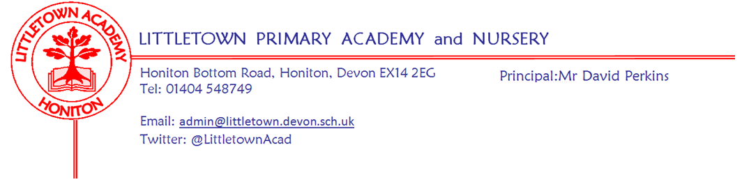

***Live . Love . Learn - Littletown***

Friday 3rd November 2023

Dear Parents and Carers,

I hope you all had a great half term break. It was great to see so many Littletown pupils participating in and enjoying watching the carnival on Saturday night and good to see lots of little monsters out and about on Tuesday night for Halloween despite the rain.

Thank you for your understanding regarding school closure yesterday. I know lots of great remote learning took place. A special mention to everyone who contributed a storm poem to my collection yesterday. Prizes were given out in assembly today and I have added Chloe’s wonderful ‘Stormy Day’ poem to the end of the newsletter for you. School meals and extended school sessions are in the process of being refunded.

In assembly today, we reflected on Halloween and storm day whilst looking ahead to Bonfire night. We discussed how our school rules of Ready, Respectful, Safe can be applied to all of these events even though they have nothing to do with school and how they are all important rules for life not just at school.

Next week, Nursery children have outdoor classroom on Tuesday and also on Tuesday some of our children take part in Bee Netball Honiton Learning Community competition. On Thursday afternoon, some of our Year 5 and 6 pupils will take part in the East Devon Cross Country finals at Bicton College. On Friday evening we have the next PTFA disco!

Next week, I will be sending out to you a Parent Questionnaire via google form next week which I will proceed to nag you about for the next few weeks! This is the first comprehensive parent survey we have carried out since the Covid-19 period, and changes to the curriculum and the school day. This questionnaire will be key to our strategic evaluation of the school.

Finally, please see below in this newsletter lots of information about anti-bullying week which we are focussing on the week beginning Monday 13th November.

Yours faithfully

David Perkins 

Principal

Swimmi

**Mental**

**Children’s news**

**Nursery:** Nursery have been doing Halloween yoga and making bread-stick sparklers!

**Reception:** Reception have been digging up pumpkins with their fine motor skills and have also been using Fred fingers.

**Year 1:** In history, Year 1 have been looking at timelines and have made gingerbread men for PSHE.

**Year 2:** Year 2 have started planning for the Christmas play and have been using glockenspiels in music.

**Year 3:** Year 3 have been learning part-whole models and have finished ball skills in P.E.

**Year 4:** Year 4 have been learning about and doing posters about Anglo-Saxons.

**Year 5:** Year 5 have started a new unit in music called Classroom Jazz and have also been learning about space in science.

**Year 6:** Year 6 have been learning a new book in PTR, (pathways to read) and writing poems about tigers.

## Anti-Bullying week Monday 13th November

We are excited to be participating in the National Anti-Bullying week later this month,

‘**Make a Noise About Bullying**’ including the famous odd socks day!

[Anti-Bullying Week 2023: Make a Noise](https://youtu.be/kfzr4e-shc8)

## What is Odd Socks day?

## Most importantly, Odd Socks Day is designed to be fun! It’s an opportunity to encourage people to express themselves and celebrate their individuality and what makes us all unique!

There is no pressure to wear the latest fashion or to buy expensive costumes. All you have to do to take part is wear odd socks to your school; it couldn't be simpler! Odd Socks day will take place on the first day of Anti-Bullying Week on **Monday 13th November**  to help raise awareness of bullying. We would like to support Anti Bullying week by asking families to make a donation (suggested 50p per family).

We will be participating in a variety of anti bullying activities throughout the week which link well with our School Personal, Social and Health Education curriculum. All classes will be learning about ‘Celebrating Difference’ in their weekly class PSHE lessons throughout the second Autumn half term, as detailed below:

**Nursery and Reception:** Identifying talents. Being special Families. Where we live. Making friends. Standing up for yourself.

**Year 1:** Similarities and differences. Understanding bullying and knowing how to deal with it. Making new friends. Celebrating the differences in everyone.

**Year 2:** Assumptions and stereotypes about gender. Understanding bullying. Standing up for self and others. Making new friends. Gender diversity. Celebrating difference and remaining friends.

**Year 3:** Families and their differences. Family conflict and how to manage it (child-centred) Witnessing bullying and how to solve it. Recognising how words can be hurtful, Giving and receiving compliments

**Year 4:** Challenging assumptions. Judging by appearance. Accepting self and others. Understanding influences. Understanding bullying. Problem-solving. Identifying how special and unique everyone is. First impressions.

**Year 5:** Cultural differences and how they can cause conflict. Racism Rumours and name-calling. Types of bullying. Material wealth and happiness. Enjoying and respecting other cultures.

**Year 6:** Perceptions of normality. Understanding disability. Power struggles. Understanding bullying. Inclusion/exclusion. Differences as conflict, difference as celebration. Empathy.

**Mental Wellbeing**

Our second Parental Minds coffee morning of the term will be being held on Wednesday 22nd November 9-10.30am in the Community Room.

**Let’s Talk Primary**

Early Help Exeter have announced the launch of Let's Talk Primary. This will be to help support parents of primary age children 5 to 9 years old. There will be two sessions covering different topics which will also share strategies and tools to help with the challenges children face. It is available for all parents /carers and is free to access online.

**Week Beginning 6th November 2023 events**

|  |  |  |  |  |
| --- | --- | --- | --- | --- |
| **Monday 6th November** | **Tuesday 7th November** | **Wednesday 8th November** | **Thursday 9th November** | **Friday 10th November** |
|  | Nursery outdoor classroom |  | East Devon Cross Country finals Y5-6 | PTFA disco |
|  | Bee Netball tournament |  |  |  |

*STORMY DAY by Chloe*

*The wind is howling round and round,*

*The lightning is striking down to the ground*

*Doing arts and crafts, our life is rosy,*

*In our house, which is all cosy,*

*Our peacock spinner is whizzing round and round,*

*The rain is pitt-patting down to the ground,*

*Out of our window, we see the lamppost quivering up high,*

*We see the grey clouds fill the sky,*

*The trees are dancing round and round,*

*The leaves have been shaken down to the ground.*

**Community news**

At Christmas:

THE ELF WHO LOST SANTA CLAUS - A festive interactive activity for all the family.

Wednesday 20th December - 11am. Suitable for all ages.

Meet Santa’s elves Sparkles, Bumble and Mistletoe. They have been tasked with arranging an afternoon for a very special group of people to meet Santa.  
Can you help them find a way to make sure Santa arrives in time?

Ticket prices will include craft materials for the children to make a keepsake to take home with them. A drink and a Christmas Cookie for the children and a hot drink and homemade mince pie for the adults.

This event is booking up quickly! To book your tickets call The Beehive Box Office on 01404 384 050

Tickets: Adults £15, Under 12 £10, Family of 4 £35.00

Accessible seating available by contacting the Box Office on 01404 384050.

To purchase your tickets online, head to our website: [www.beehivehoniton.co.uk](http://www.beehivehoniton.co.uk/) and click 'What's On / Book Tickets'