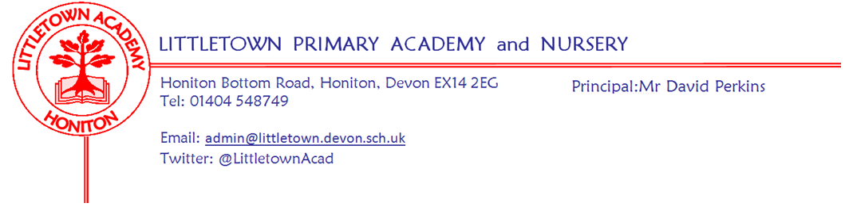
Reception – Remote Learning Update 17 April 2020

Dear Children, Parents & Carers,

We hope you are all keeping well, staying safe and have enjoyed the lovely Easter weather. From Monday 20th April we are going to use a Padlet Learning Wall to share activities and ideas for your home learning. All of the teachers at Littletown will be using this approach to ensure consistency across school. The Reception Padlet link is as follows:
https://en-gb.padlet.com/littletownreception/Bookmarks

On the page you will find video messages from Mr Perkins and the class teachers alongside ideas to keep you busy. Each note has an idea/activity, and sometimes a link to a website if needed. As time goes on we will add new notes with up-to-date learning so please look at the wall weekly.
We love seeing what you have been up to on Tapestry. You can upload photos, videos and notes to https://tapestryjournal.com/ - you have all be so busy so far; all the rainbows, cooking, writing, PE and creative activities. You can also send us messages at the following class emails:
Miss Crofts Class: classrnc@littletown.devon.sch.uk
Mrs Katene/Mrs Hawkins Class: classrnkmh@littletown.devon.sch.uk
Remember Mr Perkins will still be sharing and celebrating #littlebuilders, #littlegreenfingers, #littlechefs and #littetownwindows. Email the school photos or share directly via our facebook page and twitter feed (@LittletownAcad).
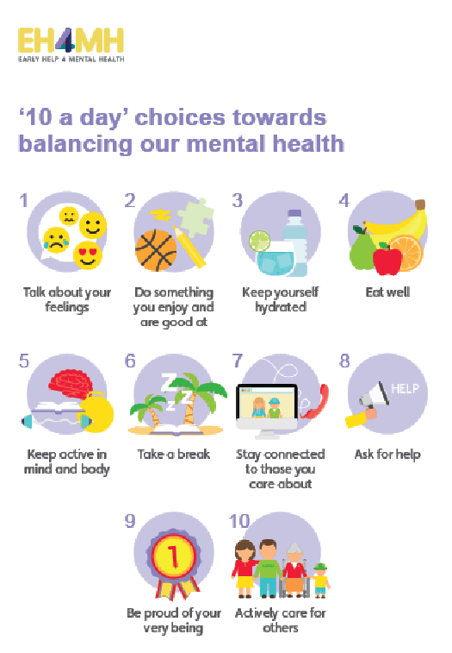
Most importantly please remember, as your child is part of the Early Years Foundation Stage a huge amount of their learning is through their own self-initiated play and learning. Opportunities to construct with junk materials or construction sets like lego provide experiences for physical development but also encourage their problem solving, planning, discussion, adapting and reviewing skills.
Playing with small world or role playing/imaginative play encourage language development as well as offering up opportunities to mark make, use mathematical skills and develop their social skills and understanding of the world – you will be amazed what learning can be achieved while playing ‘shops’.

This is a really strange time for everyone, especially for the children who need time. Time – it allows them to process what is going on and make sense of their feelings. If the only thing you manage in the day is some of the ’10 a day’ then you and your family are having a good day. This is a time to spend as family, to talk, share, play, tell stories and snuggle.

Take care, stay safe and look after one another,

The Reception Team

Please note message from Mrs Trim and Mrs Childs:
This is the link that all parents can use to access the SEND/SAFS padlet page. There is a lot of useful information, activities, links... for our SEND children and families.
https://padlet.com/lianechilds/ewjn9i9gxfpw

