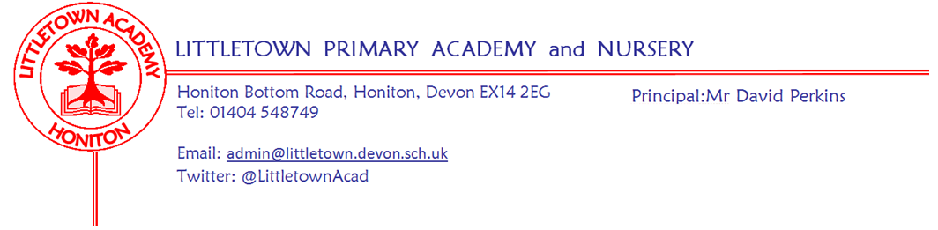
04/05/21
Brass Ensemble tuition opportunity
Dear Parents and Carers,
I am pleased to be able to bring you news of a new and exciting musical opportunity for Y3/4 Littletown pupils.
Our brass/piano teacher Gail Denning has been in school today demonstrating some brass instruments to the Year 3 and 4 children, with the intention of starting an ensemble group, during the school day, in the next few weeks. This will initially be open to 10 children across Year 3 and 4 on a first come first served basis. As this is a pilot initiative, a large percentage of the funding has been covered by Devon and Torbay Music Education Hubs, meaning that the initial cost to parents will be small - only £10. The hope is that the children will wish to continue either with the ensemble, or with individual lessons in September, once they have experienced these sessions this term. It is worth noting that these instruments will be expected to be taken home so that they can be regularly practiced and therefore, a hire agreement will need to be signed and returned before a place in the ensemble is agreed. It is also a suggestion that you insure the instrument for the time in which your child has it, in case of loss or damage.
If your child wishes to continue with lessons in September, there will be a £30 termly hire of the instrument plus the cost of lessons. Of course, you may wish to purchase your own instrument at this point.
If you require any more information about this opportunity, or wish to provisionally book a place for your child, please email littletownmusic@littletown.devon.sch.uk. Confirmation of a place will be given once the hire agreement has been requested and returned to school. Please also email the above address if you want to find out about any of the other music opportunities that we offer at Littletown.

Yours faithfully

Cathy Binmore
Music Lead

