Year 1 Spring Term 2020 Information
Welcome Back!
Literacy
We will have a Literacy and Phonic Lesson every day!
We shall be reading:
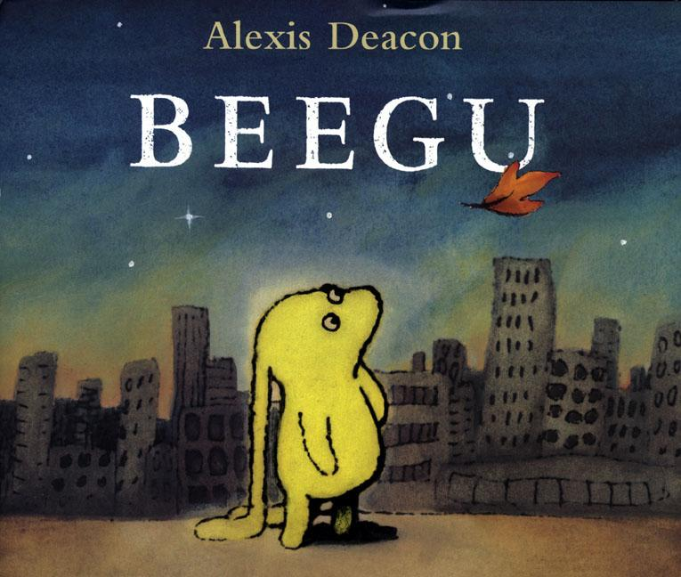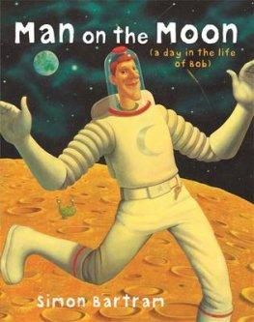
‘Beegu’ by Alexis Deacon and ‘Man on the Moon (a day in the life of Bob) by Simon Bartram.
-We will be learning how to sequence sentences to form short narratives.
-We shall be continuing to practice our cursive handwriting letters focused on one arm robot letters: r, m ,n, h, b, p and k.
-We will be learning to compose a verbal sentence before writing it and then re-reading it to check it makes sense.
-We shall be practicing using capital letters, finger spaces and full stops in simple sentences.
-We will be learning Phonics every day.
-We will be practicing to read our tricky words.

After half term we shall be reading books linked to animals with paws, claws and whiskers. In particular, we will be enjoying ‘Augustus and his Smile’ by Catherine Rayner and The Tiger Who Came to Tea by Judith Kerr.

Power Maths
We will have a Maths lesson every day!
The Key learning objectives:
- Addition and subtraction to 20.
- Numbers to 50.
- Length and height
- Weight and volume

Cornerstones
We are starting our new topic Moon Zoom! We have already had a crash landing in the playground, we’ve taken a look……it looks like a space ship has landed!!!
With each new Cornerstones topic an overview will be sent home with home learning ideas which will be celebrated in an Express event at the end of the topic. The children are welcome to bring in things to show and tell linked to our topic work
After half term we will be starting a new topic called ‘Paws, Claws and Whiskers’. We will be learning about our favourite animals such as pets at home and animals in the zoo.
Key reminders
Please be reminded that outdoor PE is every Thursday afternoon and indoor PE is every Monday morning. The children will need their PE kits for these days. Please make sure the children have suitable trainers/plimsolls to wear that fit them and a t-shirt and shorts clearly labelled and a pair of tracksuit bottoms for cold weather.
Please can you read for 20 minutes every night - this doesn’t have to be just your child. You can share the reading or read to your child.
Please ensure that all jumpers are clearly named – we already have a small collection of unnamed jumpers.
Key dates for the spring term
Stay and play dates (8.50-9.10am): Tuesday 28th January
Tuesday 25th February
Tuesday 17th March
Express event for Moon Zoom: Tuesday 3rd March 9.15am (In Year 1 classrooms)
Engage Trip for Paws, Claws and Whiskers: Axe Valley Wildlife Park Thursday 5th March 2020
(Further details to come but please let us know if you are able to help us on this trip)

If you have any questions or queries please do not hesitate to come and speak to one of the Year 1 team!
Thank you for your continued support.
Mrs Veevers Miss Meecham Mrs Childs

