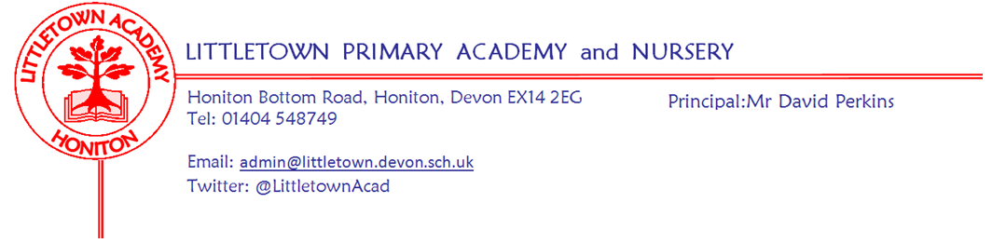
Friday 1st April 2021
Dear Parents and Carers,

As we reach the end of what has been a unique term, featuring time in school and time at home, I just want to start by saying a huge thank you to all of you for your support, and to all of the Littletown staff for their hard work in getting us to this point.

This week, we have continued working with the children to assess their understanding of concepts and skills across the curriculum and particularly in English and Maths. This is in order to further inform planning and teaching and also to give more value to our Parent Consultations scheduled for the week beginning 26th April. You should have received a letter today explaining arrangements for these. Please make sure you fill the relevant google forms for contact details at the bottom of the letter and don’t hesitate to get in touch if you have any questions.

Please be aware that, as is the case with every holiday, it is possible I will need to contact families at the start of the holiday informing them their children need to isolate. This would be where children have been in contact with somebody within 48 hours of symptoms which result in a positive test. (i.e. symptoms on Sunday, positive test result on Monday). You may feel that with the loosening of restrictions and more social mixing taking place, that now is a good time to take part in the Government scheme for Lateral Flow Testing for family members of Primary age children. I have put this information again below in this newsletter.

My thanks to the PTFA for a very successful Easter egg colouring competition raising £160 for the children. Photos of entries and details of winners can be found below.

On Monday 19th April we give a warm welcome to Mrs Bruce as she begins her role as Receptionist. Mrs Bruce has lots of experience in administration, knows the school well and impressed at interview. I would like to give a special mention and thank you to Mrs Gibbs and Mrs Rawlins for holding the fort so admirably as an admin duo, and covering the vacant Receptionist position for the entire Spring Term during a very busy period and challenging time.

Please find below the featured 10 a day focus from Mrs Davis. Let's all take some time to enjoy doing some things we are good at this Easter in between the eating of chocolate!

Finally, I would like to wish you all an enjoyable and relaxing Easter break and I look forward to seeing you all when we return to school on Monday 19th April.

Yours faithfully,
David Perkins
Principal

Mental wellbeing
This week’s 10 a day focus is to; ‘Do something you enjoy and are good at’. If you would like more information about the 10 a day and Normal Magic then please visit normalmagic.co.uk
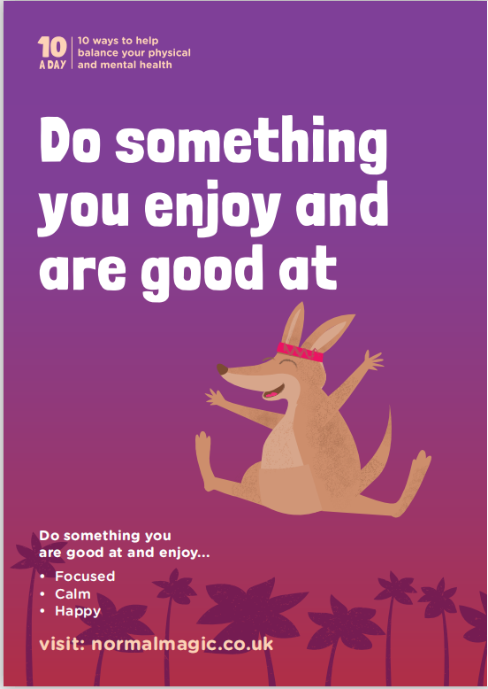

Hallie’s Gymnastics
Speaking of doing things we are good at… Many of you will have seen Littletown pupil Hallie on the BBC spotlight news this week marking her achievements in the recent Global Acrobatic Blocks competition. Hallie achieved Silver in the ‘speed test’ for U12s against 181 other competitors. A truly remarkable achievement. Hallie also performed incredibly well in the Endurance event where she came 6th and the Technique event where she came 14th. It won’t surprise you to know that as a school we’ve not had much to do with Hallie developing this phenomenal talent! However, we are incredibly proud of her and I’m sure you will all want to join me in saying a massive well done to Hallie. Full write up on Honiton Nub news can be found here:
https://honiton.nub.news/n/honiton-gymnast-hallie-wins-silver-in-global-acrobatics-competition?fbclid=IwAR3ezukDLrtBJBkjPLSlKXOnabhPdGSUx6LR-Oap9IyRK8JNdx9phnBHCGQ Tuesday’s BBC Spotlight can be found on the BBCiplayer.

Lateral Flow Tests for Primary school pupils
The Department of Health and Social Care announced that from Monday 1st March, households with primary school, secondary school and college age children, including child care and support bubbles, can test themselves twice every week at home as schools return from Monday 8th March. The twice weekly test kits can be accessed:

- at a local test site
- by collecting a home test kit from a test site
- by ordering a home test kit online

Please find here a link which provides further information on how to obtain the tests which is quick and easy to use. https://www.gov.uk/guidance/rapid-lateral-flow-testing-for-households-and-bubbles-of-school-pupils-and-staff?utm_source=1%20March%202021%20C19&utm_medium=Daily%20Email%20C19&utm_campaign=DfE%20C19
As Public Health England states: Around 1 in 3 people with coronavirus (COVID-19) do not have symptoms but can still pass it on to others. Regular testing of people without symptoms (asymptomatic testing) is important to help stop the virus spreading.

PTFA news
Thank you to all of you who entered our Easter Egg colouring competition. We had so many entries and some amazing art work and imaginative designs. Well done to everyone. We have raised £160.
It was very difficult to choose between them, but we would like to congratulate the winners.
Overall Winner - Mya (Year 6)
Year 6 – Niamh
Year 5 – Poppy
Year 4 – Sophia
Year 3 – Oscar
Year 2 – Maddie
Year 1 – Lily
Reception – Mason
Nursery - Finley
