Live . Love . Learn - Littletown
Year 6 Autumn Term 2026 Information
Welcome
Welcome back. We hope that you all had a restful break over the summer holiday and hope your child is excited to be back for the Autumn Term.

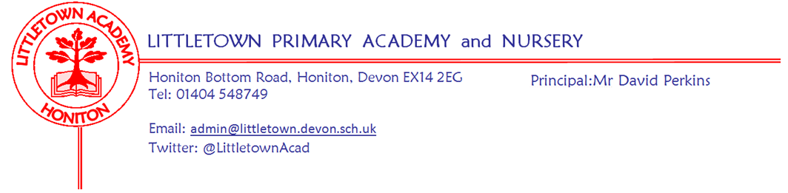
Literacy
Literacy sessions will take place every day. Writing, including sentence construction and grammar, will be taught through a variety of teaching sequences from Pathways to Write, which is our school writing scheme, using two main texts – Star of Fear, Star of Hope and The Selfish Giant. Handwriting, grammar, spelling and reading comprehension will be further developed within discrete lessons and using Pathways to Read. There is an expectation that the children will spend at least 20 minutes per day reading at home.
Maths
Maths sessions will take place every day. These will be taught using the Power Maths scheme through which pupils will be encouraged to gain a deeper understanding of the following areas: Place value, 4 operations, measurement and fractions.
In addition, the children will consolidate their arithmetic skills and formal written calculation methods, applying these skills to develop their mathematical reasoning. They will continue to develop these skills in discrete arithmetic sessions. The children will continue to develop their multiplication facts fluency, using Times Table Rock Stars (TTRS) online.
Curriculum Maestro History Project
Britain at War – This project teaches children about Britain’s involvement in wars prior to WW1, the causes, events and consequences of the First and Second World Wars, the influence of new inventions on warfare, how life in Great Britain was affected and the legacy of the wars in the post-war period. Towards the end of the project, the children will have a day where, dressed as an evacuee, they will have a ‘street party’ to celebrate VE Day.

PSHE
During the first half of the term, we will be looking at the Jigsaw unit ‘Being Me in My World’ with the following learning intentions: I can identify my goals for this year, understand my fears and worries about the future and know how to express them; I know that there are universal rights for all children but for many children these rights are not met; I understand that my actions affect other people locally and globally; I can make choices about my own behaviour because I understand how rewards and consequences feel and I understand how these relate to my rights and responsibilities; I understand how an individual’s behaviour can impact a group; I understand how democracy and having a voice benefits the school community.

During the second half of the term, we will be looking at the Jigsaw unit ‘Celebrating Difference’ with the following learning intentions: I understand there are different perceptions about what normal means; I understand that everyone has a right to be who they are; I can explain some of the ways in which one person or a group can have power over another; I know some of the reasons why people use bullying behaviours; I can give examples of people with disabilities who lead amazing lives; I can explain ways in which difference can be a source of conflict and a cause for celebration.
Key reminders
P.E. (Monday & Tuesday)
Children will be required to come to school in their PE kit on their timetabled PE days of Monday and Tuesday. As the weather gets colder, the children can wear jogging bottoms.
Water Bottles: Please ensure your child has a named bottle of water (not juice) in the classroom for drinking throughout the day. They may have juice in their lunchbox but no fizzy drinks.

Packed Lunches: We have peanut allergies in school so we ask that no children have nuts or nut based snacks/spreads in their lunchboxes. We are a healthy school and ask that children do not bring in chocolates or sweets for lunch.
Medication: Please let us know if your child has to take any prescribed medication at school. There is a green form for you to fill in so that we can administer it. We can only give prescribed medication and the medication must have the prescription label on. If your child has an inhaler, please provide the school with the asthma care plan that you should have received from the asthma nurse. Please log any absences on Arbor, if your child is off sick, specifying the reason for their absence. You will need to log the absence every day that your child is away.

Birthdays: If it is your child’s birthday they can come to school in their home clothes. Please do not bring cake/sweets.
Homework
Homework will be set each Saturday and should be completed by the following Friday. We will be using an online learning platform called Learning by Question (LBQ). The children will be given either a Literacy or Mathematics based exercise each week to complete. If you have any difficulties with your child accessing a computer to do this, please let us know - we may be able to loan you a device.
Learning by Questions | LbQ (Link to homework website - Login details have come home with your child)

As always, we expect the children to read for about 20 minutes per day, spend time learning their spellings and learn multiplication facts using Times Table Rock Stars. Spellings can be found on their Google Classroom at the bottom of their reading diary pages and will be sent home in their spelling books, (to be brought back to school on Monday).
It is always the case that we expect children to ‘have a go’ at the LBQ element of the homework, but we do not expect it to cause tears or tantrums from children (or parents) so please encourage your child to come and ask us if there is any part of the homework they are having trouble with.
We run a drop in Homework Club on Wednesday lunchtime, from 12.15pm - 12:30pm for children who feel they are struggling with elements of that week’s homework or for children unable to access this at home.
Weekly Reading Record
We have an online system in Year 6. The children will no longer have a paper reading diary; this is in preparation for secondary school where there is a similar system. Year 6 have a Weekly Reading, Spelling & LBQ HWK Record set up on their Google Classroom. The children are expected to record any reading they do. This will be monitored. If they are unable to do this at home, they will have the opportunity to do this at school.
Key dates for the autumn term
Tuesday 22nd September 3.45pm-4.45pm: Open Classrooms
29th, 30th September and 1st October: Parent Consultations (more information to be sent out by Mr Perkins)
Tuesday 6th October: Year 6 Trip to Tiverton Museum
Thursday 15th/Friday 16th October: Y6 HCC Open Mornings (should receive info from HCC)
Wednesday 14th October at 5pm: Pixies Holt meeting for parents, where you will find out all the details about the residential, the activities and information about a payment plan for the residential. If you can’t make the meeting, we will send the information home on Friday 16th October - feel free to email any questions or concerns you may have.
Monday 26th October - Friday 6th November: 2 week half term holiday
Tuesday 10th November: Space Dome (linked to Evolution and Inheritance topic)
Tuesday 8th December 2pm: Christmas Concert at St Paul’s church Year 5 and 6.
Wednesday 9th December 6pm: Christmas Concert at St Paul’s church Year 5 and 6.
Friday 18th December: Last day of autumn term
Tuesday 5th January: First day of spring term
Year 6 Team (Mrs Binmore, Miss Bodgin and Mr Daniels)

