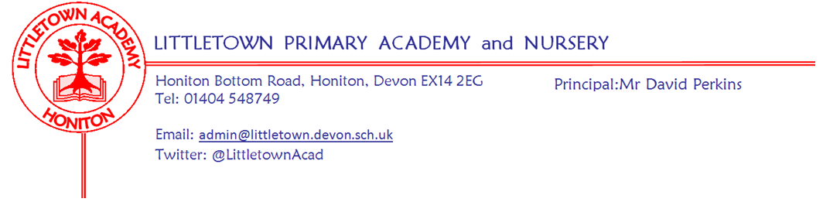
Friday 26th June 2020

Dear Parents and Carers,

With Phase1 now truly in full swing, and everyone continuing to grow in confidence with arrangements, there has been a lovely feeling of nurture and learning at school this week. It has also been great to see so much excellent remote learning going on despite the very hot weather.

This week, we have been able to finalise plans and arrangements for Phase2 of our reopening, when we welcome back Year 6 from Monday 6th July. Next Monday, 29th June, parents of all children due to be in school from 6th July onwards where there are changes, will receive a letter with information and details. This will include links to videos to share with children, just as with phase 1. In order to receive Year 6 and keep pace with substantial increase in demand for key worker places, we have had no choice but to move some children around to different pods and increase the number of children in each pod. Numbers of children will still be lower than the fifteen referenced in the Department for Education guidance. This could however, mean your children are in a different space and have a change of drop off and pick up time. I know this could be disruptive and have tried to minimise changes for this reason. If you do not receive a letter on Monday, this is because all arrangements remain unchanged for your children going into Phase2. All Nursery parents and some Reception parents will not receive a letter because the only change will be a few more children joining their child’s existing pod. I would like once again to thank senior leaders for their hard work in this, and thank chair of Governors Tina Sillitoe and her husband Bob for assisting us with lines and markings.

Since school has been reopened, I have had several parents speak with me about concerns over social distancing measures not being complied with by returning Littletown pupils outside of school. Arrangements at school are in place to keep children and staff safe. These will be totally ineffective if, outside of school, groups of pupils are mixing and not following social distancing rules. The Department for Education guidance states that schools will be able to refuse the admission for fourteen days of any pupils where we have a strong belief that social distancing rules have not been followed by the family outside of school, and therefore pose an increased risk to the school community. This includes more than six people from other households in gardens, playing in parks, sleepovers, group beach trips and barbecues. I am sure that all parents will support me in enforcing this guidance where appropriate in the interests of safety for all. I know it is a very complicated time at the moment with ever changing guidance for society. Please make sure you are aware of and follow the most up to date social distancing measures so that your child can continue to come to school. A similar message is appearing in the Honiton Primary School newsletter today.
Here is the link to the current guidance for your reference: https://www.gov.uk/government/publications/staying-alert-and-safe-social-distancing/staying-alert-and-safe-social-distancing

No doubt, like me, you have been watching the news and seeing various announcements about education over the last week. These include, Covid catch up funding, Summer tuition, full classes in September and a Summer food scheme. As has unfortunately become commonplace, schools found about all this at exactly the same time as everyone else and as yet we have had no further information on these. As soon as we get details we can begin planning accordingly and communicating with you. At time of writing we are working under the assumption that schools will not be expected to run Key Worker provision over the Summer holidays, but await confirmation on this.

In terms of September, I am pleased to inform you that this week we appointed Miss Meecham and Mrs Rossiter to KS1 teaching positions for next academic year. Miss Meecham will teach in Year 1 and Mrs Rossiter in Year 2. We are finalising staffing for September and working on the premise of keeping things the same in school as much as possible during this time of continued disruption. We do not yet know what school is allowed to look like in September so bare with us while we await further direction on this.

I would just like to finish by thanking all of you once again for your ongoing patience and support during this difficult time for schools and families. I continue to be blown away by the many verbal comments and emails of support and praise, staff and myself continue to receive. These are greatly appreciated. Once Phase2 is up and running and we are in a better position in order to make plans for the future, I will be reaching out to all families to give an opportunity for feedback and views about how the last few months have been and to make suggestions about how we move forward next year. This will be in place of the usual Annual Parent questionnaire to allow a sharper focus to the consultation.

Yours faithfully,
David Perkins
Principal

