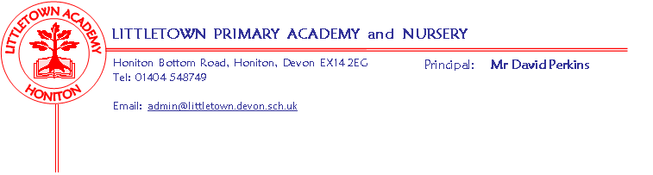
Year 4 Spring Term 2019 Information
Literacy
Literacy is taught on a daily basis, on a Tuesday it is a written reading comprehension focus. In Literacy this term, we will be focusing on a book called ‘Oliver and the Seawigs’ we ties in with our Project ‘Blue Abyss’. This unit will expose children to a varied range of creative writing genres. SPAG will be taught throughout the week both integrated in the lessons and taught discretely. Additionally, Accelerated Reader will continue on a daily basis to encourage children to read a wide range of texts and answer questions on those books in the form of quizzes. After half term, we will be focusing on poetry and a book related to our Project ‘I am Warrior’.
Maths
Following the Power Maths scheme, we will be learning about measurement and perimeter, multiplication and division and fractions this term. Times tables will be strengthened using TT Rockstars.
Cornerstones
Our Cornerstones Topic for the first half-term is Blue Abyss (ocean habitats). A letter about this topic has already been sent home with your child. The topic after half-term is ‘I am Warrior’ and covers the topic of the Romans.

Key reminders
Please can the children have their P.E kits in school for the whole week (we are doing our outside PE on Monday mornings this half-term). Please make sure all school uniform, coats and kit are named as we now have a huge pile of lost property! Please remember that Home Learning ideas are in place to reduce homework stress but we do have an expectation of reading 20 mins a night and some time also spent on Timestable Rockstars.

Key dates for the spring term
Y4 Cake sale – Friday 25th January
Our Express Event for Blue Abyss will be on Friday 15th at 2:40
Swimming – begins Monday 11th March (for 8 weeks)
Roman Day – Tuesday 12th March
Outdoor classroom – to be announced
Thank you Year 4 Team

