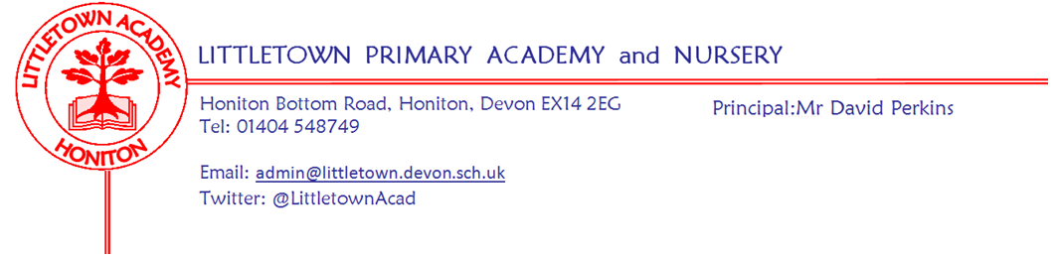
Friday 19th November 2021
Dear Parents and Carers,

It has been a busy and vibrant week here at Littletown which started on Monday with lots of wonderful odd socks on show from children and staff. This was part of National anti bullying week which has been taking place this week. The theme has been around verbal bullying and the upset this can cause under the campaign of ‘one kind word’. Children have been discussing this in class and in assemblies. More information can be found here:
Anti-Bullying Week 2021: One Kind Word

Yesterday we were delighted to host school photographs. Children all looked very smart. My thanks to the school admin team for the significant organisation involved with the day.

Today it has been great to see all the children enjoying coming to school in their pyjamas to raise money for Children in Need. Lots of children have taken part in the special Joe Wicks workout in classrooms this morning. We will let you know the total raised next week. This afternoon, our Cross Country runners from Year 3 to Year 6 have travelled to Bicton College for the East Devon Cross Country finals. We will let you know how they get on next week. Please see information from Mrs Davis below about our Mental Wellbeing logo competition.

Please see below news from the PTFA and also notice of the Annual General Meeting of the Governing Board of the school to which everyone is invited. It would be great to have lots of people in attendance. Please get in touch if you have any questions.

Thank you to those who completed the google form on Vision and Values. This is now closed. Parents have until the end of next week to complete the Consent Form regarding photographs etc.

Don’t forget to check out our Facebook and Twitter pages for information and sharing of great Littletown Learning. This week there have been posts on the digestive system (don’t view during dinner!) and some artwork from nature.

Thank you also for all the positive feedback about the plans shared with you last week about Christmas performances. Rehearsing has begun in earnest this week and the children seem to be really enjoying the prospect of their year group performances.

Next week is a slightly quieter week before the run up to Christmas. Year 3 have outdoor classroom on Tuesday, Nursery outdoor classroom on Thursday and Reception outdoor classroom on Friday.

Yours faithfully,
David Perkins
Principal

News from pupil reporters

Nursery
This week, Nursery have been drawing and painting pumpkins

Reception
This week, Reception have been making bear puppets and naming 2d shapes

Year 1
This week, Year 1 have been learning about anti bullying and decorating odd socks

Year 2
This week Year 2 have been learning about owl facts

Year 3
This week we have been writing similes, writing a list to Santa and practicing Christmas songs.

Year 4
We made digestive system models and in outdoor classroom we made leaf patterns.

Year 5
We have been writing a letter to the character’s cousin in our new book. In cornerstones we have been planning a Tudor menu with all the things Tudors ate. We have also been planning a play about Anne Boleyn’s trial.

Year 6
This week in our classroom we have been proof reading our narratives. Also, we have tested our Anderson shelters to see if they would stand up and if they could withstand a direct hit from a 500g bomb.

Mental Wellbeing
This week we judged the Mental Wellbeing Logo Competition which was launched during Mental Wellbeing Week before half term.
I am very pleased to announce that the Key Stage 1 winner is George from 2CB/DB and the Key Stage 2 winner is Annabelle from 5ZH. Both children were presented with their certificate and prize by Mr Perkins in assembly this morning.
The overall winner and the design we will be using as our Mental Wellbeing Logo in school has been designed by Annabelle.
I would like to take this opportunity to say a big well done and thank you to everyone who entered the competition as the standard was very high and it was a pleasure to look through them all.

Annual General Meeting
Honiton Littletown Primary Academy Trust
COMPANY NUMBER: 07851471
NOTICE OF ANNUAL GENERAL MEETING
Notice is hereby given that the Annual General Meeting (the “Meeting”) of Honiton Littletown Primary Trust will be held virtually on Tuesday 7 December 2020 at 5.30pm to transact the following business:
1. To receive the Chairman’s report;
2. To receive and adopt the company's annual accounts for the financial year ended 31 August 2021 together with the directors' report and auditor's report on those accounts;
3. To appoint the Company's auditors to hold office from the conclusion of the meeting to the end of the next period for appointing auditors under section 485(2) of the Companies Act 2006, at a remuneration to be determined by the directors;
4. To appoint new Members to the Board and accept any resignations from the Board by current Members.
By order of the Board
Tina Sillitoe
Chair
Honiton Littletown Academy Trust
If you would like to attend please contact Jenny Rawlins (littletownclerk@littletown.devon.sch.uk)

Next week’s events
Monday 22nd November | Tuesday 23rd November | Wednesday 24th November | Thursday 25th November | Friday 26th November
 | Y3 Outdoor  Classroom |  | Nursery Outdoor Classroom | Reception Outdoor  Classroom

PTFA news
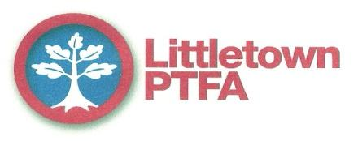

Thank you to everyone who ordered Christmas cards this year. We had some really lovely designs from the children and I hope everyone was pleased with their orders. We made over £450 in commission from the sales.
We also had a very successful cake sale from year 5 where we made £127. Thank you to all our year 5 bakers and sellers. Year 4 will be holding their cake sale on Friday 26th November.
We had our planning meeting earlier in the week and we have lots of plans for the rest of the term. Thank you to all those who came along to join us.
Christmas Performances: We will be serving refreshments at most of the classes Christmas performances. It will be £1.50 for a choice of cake and cold drink. Please bring the correct money with you if you can so we can avoid queuing.
Raffle: We have a great selection of prizes for our Christmas raffle including a hamper, vouchers from local businesses and other prizes. Tickets will be available in December and at the Christmas performances. Look out for more information.
Jolly Jars: Our Jolly Jars stall is always very popular at our Christmas Fayre so, as we are not able to have a fayre this year we will be doing a Jolly Jars stall in December. We will be having a non-uniform day on Friday 3rd December where we will ask the children to bring in a jar filled with small items such as sweets, pencils, hair accessories, or any other small gifts. We will then have a stall after school on Monday 6th December in the playground where the children can pay £1 to get a ticket to win them a jar. More information about the jars will be given to the children in an assembly but save your empty jam jars ready.
Colouring competition: Our Christmas colouring competition will be sent out during December for the children to enter with a chance to win a prize.
Over the Christmas holidays we will also be running an Elf treasure Hunt and a Christmas themed quiz. More details of these will be emailed to you nearer the time. Everyone can have a go at these – we want to give everyone a chance to have some fun with them - you will only need to pay if you want to submit your answers with the chance of winning a prize.
Please try to support these events to help us to make as much money as we can to support the school.

Community news

Honiton carnival this Saturday
This Saturday 20th November at 5pm is Honiton Carnival and Honiton high street which includes the official turning on of the Honiton Christmas lights. It would be great for many Littletown families to support this event as we have been so kindly helped by Honiton Carnival with the long term loan of all the yellow cones to help keep our children and families safe during the pandemic.

British library competition
Honiton library have shared the following information with us regarding a competition which ongoing currently:
What makes your hero super?
bl.uk/superheroes
From 11 October to 30 November, we’re asking children to create a comic and help us assemble a new galaxy of superheroes! We’re celebrating heroes of every kind – whether they have the power to scale walls, save forests or make someone smile.

Teachers and parents can help themselves to a raft of free online resources. There are top tips, videos and templates to inspire you to make comics, flying heroes and flip-books: https://www.bl.uk/childrens-books/activities/what-makes-a-hero-super

Share your creations
Share photos of children’s work on Twitter @BL_Learning or by emailing childrens.books@bl.uk. On 30 November we’ll pick 5 lucky schools and 5 lucky families out of our (virtual) hat to win National Book Tokens.

