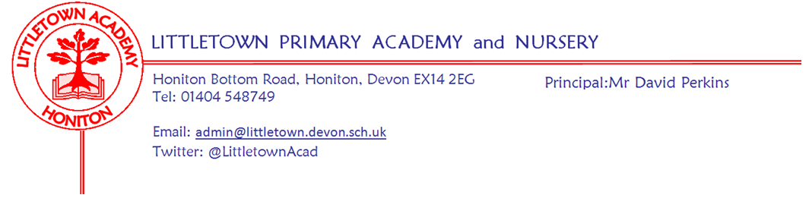

Year 3 Autumn Term 2026 Newsletter

Welcome
We are very pleased to be welcoming the children to Year 3. We have lots of exciting activities planned for the children to help them with their learning.
The Year 3 Team
3JSSD:
- Mrs Searle (Teacher on Monday, Tuesday and Thursday).
- Mr Driscoll (Teacher on Wednesday, Thursday and Friday)

3SC:
- Miss Chalmers (Teacher)
- Miss Gibson (Trainee Teacher)

Teaching Assistants:
- Mrs Green (Monday - Thursday)
- Mrs Holmes (Monday and Friday)
- Mrs Ryerson (Friday)

Literacy
For the first part of the autumn term, we will be reading Seal Surfer by Michael Foreman. The final writing outcome for this text will be to write a letter in role, recounting events of the story. During the second part of the autumn term, we will be reading Stone Age Boy by Satoshi Kitamura. The final writing outcome for this text will be to write a stone age adventure in the first person.
Maths
Maths lessons will take place every day using Power Maths. This term will focus on Place Value within 1000, Addition & Subtraction and Multiplication & Division. The children will continue to develop their multiplication facts fluency using Times Tables Rock Stars.

Foundation Subjects
Our main topic for the autumn term is ‘Through the Ages’. This project teaches children about British prehistory from the Stone Age to the Iron Age, including changes to people and lifestyle caused by ingenuity, invention and technological advancement.

Our science topic is ‘Skeletal and Muscular Systems’. This project teaches children about the importance of nutrition for humans and other animals. They learn about the role of a skeleton and muscles, and identify animals with different types of skeleton.

Our Art and Design topics for the term are: Contrast and Complement - this project teaches children about colour theory by studying the colour wheel and colour mixing. It includes an exploration of tertiary colours, warm and cool colours, complementary colours and analogous colours, and how artists use colour in their artwork. Prehistoric Pots - this project teaches children about Bell Beaker pottery. It allows the children to explore different clay techniques, which they use to make and decorate a Bell Beaker-style pot.

Our Design and Technology topic is ‘Cook Well, Eat Well’. This project teaches children about food groups and the Eatwell guide. They learn about methods of cooking and explore these by cooking potatoes and ratatouille. The children create fajitas according to specific design criteria.

Our Geography topic is: ‘One planet, our world’. This essential skills and knowledge project teaches children to locate countries and cities, and use grid references, compass points and latitude and longitude. They learn about the layers of the Earth and plate tectonics and discover the five major climate zones. We also learn about significant places in the United Kingdom including our counties and major cities.

PSHE (including Relationship, Sex and Health Education)

Being Me in My World: In this unit, we will be focusing on helping the children to value themselves and
know how to make someone else feel welcome and valued. Pupils will discuss how it feels to be happy, sad or scared and identify if other people are feeling these emotions. We will also discuss how behaviour brings rewards/consequences.

Celebrating Difference: The purpose of this unit is to help children appreciate family/the people who care for them. We will discuss strategies to help the children calm down including the ‘Solve it together’ technique. We will also look at bullying scenarios and how we could approach them including ways to help make someone who is bullied feel better.
Key reminders

Outdoor Classroom and Trips: Details for these are still being finalised and further information will be sent out well in advance.

P.E. All children will be able to wear their PE kit on their timetabled PE days of Tuesday & Thursday for both classes. They are also allowed to wear navy blue tracksuit bottoms when the weather is colder. Please remember to name all kit and uniform just in case it is mislaid by the children.
Reading Records & Reading Books: Reading Records will no longer be used to record reading. Please see more information about this decision in this week's newsletter. Children are still expected to practice their reading at home and will need to bring their books into school every day for reading time in class. We would appreciate it if books could be carried in the school book bag or similar, to help prolong the life of our library books. Children will either have a Read, Write, Inc book or be able to choose a reading book from their Accelerated Reader (AR) Range. All children can choose a book of their choice anywhere from the library. Those who are on AR are able to take a quiz and change books as they come in in the mornings.

NEW Spelling Records: Children will be allocated spellings by their class teacher or RWI group. These spellings will be stuck in their brand new Spelling Record on a Monday and then tested the following Monday. Tests will be done in the second half of the Spelling Record, therefore it is essential that the book is brought into school every Monday. By completing the test in the same book, you will be able to see their mistakes and help them to continue any practice, if needed.
Water Bottles: Please ensure your child has a named bottle of water (not juice) in the classroom for drinking throughout the day. They may have juice in their lunchbox but no fizzy drinks.

Packed Lunches: We have peanut allergies in school so we ask that no children have nuts or nut based snacks/spreads in their lunchboxes. We are a healthy school and ask that children do not bring in chocolates or sweets for lunch.

Break time Snacks: Please remember to send your child in with a healthy snack (fruit or fruit based) for break time as in KS2 we do not provide fruit.

Medication: Please let the office know if your child has to take any prescribed medication at school. There is a green form for you to fill in so that we can administer it. This can be found by the main entrance. We can only give prescribed medication and the medication must have the prescription label on. Please log any absences on Arbor. Specifying the reason for the absence if your child is off sick. If you have a medical appointment please let the office know and log it on Arbor.

Birthdays: If it is your child’s birthday they can come to school in their home clothes. If their birthday is at the weekend, they can choose to come in in their own clothes on either the Friday before or Monday after. Please do not bring cake/sweets.

Key dates for the autumn term

Open Classrooms: Tuesday 22nd September
Parent Consultation Phone Calls: Week Beginning Monday 28th September
Hello Yellow Day: Friday 9th October
Half Term: Monday 26th October - Friday 6th November
Christmas Performance: Monday 7th December (3JSSD am and 3SC pm)
End of Term: Friday 18th December
Beginning of Spring Term: Tuesday 5th January

Thank you for your continued support.
Mr Driscoll, Mrs Searle and Miss Chalmers

