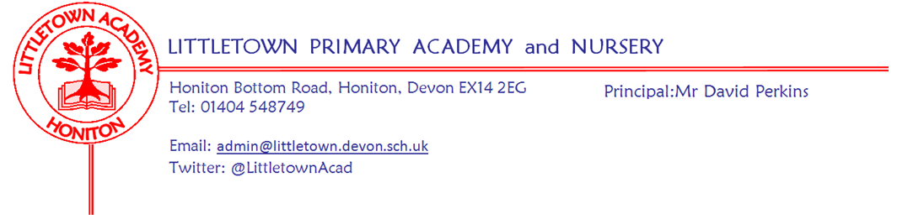
Friday 7th May 2021
Dear Parents and Carers,

I hope you all had a great bank holiday weekend. With it being a four day school week and no further updates from the DfE about restrictions and risk assessments, this will be an unusually short newsletter! Following what I wrote in the newsletter last week regarding the potential loosening of restrictions, it has been great that so many parents have asked questions about whole school events such as Sports day and performances. We continue to make plans for various eventualities and levels of restrictions so that we can communicate the chosen plan to you as soon as possible when we are made aware of the ‘roadmap for schools’. Please continue to ask us any questions about this if you have them and we will let you know any arrangements as soon as we possibly can.

This week more year groups have been able to enjoy outdoor classroom activities. A special well done to Year 4 for braving the high winds on Monday!

Please see attached a Flyer from the Devon Communication and Interaction team regarding an informal workshop for parents on speech, language and communication needs that might be of interest to some of you.

Please also see attached another article from our catering partners, Fresha.

Yours faithfully,
David Perkins
Principal

Staff vaccinations
We continue to support staff in receiving Covid-19 vaccination as soon as they possibly can when their age bracket becomes available as it progressively makes our school community safer for everybody. Please be aware that this can continue to result in some short term disruption to staffing in the school.

Mental wellbeing
Our last Mental Wellbeing Week is fast approaching and will be being held during the week beginning 24th May. The money we raise will be split between mental wellbeing at school and a local mental health charity. We will be having a non uniform day on Friday 28th May and during the week the children and staff will be undertaking a challenge..more information to follow! The Year 6 Mental Wellbeing Ambassadors will be holding a ‘Covid Secure Cake Sale’. We are not asking for home-made cakes but donated cakes from supermarkets, bakeries or coffee shops so if you are able to help please let us know via admin@littletown.devon.sch.uk. We are also going to trial using Just Giving for donations. The link will be in the newsletter prior to the Wellbeing Week.

This week’s 10 a day focus is to; ‘Keep active in body and mind’. If you would like more information about the 10 a day and Normal Magic then please visit normalmagic.co.uk
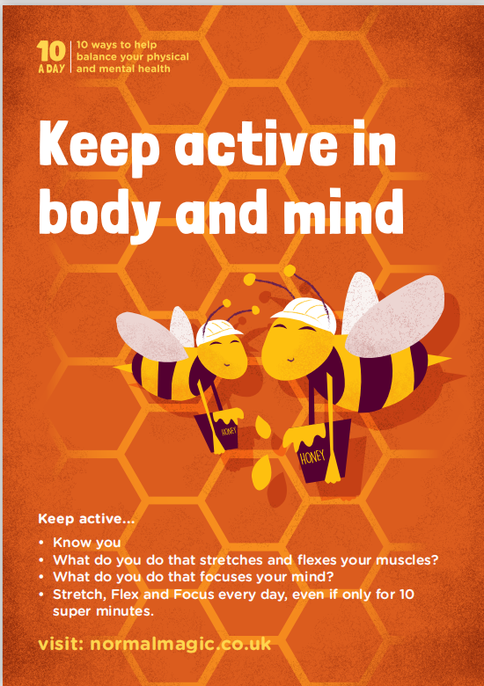

School Uniform and shoes
As you know, we have been allowing children to wear any shoes to school since March as shoe shops have been closed. We have also been understanding of issues regarding uniform during this time too. Due to the loosening of restrictions, we will be returning to the full expectations of the Uniform Policy after May half term. This gives you plenty of time to get the things you need to get, including the half term week. If you think you will have difficulties with this then please do let us know so we can support you accordingly. Many thanks for your cooperation.

Music at Littletown
Unfortunately, it has been the case that the music at Littletown has been affected greatly by the current situation. With an end in sight, we are thinking about moving forward with music at our school. As soon as the restrictions are lifted, we will be thinking about recommencing the Key Stage 2 choir which is an after school club run by Mrs Binmore. We are very lucky to have 4 music teachers who come into the school to teach individual and group lessons in a wide range of instruments including brass, guitar, piano, drums, and strings, plus a new brass ensemble which is being trialled this term. Music lessons are available once children reach Year 3, with the occasional exception for Year 2 children in certain instruments. If you would like anymore information about any of the music opportunities, please email littletownmusic@littletown.devon.sch.uk

