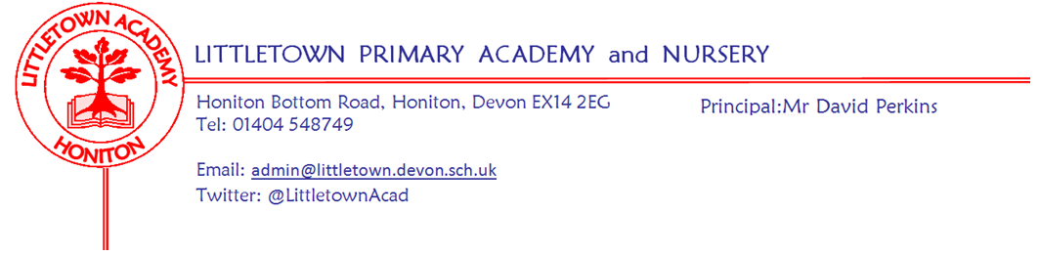
Dear Parents and Carers, 24th April 2020

I hope you have had another good week, balancing remote learning and family life. Thank you so much to children and parents who have been emailing teachers with learning from the padlets. The gallery sections of the padlets are taking shape brilliantly and it is only week 1! Just remember when sending the work to teachers, that you need to give consent for that work to be posted on the padlets, as they are publicly accessible from our school website. Teachers will continue to add to these so that they are updated for next week’s learning for Monday morning. Next week, two year group trials of resources will be taking place. Year 6 children will be trialling ‘Duolingo French’ via their google classroom and Year 5 will be trialling online Music resources via Charanga. My thanks to Mrs Luxton and Mrs Binmore for developing these for us respectively. If they go well, we will add these to other year group padlets and classrooms the following week. Also, after a week of scrutinising the BBC Bitesize lessons, some teachers may well be adding this as a suggested resource as appropriate.

Thank you again to those of you sending me pictures of little builders, little green fingers, little chefs and Littletown windows for sharing on Facebook and Twitter. Apologies that it has taken longer than usual to share some of these - technical issues with Office365 and Facebook!

Sunday would have seen the running of the London Marathon. To mark the occasion next week, there is a National 2.6 challenge to support charities. This challenge will be added to padlets and involves children choosing a 2.6 challenge. This involves any physical activity that involves a 2 or a 6 to represent the 26.2 miles of a marathon distance. Obviously, all activities must comply with Government guidelines on exercise and social distancing. Further details on this including how to donate as part of your activity can be found
here: https://uk.virginmoneygiving.com/giving/events/twopointsix/ Mrs Veevers will be co-ordinating this initiative for us next week.

Last week, as I needed to explain padlets and remote learning, I didn’t give a staffing update. However, last week we welcomed back both Mrs Lambert and Miss Huguerre, returning to us following maternity leave. Very strange circumstances in which to return to school life, but Mrs Huguerre joins 3RB/GH and will be remotely teaching and supporting learning with Miss Bodgin, and Mrs Lambert joins the Year 1 team working alongside Miss Meecham in 1LM/CL. They will be appearing on the padelts in due course! I’m sure you will join me in wishing them a warm welcome back to the team.

Finally, a message from the Student and Family Support Team: A big thank you to those parents who have completed the My Plan survey so far. This is an opportunity for you to have your say in the future development of your child’s My Plan. Your opinions will enable us to make changes that will continue to improve your involvement in your child’s plan. In line with our Ethical Protocol, all surveys will be completely anonymous Please use the link below to take part in the My Plan Survey.
https://forms.gle/HtG6DQ45QdJw8m1v9

Yours faithfully,
David Perkins
Principal

