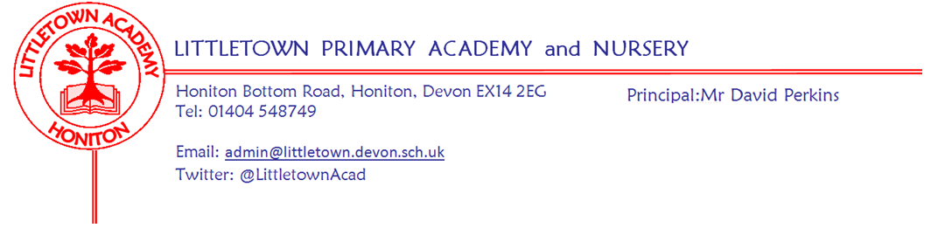

Live . Love . Learn - Littletown
Tuesday 25th July 2023
Dear Parents and Carers,
Just a short newsletter today with some comments I wish to make and some key reminders for next year.
Yesterday, we held our R/KS1 and KS2 ACE assemblies where we celebrated together the Attitude, Commitment and Effort of children across the curriculum in each year group. We also recognised Year 2 and Year 6 children for exceptional attainment and were thrilled to award Year 6s Sophia and Thomas W with Outstanding contribution to Littletown awards and trophies.
Yesterday afternoon we were delighted to welcome Year 6 families and friends to watch two wonderful performances of Courtroom Chaos. It was amazing to see our Year 6 children perform with such confidence and joy and I am still struck by how special such things are and that still only two years ago this wasn’t possible.
This morning we welcomed back the parents of our Year 6 children for what was a really special and emotional Leavers’ Assembly 2023. We are all very proud of this cohort of children’s achievements and the amazing young people they have all become. However, we know it is time to let them go and wish them every success in Secondary school and beyond. I would also like to say a big thank you and farewell to those who leave us as parents/carers today, some after a great many years of being Littletown families.
We also say farewell to three members of staff today. Mrs McFadden leaves us to continue her teaching career, Mrs Newcombe leaves us to begin her Initial Teacher Training and Mrs Childs, our SENCO, leaves us to continue her career. We thank them for their time and commitment to Littletown and wish them all the best for the future.
Over the last two days, children from Reception to Year 5 have been spending time in their classes evidencing in creative ways the key learning from some topics covered in their curriculum this year. This has resulted in some amazing learning including; websites, podcasts, interviews, raps, posters and slideshow presentations. It has been fantastic to see how much the children have learnt this year and how much they have enjoyed sharing and presenting their knowledge and understanding.
On behalf of the staff and I, I would like to thank those of you who have kindly given cards and gifts at the end of the year. It is never expected, especially in tough financial times, but every kind word does really mean the world to all of us who work in schools.
This brings to an end what has been a majorly busy year here at Littletown that started on 29th July 2022 with the fitting of an entire new roof! We’ve also extended the length of the school day, made changes to the curriculum, started a new phonics scheme, completely changed our lunchtimes and welcomed many new families as we’ve grown the Littletown community over the year. I would like to thank all of you for your support in making this another very successful year for the school. My thanks to the staff and Governors too and most of all to the children who make this school what it is as they Live, Love, Learn together. I continue to be extremely proud and privileged to be Headteacher of such an amazing school community and I can’t wait to get started again next year!
Please find below term dates reminder and details for booking breakfast and after school club next year. I would like to finish by wishing you all a wonderful Summer break (I will probably see some of you around town over the next few weeks) and I look forward to seeing everyone return to school for 2023-24 on Tuesday 5th September.
Yours faithfully
David Perkins
Principal

Swimmi
Mental
Parent pay and clubs next year
We are very excited to inform you that from September you will be able to book and pay for your Breakfast and Afterschool Club sessions via ParentPay Clubs. If your child is in Nursery, Reception or Year 1, in September, you will have the option to book into the Nursery Setting all other year groups will have the option to book into the Hall setting. Below are some simple step by step instructions to book your sessions:
1. Sign into your ParentPay Account
2. Click on book meals and places
3. Click clubs on the left hand side (if using a phone, click the 3 small line drop down box at the top left hand side and then click clubs)
4. Choose the relevant club
5. Click on the calendar to select your sessions.
You can also access all the information you need following this link:
https://parent-support.parentpaygroup.com/hc/en-gb/sections/15444205624209-Clubs
You will be able to book/cancel and amend sessions up until 10.00am on the day for Afterschool Club and the day before for Breakfast Club. After this time you will need to phone the school office to make any further amendments, any amendments after the cut off time will be charged. If you want to pay for your ParentPay Clubs using your Child Free Tax Account or Childcare Vouchers this payment must be made to the school. Prior to making you booking you must email Jenny Rawlins jrawlins@littletown.devon.sch.uk with the breakdown of where you require the funds to be allocated. On receipt of this email the funds will be credited to the correct areas enabling you to then book the sessions required.
If you have any problems with ParentPay Club please do not hesitate to contact Jenny at the office.

Term Dates for 2023 - 2024
Autumn Term 2023
Monday 4th September | Non-pupil day
Tuesday 5th September | Term begins for children
23rd October – 27th October | Half Term (1 Week)
Friday 15th December | Term ends for children
Spring Term 2024
Tuesday 2nd January | Non-pupil day
Wednesday 3rd January | Term begins for children
12th – 16th February | Half Term (1 Week)
Thursday 28th March | Term ends for children
Summer Term 2024
Monday 15th April | Term begins for children
Monday 6th May | Bank Holiday
27th May – 7th June | Half Term (2 Weeks)
Friday 26th July | Term ends for children

Week Beginning 4th September 2023 events
Monday 4th September | Tuesday 5th September | Wednesday 6th September | Thursday 7th September | Friday 8th September
Non pupil day | Term starts for all children

