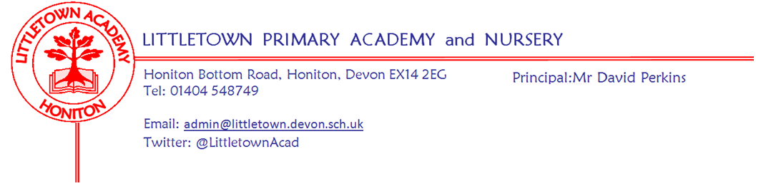
13th September 2019
Dear Parents and Carers,

The school seems very settled as we finish the end of the first full week of the academic year and the children seem to all know exactly what they are doing and what the expectations are in their new classes. Yesterday Year 6 prepared and performed their Musical in a Day entitled ‘No Man’s Land’ about the First World War. Key Stage 2 children and parents alike were really impressed with how well they sang, spoke and performed having only had 6 hours to put the whole thing together!

Today it has been a pleasure to introduce our pupil leaders to the school in assemblies. Year 6 House Captains and Sports Leaders were presented with badges having being selected on the basis of their applications to their roles.

Yesterday and today you should have received the termly information letter for your child’s year group containing key information about Cornerstones Curriculum topics, Literacy and Maths arrangements, key dates and other key information. Please do see your class teachers if you have any questions.

Next week we commence our outdoor classroom schedule with 2AL on Tuesday and 2DN/DB on Thursday.

Yours faithfully,
David Perkins
Principal

News from the children
A welcome and thank you to our new children’s news reporters; Lauren, Katelyn, Benjamin, Eleanor, Bria, Freya, Edward, and Louis and our new Editors Tom and Josh.

NURSERY
We have been making new friends.
We have been exploring the toys.

RECEPTION
We have learnt to use the learning board.
We did our first P.E lesson and practiced getting changed by ourselves.

YEAR 1
We have learned our alphabet.
We did superhero dress up day.

YEAR 2
We are learning about soldiers.
We’re learning to count in tens.

YEAR 3
Our new topic is Scrumdidlyumcious.
We have been sharing fruit and tasting.

YEAR 4
Our new topic is burps bottom and bile.
We used disposable tablets to show the plaque on our teeth

YEAR 5
We have been drawing Tudor London from our imaginations in literacy.
We have been reading a book called Treason.

YEAR 6
We did a musical in a day about 1914 called ‘No Man’s Land’
We have been learning about WW2 key leaders.

Staff news

Messages
School Dinners
Please ensure you are choosing only one type of pudding for your child when booking on ParentPay. When multiple puddings are selected children are asked to make a choice at the counter which slows down serving, and the kitchen numbers are incorrect when preparing pudding each day.
Uniform
Following on from last week’s information about uniform, we have been made aware that the link was incorrect for A1 print and stitch. The correct link is: a1printandstitch.co.uk Print and they are also offering 5% cash back to our school on all uniform purchases.
ALDI vouchers
We are collecting the Aldi’s Kit for Schools Team GB stickers. Please put any stickers in the collection bucket in the front entrance for our chance to win an exclusive school sports kit and a possible £20,000 to help with a health legacy for our school! Thank you.
PTFA AGM
The PTFA will hold their AGM on Monday 16th September at 3:30pm in the Reception classrooms. A crèche is available and it would be great to see lots of people in attendance to help support the valuable work the PTFA do for our school in raising funds for the children whilst holding key community events.

School events/Dates
Week beginning 16th September:
Monday | Tuesday | Wednesday | Thursday | Friday
PTFA AGM 3:30pm | 2AL Outdoor classroom |  | 2DN/DB Outdoor classroom

PTFA News

AGM

Please come along to our AGM on Monday 16th September at 3:30 in the reception classroom. This will be a short meeting to elect our new committee and outline our plans for the coming year. We would love to see as many people there as possible. There will be a creche available for children. If you would like to be involved in what we do, to find out what we are planning or have any ideas to share then please join us. Mr Perkins and other school staff will be in attendance. Everyone is welcome, especially new faces. It does not commit you to anything.

Uniform

The PTFA have a lot of good quality second hand uniform at 50p per item. There are request slips at reception to fill in with what you are looking for and we will return items to your child’s class.

