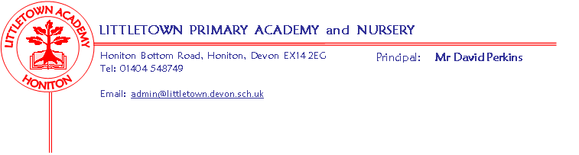 Reception Class – Home Learning Activities

As your child is part of the Early Years Foundation Stage a huge amount of their learning is through their own self-initiated play and learning. Opportunities to construct with junk materials or construction sets like lego provide experiences for physical development but also encourage their problem solving, planning, discussion, adapting and reviewing skills.
Playing with small world or role playing/imaginative play encourage language development as well as offering up opportunities to mark make, use mathematical skills and develop their social skills and understanding of the world – you will be amazed what learning can be achieved while playing ‘shops’.

Play is a crucial part of your child’s development but below are a few ideas for more specific learning to support what your child may be missing in school whilst at home:
Literacy
Reading
Please continue to read books at home – asking question about the characters, setting and predicting what will happen next. www.oxfordowl.co.uk/for-home/ have lots of levelled reading books as ebooks for you to continue reading at home.
Watch Alphablocks on Cbeebies – there are videos for each phonic sound as well as games to check learning.
Take this opportunity to practise your tricky words – play snap and bingo with the words to help recognise quickly.
Play games on Phonicsplay.co.uk (there are lots of free games) to support recognising letters and reading words.
Writing
Continue to practise letter formation – see attached sheet.
Children could keep a diary of the week or practise writing sentences about what they are up to.
Maths
Practise recognising, ordering and writing numbers (see attached sheets).
Play ‘guess my number’ games – give clues to a number e.g. it is one more than …, it is one less than … , it is …. add …..
Play board games like snakes and ladders, dice games, dominoes or games where you are adding and taking away objects
Watch Numberblocks on Cbeebies – at the end ask questions about the number introduced or the method taught.
Play maths games on topmarks.co.uk

Cornerstones Topic
As we start our new topic we would love your child to find out about their favourite animal. Maybe you could draw and label different animals that we hope to see at the zoo. Make a poster with facts about your favourite animals. Use the internet to find out information – the national geographic kids page is great for images, noises and fun facts www.natgeokids.com/uk/

Tapestry – www.tapestryjournal.com
Please remember you can upload photos of your experiences onto your child’s Learning Journey which staff will be able to access from home. We look forward to seeing what you are up to during this time.

