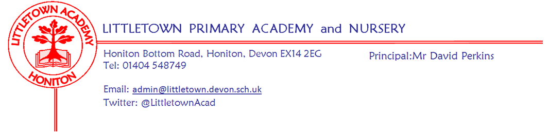
15th November 2019
Dear Parents and Carers,

We had a busy week this week with lots of different things happening at school. Thank you to the PTFA for organising the fantastic and very well attended school discos last Friday evening.

This week, on Monday some Key Stage 2 children took part in the Honiton Learning Community coordination event. On Tuesday, the children all wore ‘odd socks’ to celebrate diversity, difference and individuality as part of National Anti Bullying Week. Well done to Year 5 for their excellent Express Event featuring a Tudor play on Wednesday. Thank you to all parents who attended. Thank you also to all the parents who braved the torrential rain to attend the Year 3/4 Literacy curriculum information evening on Wednesday. My thanks to staff, some of whom who had long journeys, for putting on this meeting. The next Information evening is Year 5/6 Maths at 6pm on Thursday 28th November. Also on Wednesday, 38 children from our choir Littletown Larks wowed the congregation with their singing at St Paul’s Church as part of the ‘Light up a Life’ service. Thank you to Mrs Binmore for taking the choir children to this event. Yesterday we hosted Tempest for school photographs. Please return your forms to the office by Friday 22nd November to order the photos. This morning all children participated in the Joe Wicks ‘Big Morning Move’ joining children from across the country. We successfully raised £310.00 for Children in Need. Many thanks for your contributions.

It was fantastic to welcome lots of prospective families to our Reception open morning this morning. If you know of any families who might be interested in their children starting at Littletown in Nursery, Reception or indeed any other year groups, please encourage them to get in touch with us to arrange an appointment.

Next week we have Kwik Sticks Hockey Y5/6 on Monday afternoon. Tuesday we welcome M&M Theatrical Productions back to school for their pantomime performance of Beauty and the Beast. Many thanks to the PTFA for funding this experience for the children. On Thursday Year 6 hold their Express Event for their Cornerstones topic ‘A Child’s War’.

Finally, please see below information from the Book People about their ‘Big Book Boost’. This is a way of you buying books for your children whilst raising money for the school.

Yours faithfully,
David Perkins
Principal

News from the children

Nursery
We explored the outdoor classroom area.
We made shiny stars

Reception
We have made Hedgehogs
We have been finding the odd one out

Year 1
We’ve been reading a book called Hallabin Jackson.
We’ve been looking inside Buckingham Palace.

Year 2
We have started a new book in Literacy .
We’ve been using column subtraction.

Year 3
We have been doing column addition and subtraction.
We have learned about Mighty Metals in topic.

Year 4
We enjoyed odd sock day!
We have been rewriting Old Town Road.

Year 5
We had our Express Event and we have tasted Tudor food
We have made line graphs

Year 6
We have been working on Fractions
We have been using persuasive letters.

Staff news
I am pleased to announce that Mr Priddle is celebrating the birth of his second child this week. Mr Priddle will be absent on Paternity Leave the next two weeks. Mr Dickason who knows the school and the children well, will be covering the class with support from Mrs Fallon.

Messages
Big Book Boost
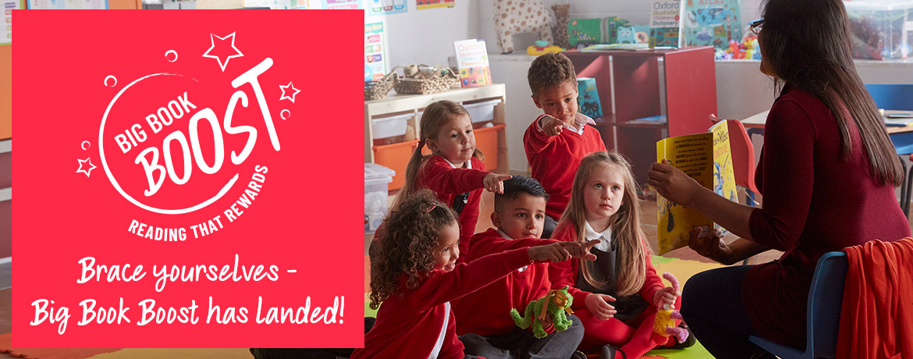

What is Big Book Boost?
Big Book Boost is The Book People’s brand new fundraising scheme. Every time you place an order with us over £10, we’ll donate £1 to a school of your choice for them to spend on books! With your help, we aim to donate 1 MILLION BOOKS to UK Schools by 2022.

How can I be a Big Book Booster?
If you’re new to The Book People, firstly WELCOME. Here’s how you can get going on boosting a school’s book budget;
Choose a school below and then simply start shopping! Once you’re ready to check out, you can either login or set up your account and off you go!
School events/Dates
Week beginning 18th November :
Monday | Tuesday | Wednesday | Thursday | Friday
Flu Immunisations  Y5/6 Kwik Sticks Hockey  Bikeability for 5CB all week. | School pantomime 2pm |  | Y6 Express Event 2pm

