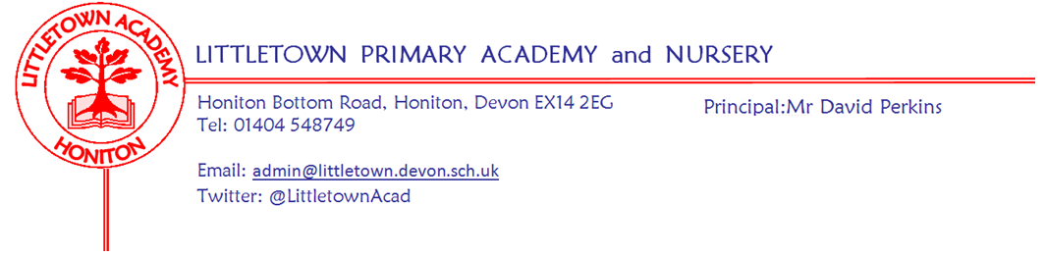
13th March 2020
Dear Parents and Carers,

You won’t be surprised that I will be starting this newsletter by updating you on the Corona virus situation and the impact on our school. The Government announced following the Cobra meeting yesterday that schools will remain open, but anyone who displays symptoms of a cold or a fever must self isolate for seven days. Clearly this could have a significant impact on pupil attendance as well as attendance of staff in key roles at school. In order to keep the school open and keep children safe and educated we may be forced to take measures if we are unable to cover all staff absence at any given time. This may include combination of classes, removal of support interventions and enrichment groups, variations to lunchtime arrangements. I will keep parents updated with any alterations to provision if and when they arise via email.

Children will continue to be instructed to wash their hands regularly for more than 20 seconds throughout the school day and after activities such as today’s obstacle course where germs could be spread.

We have not spoken explicitly about the virus to children in assemblies. However, class teachers have been doing their best to answer children’s questions in classrooms by striking the balance of being honest to the children, being reassuring to the children and being age appropriate in their responses. Talking to children about such things can be challenging. To support parents here are two really good links you might want to use with your children. Dr. Rang from Cbeebies explains all about Corona Virus https://youtu.be/oMHacLHchI0 and BBC Newsround children’s questions answered: https://www.bbc.co.uk/newsround/51791626

I have written to you all today to outline our preparations and arrangements for ‘remote learning’ if the scenario arises where the school is to close. Please make sure you read this letter and contact us if you have any questions.

On Saturday we had a very successful Nursery open morning. Thank you to all the Nursery staff for their attendance and support. This week on Monday some Year 4 children went swimming. Thank you to parents who supported. Yesterday we welcomed Colyton Grammar school to work with some of our Year 4 children, Year 3 welcomed parents to their Express event on ‘Predators’ and six children from Year 5 spoke brilliantly at the Honiton Learning Community Youth Speak competition. Thank you to parents who assisted with transport.

All this week children have been enjoying participating in House competitions as part of Sport Relief. Today the whole school dressed in sports kit and completed our obstacle course on the playground. Thank you for your donations to this cause. We raised a total of £225.00

Last night we held our first Parent Forum where we discussed behavior, curriculum information evenings and of course the Corona Virus! My thanks to all the parents who attended. Notes of the meeting taken by a forum member can be found on the school website: https://www.littletown.devon.sch.uk/website/letters/342129

You may have noticed our frosted school logo on the entrance doors around the school. My thanks to Lee Jackson (husband of Mrs Jackson) for applying these free of charge for the school on Saturday morning. I’m sure you’ll agree they look very smart.
Next week on Monday Year 6 have their final Earth Heart workshop before a performance to parents on Thursday at 2:30pm. We have two Express events next week with Reception parents invited 9 - 9:30am on Wednesday and Year 4 parents are welcomed to the Blue Abyss at 2:30pm on Friday.

Finally, I look forward to seeing lots of the children at the disco later this evening. Thank you to the PTFA for organising yet another great event for the children.

Yours faithfully,
David Perkins
Principal

News from the children

Nursery
We have been building houses for the Three Little Pigs.
We have been making flapjacks for Goldilocks.

Reception
We have been writing letters to Mr. Wolf
We have been writing invitations to our fairy tale celebration.

Year 1
We have been ordering the class in height and we measured Mr Perkins.
We have been ordering height in Power Maths.

Year 2
We have started a new topic called Bounce
We have been doing division and bar models in Maths.

Year 3
We have finished a book about a rainforest.
Last Thursday was our Express Event on Predators

Year 4
We have started a new book called River.
We have been making Ocean Top Trumps.

Year 5
Year 5 has practiced for youth speak.
We have been learning the history of Honiton, problem solving in Maths and started doing coding with purple mash.

Year 6
We have been learning about Macbeth and we're working on area and perimeter.
We started a new topic called Frozen Kingdom. We also finished our book

Messages

Week beginning 16th March 2020 :
Monday | Tuesday | Wednesday | Thursday | Friday
Y4 Swimmers  Earth Heart workshop Y6 | Year 3 Outdoor classroom | Reception Express Event | Year 1 Outdoor classroom  Earth Heart performance 2:30pm | Year 4 Express Event 2:30pm

