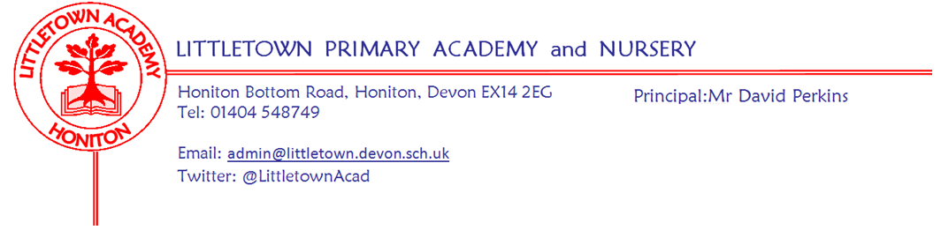

Live . Love . Learn - Littletown
Friday 21st July 2023
Dear Parents and Carers,
It is hard to believe we have reached the end of the last full week of term for the year and what a busy week it has been with many visits and trips and culminating today with end of year reports going home.
On Tuesday this week we held our rearranged Early Years/Reception and Year 1/2 Sports Days. My thanks to all the parents who attended and supported all our sports day this year. My thanks to Miss Bodgin and Mrs Lambert for organising these and to the teachers for preparing the children. Yesterday, we held our sports day results assembly where we celebrated 84 children across the school for showing the school games values of determination, honesty, passion, respect, self belief and teamwork. I then announced the results of the House games in the Autumn and Spring terms, each of the sports days and then the overall winner which was Beech. Full results can be found below in this newsletter.
On Wednesday, we welcomed children’s author Brittany Lakin to work with the Year 3 children about story writing. Yesterday, we were thrilled to welcome the Devon Royal Marines brass band to school to perform to the children on the top playground. It was a fantastic event filled with happiness, music and joy as children (and staff!) clapped, sang and danced. I was delighted that the band said Littletown was the best school they had visited this week. Year 1 had their outdoor classroom yesterday where they investigated the senses of Earthworms! Year 6 have visited Crealy today for their end of Primary school treat, partially funded by profit from their business ventures last week!
Next week on Monday we have our KS1 and KS2 certificate assemblies where we celebrate together the achievement of children across the curriculum. We also look forward to welcoming Year 6 parents to performances of Courtroom Chaos on Monday afternoon and evening. On Tuesday we celebrate the last day of term and say a sad goodbye and good luck to our Year 6 children as we welcome their parents to attend our Leavers Assembly at 9:15am. Children in other year groups will be spending time in their classes evidencing in creative ways the key learning from some topics covered in their curriculum this year.
A reminder that next week, children who have their birthday over the Summer holiday can wear non-school uniform on Monday. All children can come in non-school uniform on Tuesday 25th July. Children will be spending time in their classes displaying in creative ways the key learning from some topics covered in their year groups this year. We would like to send some of the children’s learning home for you to see next week. Please can we ask that every child comes in with a carrier bag on Monday so they can bring some learning home on Monday or Tuesday.
Yours faithfully
David Perkins
Principal

Children’s news

My thanks to all of the Year 5 news reporters this year for finding out what the children have been learning every week this year.

NURSERY: Nursery have been doing sports day and have been enjoying climbing the tower.

RECEPTION: Reception have loved watching the End of Year 6 Production (Courtroom Chaos) and the Royal Marine Brass Band.

YEAR 1: Year 1 (and all other year groups) have been watching a brass band playing music outside. They have also been experimenting with earthworms.

YEAR 2: Year 2 have been sewing in Design and Technology and writing stories about Giants.

YEAR 3: This week, Year 3 have been building mini greenhouses in Design and Technology and they finished their adventure stories.

YEAR 4: This week, Year 4 started playing a game called Guardians of Mathematica. They have also written letters about ‘toilet twinning’ to Mr Perkins.

YEAR 5: This week, Year 5 watched Hercules (it was to do with their topic,: Groundbreaking Greeks). They watched the royal marines perform (actually everyone except Nursery watched it)

YEAR 6: This week, Year 6 got their SATs results (I hope they got good results). They performed their dress rehearsal (courtroom chaos) and they went to CREALY!!!!
Rounders tournament.

Swimmi
Mental W
Sports day results

Autumn Inter House competition results
1st Maple Joint 2nd Oak Beech 4th Ash

Spring Inter House competition results
1st Maple 2nd Beech 3rd Oak 4thAsh

Early Years sports day
1st Ash 2nd Beech 3rd Oak 4th Maple

Year 1/2 sports day
1st Maple 2nd Beech 3rd Ash 4th Oak

Year 3/4 sports day
1st Beech 2nd Maple 3rd Oak 4th Ash

Year 5/6 sports day
1st Ash 2nd Beech 3rd Oak 4th Maple

Overall combined results
Beech 18pts Maple 17pts Ash 13pts Oak 11pts

Parent pay and clubs next year
We are very excited to inform you that from September you will be able to book and pay for your Breakfast and Afterschool Club sessions via ParentPay Clubs. If your child is in Nursery, Reception or Year 1, in September, you will have the option to book into the Nursery Setting all other year groups will have the option to book into the Hall setting. Below are some simple step by step instructions to book your sessions:
1. Sign into your ParentPay Account
2. Click on book meals and places
3. Click clubs on the left hand side (if using a phone, click the 3 small line drop down box at the top left hand side and then click clubs)
4. Choose the relevant club
5. Click on the calendar to select your sessions.
You can also access all the information you need following this link:
https://parent-support.parentpaygroup.com/hc/en-gb/sections/15444205624209-Clubs
You will be able to book/cancel and amend sessions up until 10.00am on the day for Afterschool Club and the day before for Breakfast Club. After this time you will need to phone the school office to make any further amendments, any amendments after the cut off time will be charged. If you want to pay for your ParentPay Clubs using your Child Free Tax Account or Childcare Vouchers this payment must be made to the school. Prior to making you booking you must email Jenny Rawlins jrawlins@littletown.devon.sch.uk with the breakdown of where you require the funds to be allocated. On receipt of this email the funds will be credited to the correct areas enabling you to then book the sessions required.
If you have any problems with ParentPay Club please do not hesitate to contact Jenny at the office.
Music lessons next year
At Littletown we are lucky enough to have many private instrument teachers who teach a plethora of musical instruments. We usually suggest Year 3 as being the best age to begin but please contact the teacher directly or the school's music email address for more details, as in some cases our teachers will take on younger students. Please see table for details:

Name | Instruments | Contact
Matt Parr | Drums | mattparr@icloud.com
Joseph Binmore | Singing | joe.binmore@gmail.com
Emily Miller | Ukulele  Violin | emilymillermusic@yahoo.co.uk
Alan Webster | Guitar | 07930 358832
Gail Denning | Piano  Brass (trumpet/cornet) | gaildenning@outlook.com
Steve Grant - (New from September providing there is enough uptake) | Woodwind (flute/clarinet) | kandsmusic@outlook.com  07810806627

Term Dates for 2023 - 2024
Autumn Term 2023
Monday 4th September | Non-pupil day
Tuesday 5th September | Term begins for children
23rd October – 27th October | Half Term (1 Week)
Friday 15th December | Term ends for children

Spring Term 2024
Tuesday 2nd January | Non-pupil day
Wednesday 3rd January | Term begins for children
12th – 16th February | Half Term (1 Week)
Thursday 28th March | Term ends for children

Summer Term 2024
Monday 15th April | Term begins for children
Monday 6th May | Bank Holiday
27th May – 7th June | Half Term (2 Weeks)
Friday 26th July | Term ends for children

Week Beginning 17th July 2023 events
Monday 24th July | Tuesday 25th July
Y6 performance | Y6 Leavers assembly
 | Non-school uniform

Community news
There is a great deal happening in and around Honiton over the school holiday, including the performance of High School Musical featuring numerous ex Littletown pupils. Please find plenty of flyers and posters attached!

