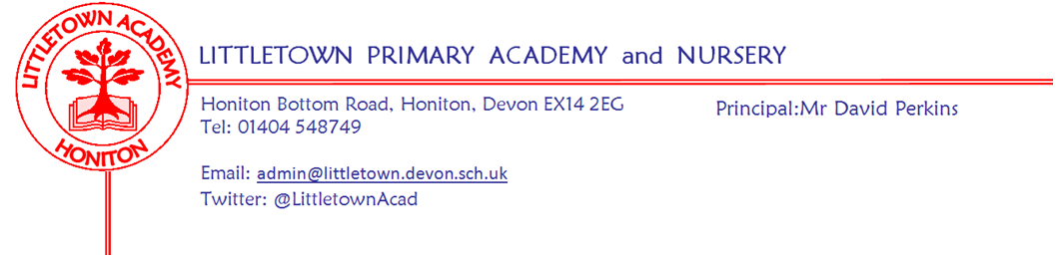
Friday 16th October 2020
Dear Parents and Carers,

It has been lovely to see the children looking so smart and smiley for their school photographs today. I’m really pleased we have been able to hold these despite restrictions and thank you all for your understanding in there being no family photographs this year. My thanks to the admin team for organising these and ensuring cleaning between bubbles coming for photographs.

Teacher and parental feedback suggests that Parents’ Evenings phone calls have been very successful this week. I am delighted with what a positive start to the year so many children have made despite the restrictions the school is operating under. This is testimony to the staff, but also your support as parents and most of all, the attitude of the wonderful children. My thanks to the teachers for making these phone calls. Hopefully we will be able to return to normal arrangements in February. If we were unable to contact you via a phone call, as mentioned in last week’s newsletter, you will receive a very brief email overview from the teacher by the end of the first week back after half term.

This week 2DB/VR have made wormeries in Outdoor Classroom. 2AL will do this after half term. Year 4 have been constructing their fantastic models of the human digestive system featuring all accurate detail!

Last week, the Government and Department for Education issued further guidance and expectations for schools, parents and children in regards to Remote Learning for absence related to Covid-19 from the end of October. We have been working hard on developing plans. We will share all the information on our approach with you after half term. My thanks to the classes which have trialled different resources and approaches this week.

We are also reviewing our hand washing protocols over half term and considering moving towards increased use of Antibacterial Hand Gel from safe dispensers resulting in less use of soap and paper towels. This would better protect children’s hands whilst still complying with the safety guidance.

I have been thrilled with how well Lexia has gone across the school since September. This includes pupil progress due to the additional 30 minutes per week at home for many children. Staff at Lexia commented that they have never seen a school have such great usage and impact using the programme. Although we want children to have a proper break over the two weeks, and usage over the holiday is not in any way an expectation, we know some children may want to keep going with a little Lexia over half term. Therefore, Mrs Binmore and myself will monitor the dashboard, email certificates and reply to emails to the lexiasupport@littletown.devon.sch.uk email address over the two week half term.

Finally, I again thank you for all your support over this most challenging of half terms for the school. I wish you all a very restful and relaxing two week half term and look forward to seeing you all in the queues for the gate on Monday 2nd November!

Yours faithfully,
David Perkins
Principal
Flu vaccinations Tuesday 10th November at Littletown
Please find detailed below information from Virgin Care:-
Dear Parents/guardians,
Your child is eligible for a Free Nasal Childhood Flu Vaccination.
This will be administered adhering to all up to date Infection Control, PPE and social distancing guidance at the time. Flu vaccination is one of the most effective interventions we have to reduce pressure on the health and social care system which is going to be more important than ever this year. For this reason, it is essential we deliver the vaccine to as many children as possible to prevent the spread of infection to those most at risk in society.
In light of the above we are expecting demand to be high and therefore we urge you to follow the below link to consent to your child’s vaccination now.
Even if you do not want your child to receive this vaccination, please complete the consent form stating “no” consent. You will also find answers to your FAQ’s on this link.
https://schoolimms.virgincare.co.uk/flu/2020/devon
If you have any difficulties with completing the consent form please contact the Immunisation Team on our Single Point of Access (SPA).
Governor vacancies
Governors at Littletown are very much part of 'Littletown Big Team' and we would really like to recruit some new members. We are looking for enthusiastic people prepared to give a little back to our school community, governors help in setting the strategic direction of the school, we offer our expertise and knowledge to help support the school leadership team. Governors meet once a month currently online but we are a friendly bunch and would welcome you to join us. We would love to hear from you if you have legal, financial or building skills but equally if you are like me and just want the best for the children in our community get in touch to find out more. Closing date Friday 6th November. tsillitoe@littletown.devon.sch.uk

