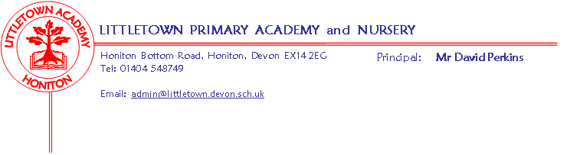
Year 5 Spring Term 2019 Information
Literacy
For the first half of the term we will be basing our literacy and comprehension lessons around Shakespeare’s The Tempest, exploring language, scripts, poetry and performance. This links in with our Cornerstones project Alchemy Island.
During the second half of the term our CLPE text will be Varmints. The children will explore this book through persuasive letter writing, poetry and descriptive writing.
Maths
Maths is taught 5 times a week using Power Maths. Each lesson begins with a power up that is designed to give the children a quick reminder of past learning. We then move on to the main focus of that day’s lesson. This term our units will be Area and Perimeter, Multiplication and Division, Fractions, Decimals and Percentages.
Cornerstones
This half term we will be continuing with our Alchemy Island topic and in the following half term we will be beginning our topic entitled Allotment. The overview for this will be sent home at the beginning of the topic.

Key reminders
- Please remember that P.E. kits need to be in school every day.
- Please name all items of school uniform.
- Please ensure that your children are not coming onto the playground too early in the morning as we cannot be responsible for them before 8.50am.
- Please encourage your children to read at home for at least 20 minutes every day and to use Timestables Rockstars as much as possible to practise their multiplication and division facts. This is now a homework requirement.

Key dates for the spring term
Parents’ meetings w/c 11th February.
Outdoor Classroom 15th February.
Bikeability (More information to follow)
5CB w/c 4th March
5ZU w/c 11th March

