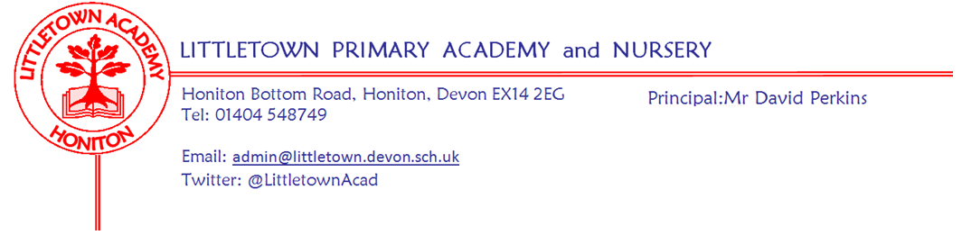
Friday 13th March 2020

Re: Preparation for potential closure and remote learning

Dear parents/guardians,

I have no doubt you are aware that there is much talk about potential school closures as part of the Government response to Covid-19. Yesterday, the Government announced that despite moving into the ‘Delay’ phase of the plan schools are to remain open for the time being. We will only close if instructed to do so by the Department for Education and Public Health England. However, as a school, we have been making preparations for this over the last week or so. Quite rightly, one of the things we have to do as a school is co-ordinate arrangements for 'remote learning'. I am taking this opportunity to write to you to explain what will happen if this scenario does arise, how we are going to ensure we are best prepared and how you can help us now, to ensure this is the case.

Next week, all parents will receive an email from teachers for your child's year group via ParentPay mail, outlining learning which can last up to two weeks. This will include information on things for children to do, how to record/submit their learning and links to useful websites and resources. Children will also come home with an envelope containing paper resources for learning, such as reading comprehension and handwriting etc. Please keep this somewhere safe so it can be accessed if required and returned to school if not needed because school remains open. As much as possible, this learning will be differentiated for your child. There will also be information about Cornerstones topic activities and ideas for children to complete at home, with the idea that children complete two of these a week.

We know that parents are not teachers and this may be a very challenging time for families. A lot of thought and time has gone into ensuring that our expectations are realistic and manageable, but as I am sure you can appreciate, this is not a scenario of which we have any experience. We know that children completing remote learning can help give some structure to days at home and that this works best when scheduled or timetabled around other activities (eg first thing after lunch etc), but that each family should be able to organise their time accordingly. It is also possible that other local schools or schools you know elsewhere do things differently. We have decided on these approaches to give Littletown children the best opportunity to make academic progress across the curriculum, despite not being able to attend school. Teachers and Teaching Assistants will be monitoring learning as best they can, via digital platforms and engaging with children as much as possible through google classroom etc.

If the school is closed for a longer period of time, parents will receive remote learning ideas and resources from year group teachers on Mondays, Wednesdays and Fridays, but we will be in constant communication with you about this if the situation develops in this way.

Right now, we need your help in checking, prior to any closure, that your children can access the resources they will require at home. This varies depending on the age of the children, but will include some or all of the following:
- Logging into and being able to 'quiz' on Accelerated Reader
https://ukhosted44.renlearn.co.uk/1922601/
- Logging in to 'Spellodrome'
http://uk.spellodrome.com/#/home
- Logging in to 'Timestables Rockstars'
https://play.ttrockstars.com/auth
- Accessing their Gsuite for Education account for use of Google drive and Google Classroom
firstname.secondname@littletownacademy.org
Please let your class teachers know if you cannot access any of the above, or email me head@littletown.devon.sch.uk if necessary and we can help accordingly and provide login details as necessary.

One thing we need to solve is children not being able to change reading books in the library. We would like you to assist in this by using https://www.oxfordowl.co.uk/for-home/ Oxford Owl which with simple registration using an email address allows access to a large range of eBooks. Can you please register for this resource and let me know if you have any problems?

Obviously our fantastic town library is a valuable resource and likely to remain open even if school closes. The library has a high quality and extensive range of books for children of all ages.

Can Nursery and Reception parents please check they can successfully login to 'Tapestry' and let staff know if they are unable to?

School contact will always be available to all parents via the admin email address admin@littletown.devon.sch.uk and my email address head@littletown.devon.sch.uk We can then contact teachers as necessary.

I will also have a go at setting some whole school challenges and competitions via Twitter @littletownAcad and our Facebook page!

If and when we do hear that we are required to close the school for any reason, I will contact you again with further details. In the interim, please do not hesitate to contact me if you have any questions.

Many thanks for your ongoing understanding and support,

David
David Perkins
Principal
Littletown Primary Academy
01404 548749
@LittletownAcad
'a nurturing and exciting place to learn and work'
OFSTED 2019

