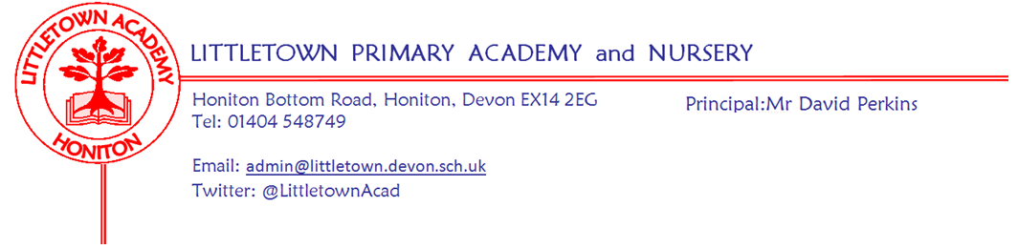
Friday 15th January 2021
Dear Parents and Carers,

I hope you have all had a good week as we all find our rhythm in this lockdown. It has been amazing to see great learning happening in school and at home. I have also enjoyed seeing the children in the classrooms and seeing children in google meets with their classes (and pets!) and teachers from home. I am very impressed with the quality of the learning being produced in school and at home.

I would, once again, like to thank you for all your ongoing patience, understanding and support. We have received lots of positive feedback from parents this week about provision in school and remote learning. Feedback like this is so greatly appreciated as we move the school through these challenging times. Staff, parents and especially the children continue to amaze me with effort, support and attitude. Once again the Littletown BigTeam is rising to the challenge. Please remember whether your child is in school or you are teaching at home, we are here to support you as much as we can. Please do keep in touch with us and don’t hesitate to ask any questions about anything as we continue to find our way through this.

Yours faithfully,
David Perkins
Principal

In school bits
You will have noticed that the Government has now changed their guidance to mirror more closely the guidance from previous school closures and the messages we have been suggesting as a school since the outset. The Government guidance is now that even if you are a key worker you should only send your children in to school if you really need to and keep them at home if you possibly can. As we have been suggesting this to parents from the outset, I don’t envisage this change impacting on individual circumstances of families we have in school. If however, this isn’t the case and you feel you can have your children at home more, please do contact us so we can make this the case.

Road Closure Honiton Bottom Road
You will have noticed a notice about road closure next week from 20th January for 3 days. This is next Wednesday, Thursday, Friday. Despite many pleas to the Community Liaison Officer I have been told that they cannot change the time of road closure by 15minutes to 3:15. Sadly, this means that although the road should be open in the morning until 9:30am allowing ease for dropping off, the road will be closed until 3:30pm at the end of the day. The road will be closed from Battishorne Way to the mini roundabout. This means parents will have to turn around and head towards Littletown Road when leaving school. I can only apologise that this inconvenience cannot be avoided. If you are turning around on the road, please be extremely careful and vigilant of pedestrians and children on foot.

Breakfast and After school clubs
Just a reminder to reassure you that as part of the key worker provision and hours you have told us you need, we will automatically roll forward the sessions you need week to week unless we hear otherwise from you. This should mean rebooking these is one less thing you need to worry about.

------------------------------------------------------------------- ----------------------------------------------------------------------------------

At home bits

Submitting learning
Last night in a staff meeting, we discussed the learning being submitted by parents that the children have been doing at home. We have been blown away by the amount and quality of the learning children are doing and parents are sending in. So much so, that staff are struggling to keep on top of it all and value it accordingly! We would like to request that parents try to ‘batch’ their submissions by way of sending an email or uploading to tapestry a day’s worth of learning, lessons and work. Primarily, this will make it easier for you and ease the pressure you may feel to submit learning as soon as possible. It also means the amount of notifications staff receive is reduced and entering data into spreadsheets becomes much easier. If everyone does this, it will ease pressure all round and will create increased capacity for staff to celebrate learning and give more detailed feedback. Thank you for your cooperation with this.

Free school meals voucher scheme
The Government has not been overly helpful this week in supporting us with this. On Monday, we were told we could not use the delayed National Voucher Scheme if our school caterers were able to produce food parcels. We then worked rapidly alongside Fresha to organise and get these produced and delivered to school by Tuesday lunchtime. The Government then changed their guidance on Tuesday evening to say schools could use the National Voucher Scheme in light of media coverage of substandard food parcels. As we have already entered into an agreement with Fresha for the remainder of the lockdown it would not be right to renege on this. I am also happy with the quality of the food parcels from Fresha with local quality produce put together by Kirsty and the team in the kitchen.

It’s all crashed!!
I know on Monday there was high panic here at school and in homes around Honiton as padlet ‘crashed’. This was due to a high level of traffic, as lots of parents of lots of schools all clicked on padlet links simultaneosuly! I guess this is a good thing as it shows high engagement in remote learning. They have told us they have worked on this so hopefully it won’t happen again. As mentioned in last week’s newsletter, in an ideal world we would have padlets ready to go before the weekend. Staff workload means this just isn’t a realistic expectation for me to put upon the staff.

Tapestry also had a crash on Monday too, but hopefully this has been sorted and won’t happen again either.

Google then temporarily decided not to recognise domain logins for about half an hour for no reason whatsoever. Again, hopefully, this won’t happen again.

Apart from that everything went swimmingly! Apologies for any stress caused by technical issues.

Devices
Lots of children are now using Playstations or Xboxes as additional devices and we have given out several USB keyboards to assist with this. If you would like one to enable you to do the same, please let me know head@littletown.devon.sch.uk

In some circumstances we are also able to support families by issuing chromebooks to use at home. Priority goes to families with multiple children and no single device. If you think that your circumstances may mean that you are eligible for this then please get in touch head@littletown.devon.sch.uk

Please see below helpful information from last week’s newsletter about google classroom, xbox and playstations and getting me to assist you in free phone data for hotspots.

Google classroom
Our partners at Computeam have made this helpful suite of videos for those of our using google classroom with your children for the first time. It does take a little getting used to, but it is a brilliant way for children to receive and submit learning, so please do persevere with it and email me or the year remote learning email address if you are having issues. https://vimeo.com/showcase/parenthowtoguides

Xbox and Playstation
It is easy to use google classroom and open padlet pages and watch the lesson videos on your tv via an Xbox or Playstation if you have them. With a USB keyboard, (which we can provide if necessary) these devices can be effectively used as PC computers. This could be a game changer for families sharing devices. The following link shows you how to do this easily on either device:
https://franklin2017.s3.amazonaws.com/6/ckeditor/Access_Google_Classroom_with_PS4_and_Xbox_p2sCytqjNo.docx%20%282%29

Hotspots and data
Remote learning is a real challenge for those of you without wifi and some of the videos etc can eat through phone data. The Government’s plan for this is to allow me on your behalf to register for free data on your phone so you can use your phone as a hotspot to generate wifi. Here is a link to a helpful guide on how to use your phone as a hotspot. Please contact me if you need me to fill in the form to get you free data if you are a customer of EE, O2, Sky Mobile, SMARTY, Tesco mobile, Three or Virgin mobile.
https://uk.pcmag.com/mobile-phones/41270/how-to-turn-your-phone-into-a-wi-fi-hotspot

