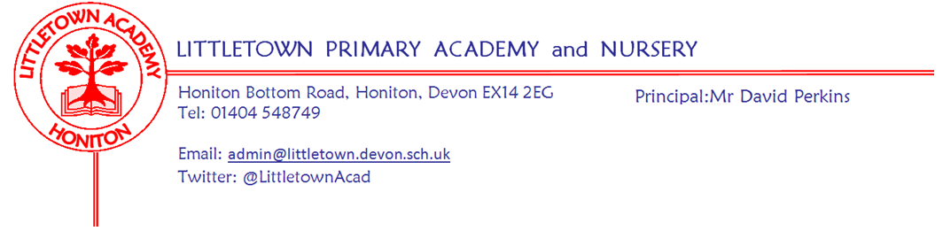
28th February 2020
Dear Parents and Carers,

Welcome back to school after the half term break and to the second half of the academic year. We once again started our half term recognising and celebrating the Attitude, Commitment and Effort of 42 children across the school in our ACE award assemblies. Also on Monday Year 6 had their second Earth Heart musical workshop and Year 3 enjoyed swimming. Yesterday we welcomed students from Colyton Grammar School to work with some of our Year 4 children on creative writing in the Community Room. Thank you to Year 3 families for providing cakes for this afternoon’s PTFA cake sale. Please see further PTFA news below.

Today you should have received a letter a letter regarding Parent Governor elections. Please see Jenny in the office if you're interested and feel free to speak to me about this also.

Attached to this newsletter is information regarding our exciting new Personal Social and Health Education (PSHE) curriculum which includes Relationships and Sex Education and Health(RSE). My thanks to Mrs Hawkins for compiling this information and for implementing our new curriculum. The children have really enjoyed the start of the first unit entitled ‘Being me in my world’ which featured an assembly with Mrs Hawkins and some shaving foam! If you have any questions then please don’t hesitate to contact us.

Next week, on Monday Year 3 have their final swimming session. On Wednesday our Year 5 and Year 6 Netballers will be taking part in the Devon finals at Kings school in Ottery St Mary. Year 4 parents are invited to a meeting about the Escot residential on Wednesday at 3:30pm. On Thursday we have World Book day where children can come to school dressed as a book character. We will be taking part in the global ‘Share a million stories’ campaign.
Finally, a reminder that next Saturday we have our Nursery open morning. Please do share this with anyone who may be interested.

Yours faithfully,
David Perkins
Principal

News from the children

Nursery
We have been learning about the story Goldilocks and the Three Bears.
We made pancakes.

Reception
We have learnt how to use bee bots.
We have been writing the Gingerbread man story.

Year 1
We met Jack and Paws for our Jigsaw lessons
We have been learning about space.

Year 2
We started a new topic called bounce.
We have been doing division in Maths.

Year 3
We have been learning about different skeletons.
We have been performing a poem about a rainforest.

Year 4
We have been learning about Shrove Tuesday and Ash Tuesday.
We have been doing Tag Rugby in P.E.

Year 5
We have started a new topic called Time Traveller
We have been creating graphic novels.

Year 6
We have enjoyed the second part of the Earth Heart Workshop.
In science, we looked at the components of blood and made blood in a test tube.

Messages
Swimming volunteers
We are looking for parents with a DBS who are available on Monday afternoons to help with swimming. Please contact the school office if you think you might be able to help.
World book day
World Book Day is next Thursday. Children will again be invited to dress in their own clothes as a favourite book character. We are registered to be part of the worldwide ‘Share a million stories’ campaign. More information to follow, but some information can be found here: https://www.worldbookday.com/share-a-million-stories/ We will also be issuing National Book Tokens as usual.

Week beginning 2nd March 2020 :
Monday | Tuesday | Wednesday | Thursday | Friday
Year 3 swimming |  | Devon Netball finals  Y4 Residential meeting 3:30pm | World Book day dress as book character

PTFA News
School Disco: Friday 13th March 2020
Key Stage 1 (nursery to year 2) 6-7pm
All children for the above disco must be accompanied by an adult for the duration
Key Stage 2 (year 3 to year 6) 7.15pm – 8.15pm
Children must be collected from the school hall and will not be allowed to leave unaccompanied.
£2.50 entrance fee to include crisps and unlimited drinks.
Children should NOT be using mobile phones at the disco. The same rules apply as during the school day so please don’t bring them.
If your child has any allergies or medical conditions which we might need to be aware of whilst your child is at the disco please let us know.
There will always be members of staff present but the PTFA are ultimately responsible for the running of the disco. We want everyone to enjoy their evening and work hard to make this happen. Any children who persistently misbehave may be prevented from attending future discos.
If you would like to help serve drinks or do tattoos on the night, please sign up on the PTFA noticeboard or email ptfa@littletownacademy.org.
Thank you.

