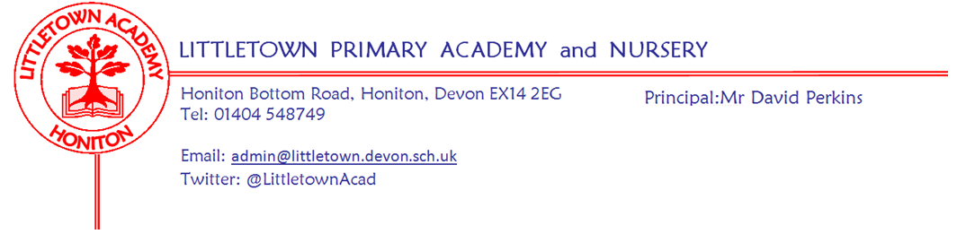
Year 2 – Remote Learning Update 17 April 2020

Dear Children, Parents & Carers,

We hope you are all keeping well, staying safe and have enjoyed the lovely Easter weather. From Monday 20th April we are going to use a Padlet Learning Wall to share activities and ideas for your home learning. All of the teachers at Littletown will be using this approach to ensure consistency across school. The Year 2 Padlet link is as follows:
https://padlet.com/aluxton1/dac97pn7ltt4

On the page you will find video messages from Mr Perkins and the class teachers alongside ideas to keep you busy. Each note has an idea/activity, and sometimes a link to a website if needed. We will add new notes with up-to-date learning so please look at the wall weekly.

We understand that accessing a device to view the Padlet wall might be difficult at times during the days and weeks. If this is true for your situation, using paper and pencil to practice spellings, times tables (and division calculations relating to the times tables; 2 x 8 = ____ and 16 ÷ 2 = ______) and sentence writing will always be useful for Year 2 children. We have tried to include ideas which can be undertaken and completed on paper so there isn’t too much demand on devices in the household.
We love seeing what you have been up to. You can send your photos, videos and notes to:
Mr. Luxton's class - class2al@littletown.devon.sch.uk
Mrs. Bentham's and Mrs. Rossiter's class - class2dbvr@littletown.devon.sch.uk
Remember Mr Perkins will still be sharing and celebrating #littlebuilders, #littlegreenfingers, #littlechefs and #littletownwindows. Email the school photos or share directly via our facebook page and twitter feed (@LittletownAcad).
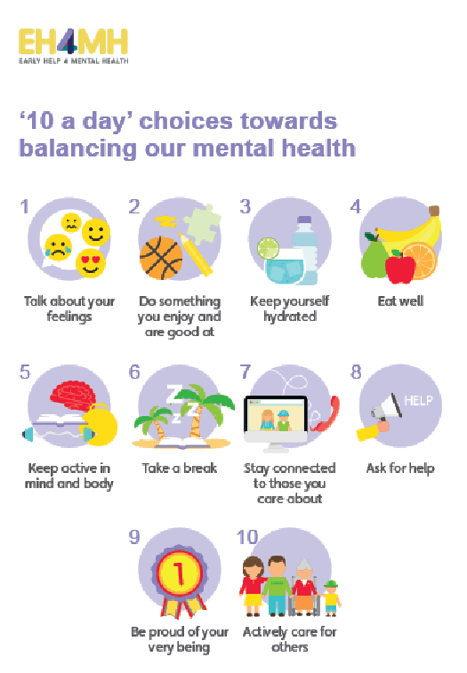
This is a really strange time for everyone, especially for the children who need time. Time – it allows them to process what is going on and make sense of their feelings. If the only thing you manage in the day is some of the ’10 a day’ then you and your family are having a good day. This is a time to spend as family, to talk, share, play, tell stories and snuggle.

Take care, stay safe and look after one another,

The Year 2 Team

Please note message from Mrs Trim and Mrs Childs:
This is the link that all parents can use to access the SEND/SAFS padlet page. There is a lot of useful information, activities, links... for our SEND children and families.
https://padlet.com/lianechilds/ewjn9i9gxfpw

