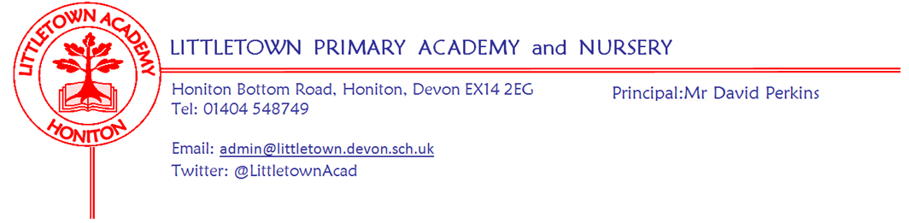

Live . Love . Learn - Littletown
Friday 27th February 2026
Dear Parents and Carers,

Welcome back to the second half of the school year! It has been great to hear of children’s half term breaks and to have some lighter days with less rain as we approach March.

This week, we started by marking World Thinking Day, allowing all beavers, cubs, scouts, rainbows, brownies and guides to wear their uniforms to school. I couldn’t quite believe just how many we have! On Tuesday, some of our children took part in the KS1 coordination event and then after school some children took part in the next round of TAG rugby. My thanks to Mrs Gibson and staff and parents who accompanied the children. This week we have also welcomed Thelma Hulbert Gallery to work with our Year 5 and 6 pupils on art projects over the week both at the gallery and here in school.

Next week is World Book day on Thursday. Please see full information on this below. My thanks to Miss Chalmers for all her time and energy in making this set to be a great day for the children.

Please also see below in this newsletter information about Personal, Social Health Education for this half term.

You will have noticed that the ‘top steps’ are now open again now we have had dry enough weather to set the concrete. Thank you for your patience while this was done and thanks to Mr Jeffery for completing this.

Finally, earlier today you should have received details about our Spring Term Parent Consultations which will again be in the school hall to ensure these are fair for all parents and run to time to prevent inconvenience. Please make sure you return the slip on Monday.


Yours faithfully
David Perkins
Principal

Children’s news

Nursery
We have been looking for signs of Spring and making bear faces out of paper plates.

Reception
In Reception we have been learning about Jack and the Beanstalk and they have got eggs in an incubator!

Year 1
In Year 1 we have been making art out of outside material and in Geography we are learning about
London. In Maths, we have been solving number problems.

Year 2
In Year 2 we are learning about dangers at the coast in Geography and in Science we are learning about recycling. In PE we are practising throwing and catching a ball.

Year 3
In Year 3 they have been learning in P.E about football and how to dribble the ball also they have been learning about the ring of fire. They have been learning about bottle nose whales too.

Year 4
In Year 4 they have been learning about classification in Science and in P.E they have been learning how to play Handball. They have also been learning about mountains in Geography.

Year 5
In Year 5 we went on a school trip to the Thelma Hulbert art gallery. The art gallery used to be Thelma Hulbert's house. We also have started the darkest dark in literacy.

Year 6
In year 6 they have been using chalk and preparing mock tests for next week. They have also started a new book in literacy.

World Book Day 2026!
Next week, on Thursday, we will be celebrating World Book Day at Littletown. To celebrate, children can dress up as their favourite book character. A charitable donation can be made to our school library if you so wish.

As part of the event, we have teamed up with TG Jones in Honiton to help the children choose a free book. They will come home with their choice of book on Thursday, which is very exciting!

We are also running our 'Read for Fun' competition. Please see the poster attached for more details. The closing date will be Thursday 5th March with entries being brought in on this date or just before to avoid decomposing. There will be a winner from each year group including the Nursery. Winners will win a £5 National Book Token courtesy of the Littletown PTFA. We look forward to seeing your entries.

Librarians from Year 5 and 6 will give these reminders to children in assembly this afternoon as well as sharing details about our challenges on the playground for the day.

Personal, Social and Health Education update

This half term our Personal, Social and Health Education has a focus on Being Healthy. Thank you to our Year 6 Mental Wellbeing Ambassadors who have launched our new topic in both of our key stage assemblies this week,

We would like to share some of the curriculum content each year group will cover over the next 5 weeks, to help prepare and inform you for conversations or questions raised at home.

- The youngest children in Nursery and Reception will learn about the importance of exercising bodies, healthy food, Sleep, keeping clean and Safety.
- Year 1 children will learn about healthier lifestyle choices, including keeping clean, being safe (Medicine safety/safety with household items and road safety) and linking health and happiness.
- Year 2 children will learn about motivation, healthier choices, relaxation, healthy eating and nutrition.
- Year 3 children will participate in exercise fitness challenges, learn about food labelling and healthy swaps, attitudes towards drugs, keeping safe and why it’s important both online and off line, respect for self and others and healthy and safe choices.
- Year 4 children will learn about healthier friendships, group dynamics, smoking, alcohol and vaping, assertiveness, peer pressure and celebrating inner strength.
- Year 5 children will learn about smoking including alcohol and vaping, alcohol and anti-social behaviour, emergency aid, body image, relationships with food, healthy choices motivation and behaviour
- Year 6 children will learn about taking personal responsibility, how substances affect the body, exploitation including ‘county lines’ and gang culture, emotional and mental health and managing stress.

Volunteers wanted!
A few parents have recently voiced they would like to volunteer in school. We are always keen to have parental support throughout the school, especially supporting hearing children read. If this is something you are interested in and you have some spare time each week please contact the school admin office. You will be given a volunteer application form, complete our safeguarding procedures and be invited into school to discuss how and where your support can help our children.

Week Beginning 2nd March 2026 events

Monday 2nd March | Tuesday 3rd March | Wednesday 4th March | Thursday 5th March | Friday 6th March
 |  |  | World Book Day fancy dress.

Community news
NHS updates
We are pleased to invite all parents and guardians across Devon to a free NHS‑funded Oral Health Webinar taking place on Saturday 28th February at 10:00am.
This session is suitable for families with children aged 0–12 years, and it provides practical, evidence‑based guidance on supporting good oral health at home.
This opportunity is open to all families, whether or not your setting currently takes part in our supervised toothbrushing programme.
Please feel free to share the link below with all year groups in your setting:
👉 Webinar link:
Big Brush Club Webinar - Saturday 28th February at 10am - For Parents and Caregivers of young children
We hope this will be a useful resource for your families, and we appreciate your support in sharing it widely.
If you have any questions, please don’t hesitate to get in touch.

Half term Art workshop art Thelma Hulbert Gallery
We are really pleased to be offering a half term workshop with printmaker Emma Molony, a local artist who was commissioned to create beautiful prints for our current exhibition - find out more about this here
This is a family drop-in workshop that is free to participate in - although donations are always welcome!
Here is a link to more information:
Event Detail
