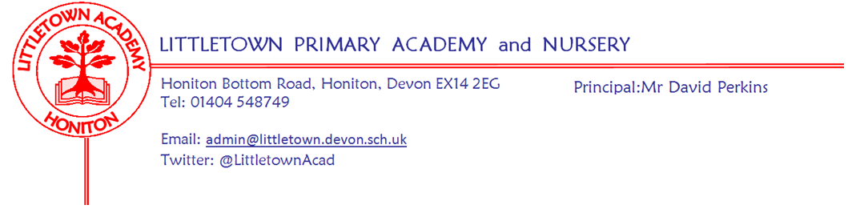

Year 2 Summer Term 2021 Information

Welcome
We are very pleased to be welcoming back the children for the summer term in Year 2 and have been impressed already with the positive way the children have returned. We have many exciting activities planned for the children to help them with their learning this term. We also have a trainee teacher, Miss Chalmers in Mrs. Bentham's and Mrs. Rossiter's class who will be with us this term.
Literacy
For the first half of term we want to help the children improve their story writing by using the theme of a space story, and then learn about writing a biography of one of the significant individuals we learn about in our Movers and Shakers topic lessons. In the second half of term, we will be focussing on building stamina for writing and writing non-fiction text based on our topic ‘Beachcomber’.
Maths
We will be starting our Power Maths book C next week (after finishing our unit of shapes) which will cover position and direction, problem solving and efficient methods, telling the time and weight, volume and temperature. If you would like to help the children get a head start with telling the time, practising at home would be of great benefit to them.

Cornerstones Topic
Our topic for the first half of Summer term is 'Movers and Shakers', where the children will learn about significant individuals from history including explorers, scientists and activists. We are sending a letter home with more information including ways to support your child at home with this theme. After half term, our topic will be ‘Beachcombers’ where we will be learning about the weird and wonderful animals and plants that live in rock pools.

PSHE (including Relationship, Sex and Health Education)

In the first half term our focus will be on ‘Relationships’, We will be learning about families, keeping safe (exploring physical contact), friends and conflict, secrets, trust and appreciation and finally, celebrating my special relationships. After half term, we will focus on ‘Changing Me’. We will be looking at life cycles, changing me, my changing body, boys’ and girls’ bodies, learning and growing and finally, coping with changes.
Key reminders.
Outdoor Classroom: Dates to follow...
Book Bags and Reading Records: Please bring book bags to school every day with your child’s Reading Record. We will check reading records every Monday in line with the school expectation that children are reading at home at least 5 times a week and that this is recorded in their reading record.
Water Bottles: Please ensure your child has a bottle of water (not juice) in the classroom for drinking throughout the day. They may have juice in their lunchbox but no fizzy drinks.

Packed Lunches: We have peanut allergies in school so we ask that no children have nuts or nut based snacks/spreads in their lunchboxes. We are a healthy school and ask that children do not bring in chocolates or sweets for lunch.
School Dinners: Please ensure you book your child’s school dinner by Friday midnight for the following week. We will inform you if your child does not eat enough school lunch.

Medication: Please let us know if your child has to take any prescribed medication at school. There is a green form for you to fill in so that we can administer it. We can only give prescribed medication and the medication must have the prescription label on. Please phone the school if your child is off sick. If you have a medical appointment please let the office know.

Birthdays: If it is your child’s birthday they can come to school in their home clothes. Please do not bring cake/sweets.

Parent helpers: We would normally love Parent Helpers but unfortunately, we cannot have parents into school at the moment.

Thank you for your support,
Mr. Luxton, Mrs. Bentham, Mrs. Rossiter and Miss Chalmers.

class2al@littletown.devon.sch.uk
class2dbvr@littletown.devon.sch.uk

