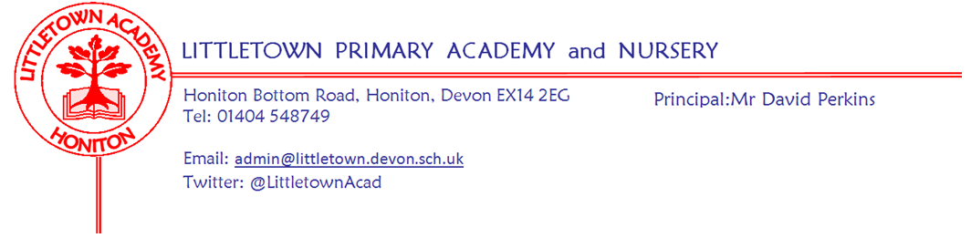
Friday 29th January 2021
Dear Parents and Carers,

I find it amazing that we have already had four weeks of partial closure. It seems to have gone quickly and yet I know for all of us with work, remote learning, being in lockdown and miserable weather, it can at times seem a bit of a long old slog. The news that this current arrangement will be extended until at least the 8th March, whilst not being entirely surprising, is sad news for all of us. We are desperate to have all the children back in school as soon as possible. However, without wanting to repeat myself, I continue to be so incredibly proud and impressed by both the children in school and children at home. I have full and complete confidence that children in school and at home will continue to be well supported and make good progress right through until hopefully welcoming everyone back on 8th March.

Lateral flow testing (LFTs) for Primary school staff
As mentioned last week, staff this week had their first round of Lateral Flow Testing. Testing will continue to take place on Sundays and Wednesdays and parents will be contacted if there are any bubble closures as soon as possible. My thanks for the staff participating in this in order to keep our school and local community that little bit safer.

Children’s Mental Health week 2021
Next week is Children’s Mental Health Week. There is much in the media about the impact of Covid-19 on Mental Wellbeing so focussing on this could never be more important. Mrs Davis and her team have worked hard to consider how we can do this really both in school and at home. I know it is another thing to think about when you are all juggling so much and the last thing we want is for Mental Health Week to have a detrimental impact on your Mental Health(!), but please look at these activities on the padlets with your children if you can. Please see information from Mrs Davis below.

Children’s Mental Health Week is taking place from 1 – 7 February 2021 and is an opportunity to
shine a spotlight on and raise awareness for children and young people’s mental health. Each year, Place2Be works to ensure that no child has to face mental health problems alone by providing school-based mental health support in schools throughout the UK. We are going to be supporting this year’s event both in school and virtually with activities on each year group’s padlet and through class google meets.

We are inviting the children who are in school to express themselves by either wearing a colourful outfit or accessories along with non-uniform on Wednesday 3rd February, no donation required. The children who are at home will be able to wear their colourful clothes/accessories to one of their Google Meets (day to be decided by the class teacher). Each year group’s padlet will have a column with activities to do and videos to watch.

There is also a link to the SAFs padlet page which has lots of useful information about how we can look after our own mental wellbeing as parents/carers during this lockdown. You will also find the updated ‘Ten a Day’ poster on each padlet which is a great resource for talking to children about what we can do to look after our mental wellbeing.

Yours faithfully,
David Perkins
Principal
In school bits

Half term closing
This week the DfE informed us that schools are to close completely during the February Half term and not offer any key worker or vulnerable pupil provision. We haven’t been given any rationale about this decision, but it seems to be that as opposed to the last closure, parents are allowed to use childcare bubbles and grandparents etc. This week will however, allow children and staff to have a much needed break and recharge their batteries for returning for what looks to be an equally complex second half of the Spring Term.

Attendance
For children in school, all our statutory attendance monitoring and reporting remains in place. Please remember to contact the school if your child will not be attending. We need to know whether the absence is due to illness, isolation or not needing your child in school that day due to changing work commitments. We have several different registers we need to complete each day with specific codes recorded for each absence. I know lots of you are juggling all sorts of shifts and commitment, but if you can remember to do this for us it will mean we don’t end up chasing you and interrupting your key work. Many thanks for your assistance.

Remote learning of part time attendees
As mentioned in previous newsletters, if your child is partially in school and partially home please make sure they complete remote learning on the days they are not in. Teachers will be teaching the lessons off the padlet for each specific day. They won’t be covering any lessons from earlier or later in the week. It is incredibly hard and unfair for the children and teachers if children are not doing the other lessons. Indeed, despite them being in school, this actually has a detrimental impact on their progress overall. Please get in touch if you have any questions about this.

------------------------------------------------------------------- ----------------------------------------------------------------------------------

At home bits

A message after 4 weeks of remote learning
As mentioned above I am so pleased and proud with how the remote learning is going 4 weeks into this partial closure. I happen to know that in lots of schools there are children and families who have made a strong start to remote learning, but are now doing less and enjoying it less. Schools that are heavily reliant on live lessons are starting to find the workload on staff and engagement of pupils look less and less sustainable. The evidence we can see at Littletown however, is that in the vast majority of cases the high quality of learning is at least sustained and in many cases continues to go from strength to strength. Children and staff also continue to really look forward to the regular google meets which foster the peer connection, social interaction, class community and fun. This is a great testament to the quality of the provision and support from the teachers, the effort and attitude from the children and the incredible focus and commitment from you parents, that make it all happen. All in all, this means I am very confident that our children will continue to make good academic progress right through to the 8th March when we hope to return to school. Mrs Hawkins and I love hearing from the teachers about the amazing learning children are doing and enjoy celebrating this. Between now and half term we look forward to dropping into some google meets as workload allows, to say a hello and well done to everyone as we do so miss the children who are at home. As I say to the children…. well done and keep it up!

